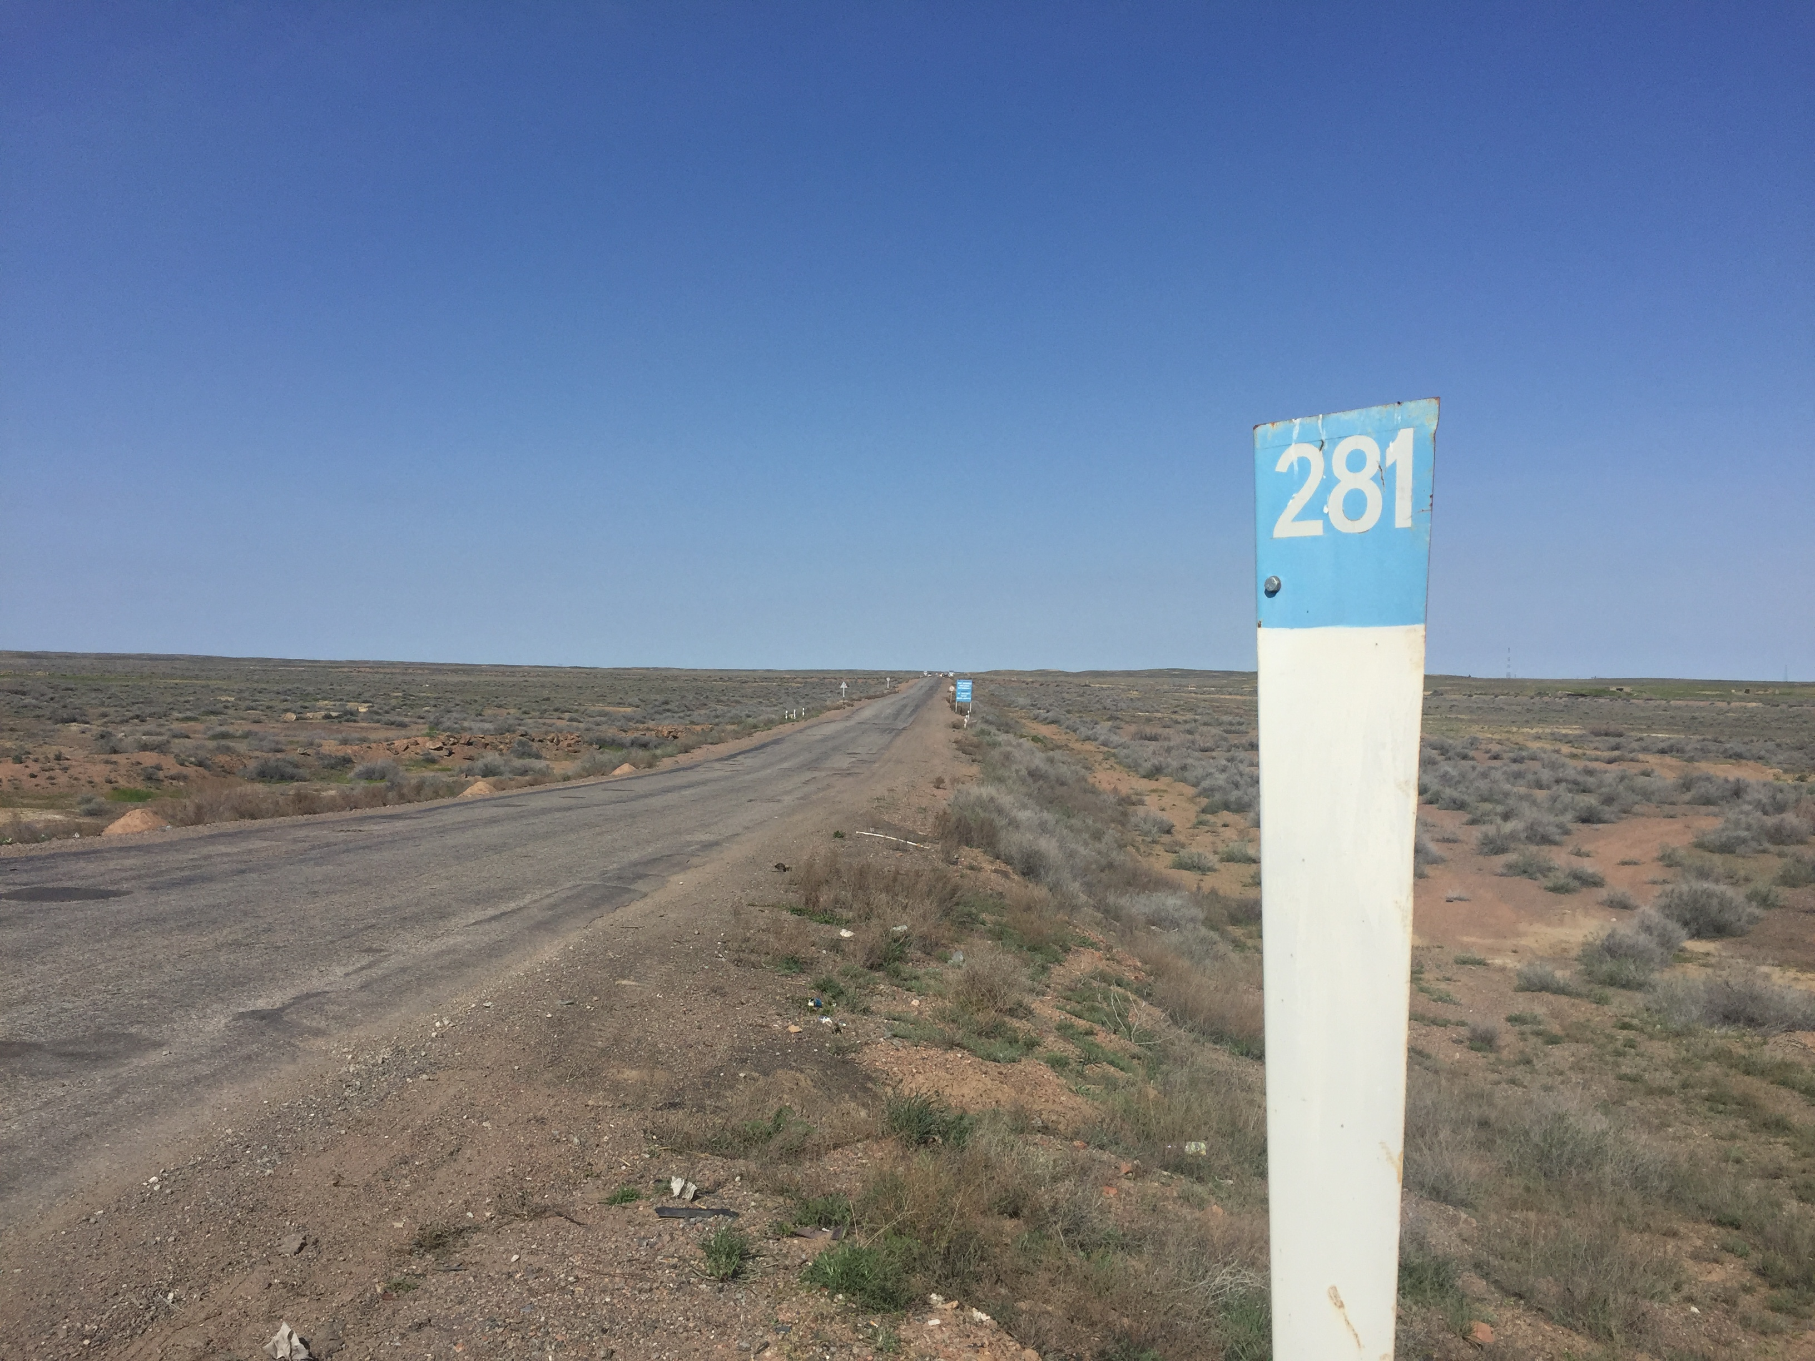
Non-Technical Summary of Environmental Impact Assessment report
Burybaytal-Aksuek 2152-2214 km, Part of the Reconstruction of the ‘Centre-South’ Corridor Linking Astana to Almaty

April 2016

Table of Contents
1. Project Description 3
1.1. Overview of the Project 3
1.2. Reconstruction Planned and Road Setting 3
2. Background 6
2.1. Rational for the Project 6
2.2. Legal Aspects and Compliance 6
2.3. Environmental and Social Considerations 6
2.4. Assessment of the Project 7
3. EIA Process 8
3.1. Project Design and Regulatory Compliance 8
3.2 Public Consultations and Disclosure and Dealing with Objections 8
4. Summary of Environmental Benefits, Potential Adverse Impacts, Mitigation and Management Measures 9
5. Summary of Social Benefits, Potential Adverse Impacts, Mitigation and Management Measures 12
6. Communications 14
6.1 Stakeholder Engagement Plan 14
6.2 Grievance Mechanism 14
6.3 Contacts 15

Project Description

Overview of the Project
The European Bank for Reconstruction and Development (EBRD) is considering providing finance for the reconstruction of a section of the 228 km “Kurty Burybaytal” or the “Centre - South” corridor linking Astana to Almaty. The Section for which the EBRD finance is sought by the JSC Kazautozhol, is 62 km (the “Project”), the Burybaytal-Aksuek section.

The proposed investments include the reconstruction and widening of the existing road, the reconstruction of bridges and upgrading of intersections as well as financing of supervising engineers, implementation assistance to the Project Implementation Unit (PIU) and institutional components.

The 62 km section (Section 1) that EBRD is potentially financing starts at the point of 281 km from Almaty, at approximately 2 km west of Aksuek. The road sections are:

- Section 1: km 2152-2214 (62 km). Current section that is proposed for EBRD financing.
- Section 2: km 2214-2295 (81 km). Previous section that has received EBRD financing.
- Section 3: km 2295-2335 (40 km)
- Section 4: km 2335-2380 (45 km)
As well as the EBRD, the other road sections will potentially be or have been financed by other International Financial Institutions (IFIs) that include World Bank (WB), Asian Development Bank (ADB) and Islamic Development Bank (IsDB).

It is planned that the time scale of the start of construction for all sections is likely to be in 2017. The estimated construction period of each section is 39 months.

This document is a Non-Technical Summary (NTS) that provides a summary of the Project in non-technical language covering the background and project description, the national Environmental Impact Assessment (EIA) process, the environmental and social benefits/impacts, mitigation and management measures that have been incorporated into an Environmental and Social Action Plan (ESAP) and the contact details for communications with a summary of the Stakeholder Engagement Plan (SEP) that includes a grievance mechanism.

Reconstruction Planned and Road Setting
The proposed EBRD funded road section is located in Moiynkum district of Zhambyl Oblast, between Burybaytal station and the Aksuek town. It is part of the transit “Centre-South” corridor of “Astana-Karaganda-Balkhash-Kapshagay-Almaty”. The entire road section is aligned in south-eastern direction. It is the last part of Astana-Almaty highway to be rebuilt.

Currently, the road has two lanes and is Category 2 under Kazakh road standards. The road will be reconstructed to comply with the Kazakh Category 1b highway requirements and will include the reconstruction of bridges and upgrading of intersections.

The designed road alignment crosses four river beds Kuyaly, Karaul-Kashkan, Karasay, Botaborym. In recent years the rivers are mostly always dry. There will be the reconstruction of 4 bridges. Other upgrades or new features will also include a junction, off ramps, rest areas, bus stops, junction overpass, railway overpass, culverts, bridge and junction lighting and a police station.

Figure 1 shows the Burybaytal-Aksuek section of the road including road features that include location of bridges and overpasses, cattle underpasses, drainage pipes, exit roads, and rest areas.

Figure 1: Kurty-Buribaytal Road: Burybaytal-Aksuek Section

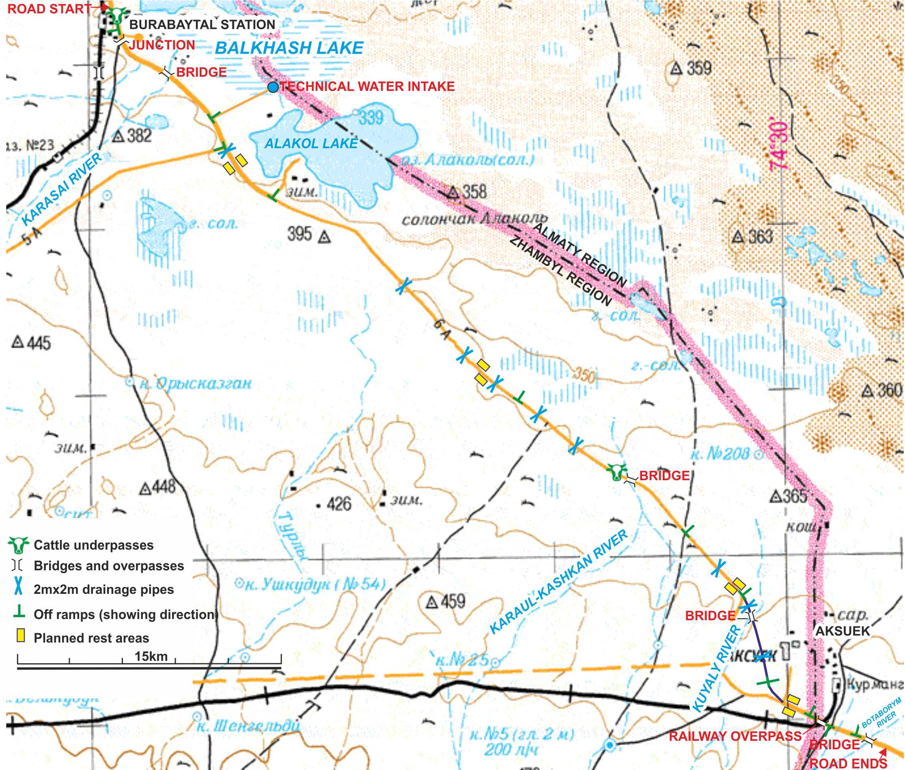

The 62 km section of the road is located in the 50,400 km² Moiynkum district which is further subdivided into 16 rural areas inhabited by some 30,000 people of more than 30 nationalities. Aksuek is located 2 km north of the southern end of the road. The population of Aksuek was reduced by 10,000 people after a uranium mine was shutdown in 1991 and the empty houses in the town have been dismantled for reuse as building materials. The population now consists of approximately 1,200 residents, mainly elderly residents who once worked at the mine. Burybaytal station at the northern start of the road section consists of some 60 houses, over time its population has gradually fallen and there are now approximately 200 residents.

Apart from a family farm 3 km southeast of Burybaytal and 166 m north of the road, there are no houses or settlements located directly adjacent to the road section. The farm uses the 200 m dirt road to enter the main road to travel in both directions. There are no houses and farms around the road due to the absence of fresh groundwater and poor pastures with grass that burns out before summer. Agriculture and small scale meat and dairy cattle farming is developed on Syrdarya River flood plain 100 km southwest of the road. Fresh water is brought to Burybaytal station by the railway and to Aksuek by a 53 km pipeline. There is limited livestock is held in these settlements. In order to cross the road, two new cattle underpasses are to be built: one immediately next to Burybaytal and the second next to the bridge through Karaul-Kashkan River that may flood the surrounding ground under the bridge once in 4-6 years and prevent the cattle from crossing for few weeks. Aksuek livestock can use two bridges and the railway overpass to cross the road.

There are various businesses such as petrol stations and cafes adjacent to the road alignment. These businesses do not need to be demolished as there is sufficient land adjacent to the alignment, for the reconstruction of the road. There will be a requirement for land acquisition for the road reconstruction, as two sections of the 62 km road will be realigned. These two sections are at the northern and southern ends of the road. The land that will be required for the land acquisition is not currently in use, and was observed to not have any informal agricultural or other commercial activities.

A certified archaeological company has undertaken a study to identify all sites and objects that are of cultural significance in the vicinity of the road. This study identified 11 fatal road accident memorials, a modern closed Muslim/Christian cemetery and 3 ancient burial mounds of unknown age.

The road corridor runs on gently hilly terrain, in the middle desert zone along the dry river beds and lakes, which is used for non-intensive herding. At present, on some days the small herds from the settlements and the farm may cross the road wherever convenient in the early morning and before dusk. The herders currently take their livestock across the road at all locations. However, because the river beds are used for pasturing, often the crossing occurs under the bridges. There is a water well near the road which is located at the farm. Its output limits the number of livestock the farm can keep. The alignment passes through the territory of Lake Alakol, and Lake Bakhash is also nearby. There are a number of dirt road connections to the lake, used for fishing, tourism and leisure activities. The road runs through the Zhusandaly Nature Preserve which is inhabited by a number of mammals including goitered gzelle, wolfs, jackals, foxes, corsac foxes, hares and various birds. Two other nature protection areas near the road alignment are the Ramsar designated Ili River Delta 23 km northeast and Andasay Nature Preserve 91 km southwest.

Background

Rational for the Project
The highway currently has two lanes that will be widened to four lanes. The road’s asphalt pavement is past its effective working life and its condition is poor. It is deteriorating at a fast rate, due to a combination of heavy traffic loading, the age of the pavement and wide variation in ambient temperatures.

Road reconstruction is urgently required to improve the ride quality of the road, minimise road user costs, reduce vehicle emissions and provide a pavement that can be maintained in a cost effective manner. The widening of the road will reduce the number of traffic accidents, as the road currently has a single lane in each direction, which forces drivers to cross into the oncoming traffic lane to overtake vehicles. The dedicated livestock underpasses will also improve road safety, as local farmers will no longer need to take their livestock across the active highway.

The road will serve local and national transport requirements, as well as the agricultural sector, which is a key sector in Kazakhstan and will be a major beneficiary. Labour movement will also be enhanced, as communities near to the road such as Burybaytal station and Aksuek will benefit from easier transport links. The road will be part of a route between China and western Europe via western China, through Kazakhstan to Russia. This will be economically beneficial from a trade and tourism perspective. The upgraded road will improve the international transportation of goods, including goods produced in countries such as Tajikistan, the Kyrgyz Republic and Uzbekistan.

Legal Aspects and Compliance
A feasibility study and detailed design has been completed, accepted and approved by the State Expertise, in accordance with the Kazakhstan regulatory regime. The final design is now completed.

A national Environmental Impact Assessment (EIA) has been developed in accordance with the rules, regulations and standards of the Republic of Kazakhstan for design and construction of roads.

An independent gap analysis review of the national EIA and other key documentation has been undertaken against EBRD’s Performance Requirements, EU standards and best practice. The gaps identified have been used to develop an Environmental and Social Action Plan (ESAP) for implementation and a disclosure pack comprising this NTS and a Stakeholder Engagement Plan (SEP) in English, Kazakh and Russian.

The SEP provides a framework for consultation activities and project disclosure information including the identification of potential stakeholders, methods used for consultation activities and the records to be kept.

Environmental and Social Considerations
Potential environmental and social (including community and occupational health and safety) impacts have been identified and mitigation measures have been developed that are presented within the EIA, and further mitigation measures are set out in the ESAP as determined in the gap analysis review with implementable ESAP actions identified. The JSC Kazautozhol are committed to ensuring that the ESAP is implemented. A summary of the key impacts and mitigation are provided in the next section.

Assessment of the Project
The project has been in the planning for a number of years. The feasibility study considered alternatives (“without project" and "with the project") and concluded that the widening of the selected alignment of the present carriageway to four lanes with a dividing strip, offered the best environmental approach to solving the problems with the present alignment, and would encourage greater economic and social links between town and cities. The key potential environment and social impacts associated with the project with mitigation measures developed during the construction and operational phases are:

Climate and Air Quality  Noise and Vibration  Water Management  Surface Water  Groundwater  Wastewater Management | Geology and Land  Ecosystems and Flora and Fauna  Geohazards  Waste Management  Cultural Resources  Visual Landscape | Occupational Health and Safety including labour standards  Community Health and Safety including Road Safety  Land Acquisition  Other Socio-Economic Impacts

EIA Process

Project Design and Regulatory Compliance
The national EIA was developed in accordance with the rules, regulations and standards of the Republic of Kazakhstan for the design and construction of roads. State Environmental Expertise Positive Conclusion on the EIA was obtained 20th March 2015, with the following prior approvals:

- The Sanitary Epidemiological Service – 30th January 2015; and
- The Balkhash-Alakol Basin Water Inspectorate approval – 28th January 2015.
The EIA has been reviewed to identify gaps that have been as addressed with Environmental and Social Action Plan (ESAP) developed with actions that are recommended for implementation in order to fully meet EBRD’s Performance Requirements, EU standards and international best practice.

The road design is now finalised and is in the process of being reviewed by the authorities. Key stages in the future will be the issue of invitations to tender for road construction companies and also the appointment of project management and project supervision roles.

All the permits and licences required by national legislation have been obtained, including land deeds, clearing permits, borrow pits / quarries permits for earthworks and soil gravel mix, pipe installation permits, lighting permits etc., with the exception of the permits required to cover air emissions which have not yet been obtained. However, as per the Republic of Kazakhstan laws these can be obtained within a year after the commencement of construction works.

Public Consultations and Disclosure and Dealing with Objections
During the EIA process, a public consultation meeting was held on 25th February 2015 in Burybaytal. The information on the forthcoming event was shared via an advertisement in local newspapers Znamya Truda (in Russian) and Akzhol (in Kazakh) both issued on 21st February 2015. The objectives of the public consultation were to explain the various elements of road construction such as road alignment, cattle underpasses, road surfacing etc. All attendees were given an opportunity to express their opinions and ask questions related to the Project. A SEP has been developed that includes a grievance mechanism to ensure that there will be effective on-going communication throughout all the stages of the project.

Summary of Environmental Benefits, Potential Adverse Impacts, Mitigation and Management Measures

Air Quality and Climate
There are no settlements near or adjacent to the existing road alignment, with the exception of the Burybaytal station (50 m from the alignment), an isolated farm (166 m from the alignment) and the village of Aksuyek (2 km from the alignment). Pollutants found in road vehicle exhaust fume gases have been assessed to see whether they would impact local human and natural receptors. The results show nitrogen dioxide concentrations only exceed maximum permissible limits within 3.5 m of the road. The measurements for this section of scheme were taken at various distances from the road where it passes through Burybaytal. As there is no development within 30 m of the road, no impacts from nitrogen oxide are anticipated.

The poor quality of the road currently is increasing emissions from vehicles (e.g. due to variable speeds related to poor road conditions). The improved road would provide better driving conditions for travellers leading to more efficient vehicle operation and reduce vehicle emissions to air.

During construction, measures would be put in place to reduce air quality and dust impacts. This will include spraying the ground with water to reduce dust creation, covering dump truck buckets carrying loose material, and halting dust creating construction activities when there are strong winds.

Noise and Vibration
Noise and vibration impacts are not expected to be significant. It is recommended that a baseline noise survey is undertaken and used to predict the operational impacts of the road at all relevant noise receptors, such as residential properties, businesses and ecological receptors.

It has also been recommended that noise and vibration associated with construction activities should be calculated. Any locations where the upper noise limits will be exceeded will have safety signs and workers will be provided with personal protective equipment. In order to meet requirements, working at night is excluded from the construction plan. Engines shall be insulated in order to reduce noise levels and regular monitoring of noise and vibration will be undertaken in working areas. All equipment will be maintained in good working order.

Water and flooding
The designed road alignment crosses four river beds Kuyaly, Karaul-Kashkan, Karasay, Botaborym. In recent years the rivers are mostly always dry. There will be the reconstruction of 4 bridges and construction / reconstruction of 61 reinforced concrete culverts under the road and at junctions to allow water to flow under the road and prevent erosion and damage to the road.

Currently the water drainage along the existing highway is in a poor condition. Rain and snow-melt water from the surface of the road collects in drains parallel to the road to control soil erosion. Surface water from bridges will pass through a gravel filtration system to stop oil and other pollutants entering waterways. Surface water discharge from the road and bridges will be within maximum limits.

Fuel and chemical storage will sit on a water-tight base with a barrier to contain any spills and prevent it entering the surface or groundwater. During construction water will be taken from the Lake Balkhash by road tankers. Measures have been recommended to ensure effective management of water supply, waste and wastewater disposal (from the workers camp and construction sites).

Geology and Land
The soils in the area are poorly developed with an alkaline nature and either grey or meadow-bog soils. The contamination of soils, particularly lead, was found to be less than recommended environment limits 20 m from the roadside.

A large volume of topsoil will need to be removed for construction. Care will be required for the preservation and reinstatement of top soil. Only licenced borrow pits and quarries will be used to obtain construction materials.

It has been recommended that identification or potentially testing for contaminated soils along the alignment should be undertaken, and that the potential for the soil works to impact on groundwater near the bridges needs to be assessed further. Implementation of monitoring during the construction phase should take place. Consideration should also be given to geotechnical hazards.

Ecosystems and Flora and Fauna
The proposed road crosses over four dry river beds and is located within the vicinity of Lake Alakol and Balkhash, so there is a variety of flora and fauna that could potentially be impacted. A large number of these species are listed as endangered and are of high conservation value. Some adverse impacts have been identified that are linked to the road reconstruction. Road operation may lead to disturbance of jeyran seasonal migratory patterns and increase death on the road for smaller animals. For other animals there are enough crossing points, via the two new underpasses, dry river beds under the four bridges and large culverts, thus reducing the impact of habitat fragmentation. A trained ecologist should undertake pre-construction surveys to check for the presence of protected species. Particularly sensitive habitats should be identified and fenced off prior to construction works. If a particular valuable or vulnerable to disturbance nesting bird species is identified in the saxaul thickets next to the road, vegetation clearance will be conducted in the way to avoid or minimise the impact. Toolbox talks should be given to construction workers to enable them to identify the main protected species and advise them on the actions to take in the event of their discovery on site.

Waste Management
Inert materials will be re-used within the project. Hazardous material will be disposed of via existing municipal waste management facilities in the form of landfill, yet to be identified. Licensed facilities should be used for the disposal of construction waste and other waste streams, including hazardous waste, and they should be identified prior to the commencement of construction.

Cut saxaul and saltwort shrubs will be used to create silt screens in the areas where the work may affect surface water (e.g. renovation of the technical water intake at the Alakol Lake). After the construction the screens will be given to the farm near the road to use as firewood. All temporary industrial sites for storage of wastes will have a detrital soil layer of at least 20 cm to reduce the spread of pollutants. Sewage from the workers’ camp will be temporarily stored on-site and then transported from site and disposed of in licenced facilities. The temporary storage will be in a concrete bottomed tank to prevent seepage and contamination of groundwater.

The wastes produced by the construction of the proposed highway are not toxic and do not pose a threat to humans and wildlife. All materials and wastes stored should be quantified and have containment measures in place, such as for the storage of oils. All waste will be safely disposed of in licenced facilities.

Cultural Resources
A certified archaeological company has undertaken a study to identify all sites and objects that are of cultural value in the vicinity of the road. The study identified fifteen memorials of particular archaeologically historical and cultural interest, including one cemetery, three ancient burial mounds and eleven road accident memorials. The identified cultural sites are located away from the proposed road alignment and do not need to be relocated. If any road accidents memorials are discovered in the immediate vicinity of the road, it has been recommended that the appropriate relocation processes are implemented with the informed consent of the owner of the memorial site. Sites should be fenced, if necessary, to ensure that construction activities will not prevent access to sites, or damage, the sites. In addition, ‘Chance finds’ should be reported to the Institute of Archaeology and other relevant institutions to undertake excavation and full archaeological assessment of the finds.

Landscape and Visual
The road development will create a raised structure in a relatively flat, open, landscape, although the road is already raised in parts. There will be no tree felling required. There will be a large amount of stockpiling during construction, followed by reinstatement of bare ground, which will result in temporary adverse visual impacts during the construction stage. There are no settlements near or adjacent to the existing road alignment, with the exception of the Burybaytal station, an isolated farm and Aksuyek town. Due to the low number of visual receptors, it is considered that visual impacts will not be significant.

Summary of Social Benefits, Potential Adverse Impacts, Mitigation and Management Measures

Community Health and Safety
There are unlikely to be significant impacts on the local communities once the road reconstruction is complete, as there are no residential dwellings immediately adjacent to the road alignment. The businesses adjacent to the alignment do not need to be relocated, and are likely to benefit from an increase in trade.

During construction, there could be disruption caused by reduced access to roads, limited livestock crossing and no alternative routes for connecting dirt roads while intersections are constructed. Communities should not be cut off during construction and also when the road has been built. To address these issues, the development of Construction Environmental Management Plans (inclusive of traffic management plans) is necessary as well as Worker Safety Action Plans to minimise accidents and incidents resulting from road works. There will also be Emergency Preparedness and Response Plans that will be developed.

The widening of the road will reduce the number of traffic accidents which have resulted due to the narrow width of the road, which forces drivers to cross into the oncoming traffic lane to overtake vehicles. An independent road safety audit report has been conducted to consider road safety measures for speed control, cattle crossings, intersection and u-turns, cross sections, roadside hazards, traffic, pedestrians and enforcement. The most appropriate and effective traffic and road safety measures will be identified in the independent audit, and should be implemented.

Occupational Health and Safety
To ensure effective contractor management, tender documents will be prepared that will incorporate all the mitigation measures that contractors should either implement, or be aware of. A review of labour and social policies should be undertaken and incorporated into contractual arrangements with contractors. The contractor selection process should include criteria for evaluating past performance. A contractor will be appointed for the road construction and there will also be the appointment of project management and project supervision roles in the future. Suitably qualified personnel should be appointed to monitor the different contractors undertaking construction activities. Independent audits should be carried out to ensure that environmental, health and safety standards are complied with and that social issues, such as the terms and conditions of employment and the standards of the workers’ camp are compliant with EBRD requirements.

A workers camp is planned possibly to serve as accommodation for up to 1,050 workers. The workers’ camp will be compliant with International Finance Corporation (IFC) standards. It is stated that the labour force will come from the closest towns and villages. It is recommended that a due diligence investigation for all security personnel is conducted to make sure they have appropriate licensing, experience and training for security contractors. It has also been recommended that for the location of accommodation, consideration for utilising existing capacity in accommodation and other local amenities is given e.g. Aksuek Town. It is currently thought that the camp will be located near to Burybaytal station.

It has also been recommended that an integrated Occupational Health and Safety Plan that is compliant with national legislation, monitoring and management systems are in place.

Land Acquisition and Resettlement
The reconstruction of the 62km section of the highways requires the acquisition of approximately 142 ha of land. Of this, approximately 119 ha will be occupied permanently by the road with the remaining 23 ha being returned. The temporary occupation or permanent removal of land is likely to cause a loss of profits to landowners. The state forestry agency owns the land and an approval for conversion of ‘land use’ is required before any work begins. Compensation for the loss of their land will be calculated and submitted by state forestry agency. On the re-alignment section near to Aksuyek, the land is owned by Asuyek Village Council, a similar process of compensation for the loss of land should be undertaken. It is unlikely that there will be any land acquisition that will result in physical or economic displacement of businesses at rest areas near to the road. For those that are on the old road for the re-alignment section near to Burybaytal station, road access to these businesses will be maintained.

The local government has acquired official data from the Land Registry and has started consultations with affected landowners to inform them about the Project and potential impacts. The land acquisition process will include the valuation of land, compensation payments and consultation with landowners. Land acquired for temporary use for construction pads and other facilities will be re-cultivated, cleaned and returned to the original owner.

Other Socio-Economic Considerations
The 11 planned off-ramps (shown in Figure 1) will give access to the field roads to isolated communities and to the Lake Alakol for leisure and tourist activities. Out of 14 regularly distributed dirt road connections to the lake, four are equipped with off ramps from Almaty-Astana direction but all these off-ramps have U-turns 1-2km away. It is recommended that further information is provided to demonstrate that none of the isolated communities near to the road will be cut off by the new rehabilitated road.

Gender impacts of the project are minimal. The key issues identified relate to the workers’ accommodation and its impacts on local communities and neighbouring settlements. The appearance of workers’ accommodation often induces the influx of workers that might lead to harassment, the spread of prostitution and Sexually Transmitted Infections (STIs) in the area. A strict code of conduct will be enforced to avoid any adverse impacts on women. It is recommended that women’s employment opportunities on the Project and the related infrastructure is supported. If there are large numbers of resident female workers and employees, the workers’ camp should provide separate facilities for men and women to avoid any unwanted contact or attention. The engagement of local women and men in employment is encouraged. It is considered that the possible location of the workers camp in a settlement area could have a positive impact on the local economy such as Aksuek.

It is considered that it is unlikely that any vulnerable groups will be directly impacted by the Project. The influx of migrant workers might escalate the vulnerability of women, though, based on local experts, it is unusual for migrant workers to target the construction industry for employment and there is local labour potentially available in Aksuek and Burybaytal station. People living with disabilities or other health issues and the elderly might be more vulnerable to the increased noise and dust resulting from construction activities; however, there are no settlements in the immediate vicinity of the road.

Communications

Stakeholder Engagement Plan
A Stakeholder Engagement Plan (SEP) has been prepared for the JSC Kazautozhol (the Client), identifying relevant stakeholders, defining communication channels and plans regarding the reconstruction of the Kurty-Buribaytal Road section 2152-2214 km part of the Centre-South Corridor that links Astana to Almaty.

The SEP aims at summarising the methods, procedures, policies and activities that will be implemented by the Client to inform stakeholders in an inclusive and timely manner about the potential impacts of the Project.

The SEP contains a stakeholder identification table where all relevant stakeholders are identified with the most appropriate communication channels and strategies, information disclosure requirements and grievance processes that will be adopted. If there are stakeholders who are not included in the SEP they can get in contact with the Client to receive information about the Project and be added to the stakeholder engagement programme.

The SEP includes a programme of immediate consultation and engagement activities required to address current stakeholder concerns, as well as regular consultation and disclosure activities throughout the project life cycle. In addition the SEP has a grievance mechanism, the details of which are provided in the next section.

Grievance Mechanism
A grievance mechanism will be implemented to ensure that the Client is responsive to any concerns and complaints particularly from affected stakeholders and communities. Special care will be focused on the training of the designated staff involved in the management of the grievance mechanism. This grievance mechanism covers both employees and non-employees (i.e. affected people and other relevant stakeholders).

Any comments or concerns can be brought to the attention of the company verbally or in writing (by post or e-mail) or by filling in a grievance form included in the SEP. The grievance form will be made available in the office of local administration, schools, community centres and other public places that are easily accessible for all relevant stakeholders, alongside with a description of the grievance mechanism. Grievance forms can then be submitted to the contact details provided in Section 6.3.

All grievances will be:

- Acknowledged within 14 working days
- Responded to no later than within 30 working days

Specifically nominated and trained members of staff will record grievance information in a grievance log. This will include:

- Stakeholder name and contact details
- Details of the grievance and how and when it was submitted, acknowledged, responded to and closed out
Individuals can request the right to have their name kept confidential and this mechanism does not preclude the right for stakeholders to process grievances through other judicial means.

Contacts
Contact details and responsibilities for SEP implementation are as follows:

Name: Zeinullina Aliya Amantayevna
Title: Environmental and Social issues Specialist of the BJSC NC “KazAutoZhol” “Directorate for construction”
Telephone: +7 7172-201-861
Address: 608 office, 24 Republic Street, Astana city, 010000
Email: a.zeinullina@kazautozhol.kz
Website: www.kazautozhol.kz

The local authorities and the Client Liaison Officer (CLO) will collate any comments and feedback associated with this project and will document these.

All comments received will be reviewed in accordance with the requirements set out in the SEP. All communications will be reviewed for the feasibility to make changes to satisfy the request and interest and the communicator will be informed of the outcome.

