

REPUBLIC OF KAZAKHSTAN
MINISTRY OF INVESTMENT AND DEVELOPMENT
COMMITTEE FOR ROADS

CENTER - WEST ROAD CORRIDOR PROJECT:
Astana – Arkalyk –Torgai–IrgizSECTION (КМ 19- КМ 894)

FINAL REPORT OF INTERIM ENVIRONMENTAL AND SOCIAL
IMPACT ASSESSMENT

FINANCED BY INTERNATIONAL BANK FOR RECONSTRUCTION
AND DEVELOPMENT AND REPUBLIC OF KAZAKHSTAN

JULY 2015
Prepared for: Prepared by:
Committee for Roads

Ministry of Investment and Development Republic of Kazakhstan KazdorNIIin association with SAPA SZ & SAEN
47 KabanbaiBatyr Ave, Transport Tower21 ManatauStr, 3rd Floor, Office 10,
Astana CityAstana City Astana Tel: +7 7172 51 81 17, E-mail: pmc_kazdornii@mail.ru

TABLE OF CONTENTS

EXECUTIVE SUMMARY 6
1. INTRODUCTION 14
2. PROJECT DESCRIPTION 15
2.1. GENERALINFORMATION 15
2.2. PROJECT SPECIFICATION 17
2.3. SECTION 1 - AKMOLA REGION 17
2.4 SECTION 2 – KOSTANAI REGION 19
2.5 SECTION 3 – AKTOBE REGION 20
2.6 RIVERS AND BRIDGES 21
2.7 QUARRIES AND BORROW PITS 24
3. ANALYSIS OF ALTERNATIVES 26
4. JURIDICAL AND INSTITUTIONAL FRAMEWORK 28
4.1 OVERALL LEGAL FRAMEWORK 28
4.2 ENVIRONMENTAL IMPACT ASSESSMENT 28
4.3 TRANSPORT LAW 30
4.4 AIR QUALITY STANDARDS 31
4.5 WATER QUALITY LEGISLATION AND STANDARDS 32
4.6 SOIL STANDARDS 35
4.7 NOISE STANDARDS 35
4.8 HEALTH AND SAFETY DURING CONSTRUCTION AND OPERATION 35
4.9 ARCHAEOLOGY AND CULTURAL HERITAGE 36
4.10 COMPARISON OF KAZAKH AND WORLD BANK ENVIRONMENTAL LAWS 37
4.11 CONCLUSIONS AND RECOMMENDATIONS FROM GAP ANALYSIS 42
5. ECOLOGICAL AND SOCIAL BASELINE DATA 43
5.1 SECTION 1 – AKMOLA REGION 43
5.1.1 GENERAL DESCRIPTION 43
5.1.2 CLIMATE 43
5.1.3 GEOLOGYCAL STRUCTURE 44
5.1.4 GROUNDS AND NATIVE ROCK 44
5.1.5 HYDROLOGIC FEATURES 44
5.1.6 FLORA AND FAUNA 45
5.1.7 LAND RESOURCES 46
5.1.8 NATURAL AND CULTURAL RESOURCES 47
5.1.9 SOCIAL-ECONOMIC FEATURES 48
5.2 SECTION 2 - KOSTANAI REGION 52
5.2.1 GENERAL DESCRIPTION 52
5.2.2 CLIMATE 52
5.2.3 GEOLOGYCAL STRUCTURE 53
5.2.4 GROUNDS AND NATIVE ROCK 53
5.2.5 HYDROLOGIC FEATURES 53
5.2.6 FLORA AND FAUNA 54
5.2.7 LAND RESOURCES 54
5.2.8 NATURAL AND CULTURAL RESOURCES 54
5.2.9 SOCIAL-ECONOMIC FEATURES 55
5.3 SECTION 3 – AKTOBE REGION 58
5.3.1 GENERAL DESCRIPTION 58
5.3.2 CLIMATE 58
5.3.3 GEOLOGYCAL STRUCTURE 58
5.3.4 GROUNDS AND NATIVE ROCK 58
5.3.5 HYDROLOGIC FEATURES 59
5.3.6 FLORA AND FAUNA 59
5.3.7 LAND RESOURCES 59
5.3.8 NATURAL AND CULTURAL RESOURCES 59
5.3.9 SOCIAL-ECONOMIC FEATURES 59
6. ENVIRONMENTAL IMPACT ASSESSMENT 62
6.1 INTRODUCTION 62
6.2 AIR IMPACT 63
6.3 NOISE AND VIBRATION IMPACT 64
6.4 HYDROLOGICAL IMPACT 65
6.5 SOIL AND LAND IMPACT 67
6.6 FLORA AND FAUNA IMPACT 68
6.7 WASTE FORMATION 70
6.8 SOCIAL AND ECONOMIC IMPACT 70
6.9 NATURAL AND CULTURAL RESOURCES IMPACT 71
6.10 ROAD SAFETY AND AESTHETICS IMPACT 71
6.11. CUMULATIVE IMPACT 72
7. MEASURES FOR MITIGATION OF ECOLOGICAL AND SOCIAL IMPACTS OF THE PROJECT. ENVIRONMENTAL AND SOCIAL MANAGEMENT FRAMEWORK 73
7.1 AIR QUALITY MITIGATION 74
7.2 QUARRIES AND BORROW PITS MITIGATION 75
7.3 NOISE AND VIBRATION MITIGATION 76
7.4 HYDROLOGICAL MITIGATION 77
7.5 SOIL EROSION AND CONTAMINATION MITIGATION 79
7.6 FLORA AND FAUNA MITIGATION 80
7.7 WASTE MITIGATION 81
7.8 SOCIAL AND ECONOMIC MITIGATION 83
7.9 CULTURAL HERITAGE 83
7.10 ROAD TRAFFIC SAFETY MITIGATION 84
8. INSTITUTIONAL REQUIREMENTS 86
8.1 ORGANIZATIONS INVOLVED IN PROJECT 86
8.2 INSTITRUTIONAL OBLIGATIONS 86
9. ENVIRONMENTAL MANAGEMENT, MONITORING PLAN AND INSTITUTIONAL RESPONSIBILITY 89
9.1 ENVIRONMENTAL MONITORING PLAN 89
10. DISCLOSUREOF INFORMATION, CONSULTATIONAND PUBLIC HEARINGS. PARTICIPATION OFPARTIES ANDGRIEVANCE MECHANISM 96
10.1 INSTITUTIONALRESPONSIBILITY ANDGRIEVANCE MECHANISM 97
10.2 GRIEVANCEREDRESS MECHANISMS INCLUDING GRIEVANCE DURING CONSTRUCTION 97
10.3 GRIEVANCE REGISTRATION 98
10.4 GRIEVANCE PROCESSING 99
10.5 DISCLOSURE OF GRIEVANCE REDRESS PROCEDURE 100
REFERENCES 101
APPENDIXES 103
APPENDIXES

APPENDIX 1: COMMUNITY CONSULTATION/ PUBLIC HEARINGS
APPENDIX 2: CONCLUSION OF ARCHEOLOGICAL EXPERTISE
APPENDIX 3: ANNOUNCEMENTOFPUBLIC HEARINGS
APPENDIX 4: INFORMATION ON NATURAL PROTECTED REGIONS ALONG ROAD SECTION
APPENDIX 5: SELECTED PHOTOGRAPHS OF THE ROAD SECTION

ABBREVIATIONS

Akimat | Regional body of executive branch in Kazakhstan
CfR | Committee for Roads (of MoID)
DE | Design Engineer
ESS | Environment and Social Sphere
EBRD | European Bank for Reconstruction and Development
EMPF  EMP | Environmental Management Plan Framework
ESIA | Environmental and Social Impact Assessment
FS | Feasibility Study
H&S | Health & Safety
HGV | Heavy goods vehicle
IFI | International Financial Institutions
IsDB | Islamic Development Bank
MEP | Ministry of Environmental Protection
MOID | Ministry of Investment and Development
PAP | Project Affected Person
PCR  CSC  PMC | Physical Cultural Resources  Construction Supervision Consultant  Project Management Consultants
RAP | Resettlement Action Plan
RPF | Resettlement Policy Framework
SEE  SoW | State Environmental Expertise  Scope of Work
WB | World Bank

EXECUTIVESUMMARY

Project
The Committee for Roads of the Ministry of Investment and Development (MoID) of Kazakhstan is implementing the Center -West Road Corridor Project: Astana – Arkalyk – Torgai– Irgiz section passing across the territory of Akmola, Kostanai and AktobeRegions. This Project involves the rehabilitation of the existing road to Category II and construction of a new road and, where applicable, including by-passes, the road length is894 km and the sectiongoes through various environments and landscapes. The Project has all the physical characteristics of a large linear infrastructure project with significant spatial extension, visible impact on landscape, biosphere and land use patterns, and also significant impacts on topography, climate, natural conditions and human activity. The Feasibility Study of the Project has commenced by a Jupiter LLC Research Centre on July 7, 2015,total length of the proposed project corridor up to Irgiz is near 894 km, this road will be connected Astana with Aktou.
This Non-Technical Summary (Executive Summary) describes the project and summarizes the results of various environmental and social studies.
It is intended that the project will be partly financed by the International Bank for Reconstruction and Development (IBRD) is a credit facility of the World Bank in the amount of $ 1.0 Billion. In order to finance the Project, the IBRD seek to ensure through its environmental and social assessment and monitoring project developing and implementing in accordance with the applicable Kazakhstan National Requirements (Environmental Code of RK, 2007 and other instructions and regulations) and World Bank Operational Policies.

Project Description
The Project involves the rehabilitation of the existing road to Category II and construction of new road and, where applicable, including by-passes, length of this section Center –West Project is about 894 km. This corridor is one of the high priority objectives of the Kazakhstan Government in a Transport Sector. Accordingly, the Government of the Republic of Kazakhstan is conducting a program to upgrade the major roads of the country, managed by the Committee for Roads of the Ministry of Infrastructure and Development. This program aims to improve transportation and transit of goods in and around the country, which is a significant contribution to the RK GDP.
Several sections of Astana-Arkalyk-Torgai-Irgiz road section is already existed as a single (2 – lane) carriageway is that of Road Category III & IV and rehabilitation and reconstruction should be necessary to make this single carriageway complying with the requirements of Road Category 1I. Few sections of the road are graded and in some places there are no roads at all, so at first this places should be covered. Detailed description of the road sections by administrative division including specifications and information on opencasts and bridges you can find in Section 2 of Project Description.
The Center - West Corridor will connect the city of Astana with Arkalyk, Torgai and Irgiz villages, and further it will connect the capital with western city Aktau. Status of car roads within the Center-West Project is very important for the connections between central and western Kazakhstan for both industrial and tourism field.

Climate of thi splace is continental and extremely dry. Winters are long, frosty with strong winds and snowstorms, summer is hot and dry. In winter, minimum temperature falls to 35-40 degrees, and the absolute minimum is 50-53 degrees below zero. The absolute temperature maximum is 41-43 degrees Celsius.
The terrain is flat, Seismic activity of the region is 9 points –SNiP RK 2.03 -30-2006.
The northern part of the republic belongs to the chernozem zone, covering almost the whole region of Akmola and most of the Kostanai region. Further to south area is covered by brown soil.
Proposed rehabilitation and construction of the Center - West Road Corridor section startsfrom19km off the Astana and ends almost at 913km in Irgiz region of Aktobe region.

Environmental and Social Impact Assessment (ESIA)
The ESIA is prepared by KAZDORNII in association with SAEN Engineering Group as a part of consulting services for the Center - West Corridor having regard to the Kazakhstan National Requirements (Environmental Code of RK, 2007 and other instructions and regulations) and World Bank Operational Policies OP 4.01 and OP 4.12.

World Bank Safeguards Requirements

The World Bank requires undertaking an environmental monitoring of proposed projects to determine the appropriate extent and type of environmental assessment (EA). The World Bank classifies proposed projects into four categories, depending on the type, location, sensitivity, and scale of the project and the nature and magnitude of its potential environmental impacts.

    - Category A– describes proposed project it is likely will have significant adverse environmental impacts that are sensitive, diverse, or unprecedented. These impacts may affect an area broader than the sites or facilities subject to physical works. EA for the Category A is an environmental impact assessment (EIA) which examines the project's potential negative and positive environmental impacts, compares them with those of feasible alternatives (including the "without project" situation), and recommends any measures needed to prevent, minimize, mitigate, or compensate for adverse impacts and improve environmental performance;

    - Category B– describes a project if its potential adverse environmental impacts on human populations or environmentally important areas (including wetlands, forests, grasslands, and other natural habitats) are less adverse than those of Category A projects. These impacts are site-specific; few if any are irreversible; and in most cases mitigation measures can be designed.

    - Category C – describes a project if it is likely to have minimal or no adverse environmental impacts. Beyond screening, no further EA action is required for a Category C project;

    - Category FI - projects are classified as category FI if they involve a credit line through a financial intermediary or an equity investment in a financial intermediary. The financial intermediary must apply an environmental management system, unless all subprojects will result in insignificant impacts.

The goal of environmental and social guarantees is to prevent and mitigate undue harm to people and their environment in the development process. Safeguard policies are the corner stone of assistance provided to developing countries by their development partners. The policies provide guidelines for donors and borrowers in the identification, preparation, and implementation of programs and projects. The following safeguards requirements were considered during implementation of the EIA.

Recommended Categorization of the Project

The World Bank’s system of safeguards classifies projects depending on the potential nature and magnitude of risk associated with a project (and subprojects).Based on the above, according to the Bank policy the Project has been classified to a Category “A”. This classification is substantiated by potential physical environmental and social impacts associated with rehabilitation and reconstruction of existing road to the Road Category II and construction of the new road where applicable under the Center – West Project.

Safeguards Policies

The following safeguards policies of the World Bank will be either triggered, or, due to their thematic relevance given enhanced attention during safeguards discussion and the preparation of safeguards documents.

Environmental Assessment OP/BP 4.01 (triggered): The main envisaged potential negative impacts during construction are the operation of borrow areas, generation of waste (construction materials, spent consumables, household waste and wastewater from camps), excessive land use, topsoil destruction and erosion. There is also a potential impact on groundwater and surface water from excessive turbidity and siltation, washing equipment in rivers (e.g. cement trucks) and accidental spills involving fuels and lubricants. During operation of the road storm drainage management, soils, ground and surface water contamination by heavy metals, soot and organic compounds (e.g. PAH), noise, dust, air pollution will be the main issues. Moreover, there is a potential risk of destruction or disruption of natural habitats and ecosystems by poor construction management.

The ESIA report contains an adequate project description and collection of baseline data, all major elements of impact analysis and useful basis for the planning of mitigation measures. Site-specific EMPs will be prepared and integrated into bidding and contract documents to provide clear guidance and contractual obligations for environmental due diligence in further project design and implementation.

Natural Habitats OP/BP 4.04 (not triggered, but addressed in ESIA):
This policy promotes and supports natural habitat conservation and environmentally sustainable land use by requiring that projects integrate conservation of natural habitats and the maintenance of ecological functions into the project design. If a project is located in a protected area or considered as a critical or sensitive area from an environmental point of view, or if a project can cause irreversible damages to such areas.

The project of Astana – Arkalyk – Torgai – Irgiz road goes through Akmola, Kustany and Aktobe regions and in 25km to Kurgaldzhinconservation area is located at the territory of the Kurgaldzhin district, Akmola region. AltynDala, Nature Reserve is locatedin Kostanai regionis in140 kmto the town ofArkalyk, in 75-80km to theprojected roadinAmangeldyand in 50-60 kmtoZhangeldinskiydistrict.About 90km ofthe projected roadwill passalong theterritory of Irgiz-Turgaistatenature reserve. According to the datareceived from thelocal akimats, the territoryofIrgiz-Turgainature reserveis locatedat a distance of 40-50km from theprojected road.

No regular or seasonal strong movement of animals is observed in this area. At the same time, bridges over the rivers, culverts and cattle and agricultural underpasses will serve as a potential routs for random movement of animals in the area of the road sections. No natural habitats will be affected within the project. The Natural Habitats policy will not be triggered therefore.

Physical Cultural Resources OP/BP 4.11 (not triggered, but addressed in ESIA):

This policy provides the protection of "cultural property" (including archaeological, historic, religious sites). Cultural property comprises remains left by previous human inhabitants. Projects that will significantly damage non-replicable cultural property will be excluded from funding. Projects shall include a plan for the protection and/or enhancement of cultural properties accidentally encountered (“chance finds”). This OP/BP is not triggered during this assessment as impacts on cultural property are unlikely to appear within the project.
Kazakhstan is a country rich in cultural heritage, especially along the historic silk-road corridor. An archaeological survey was carried out by a licensed Consultant prior to appraisal. An inventory of known physical cultural resources (PCR) was conducted in the project area and this inventory has not revealed PCR objects that may be potentially affected by the project. However, upon completion of the detailed design and during construction period some chance finds might be found. The report on Archaeological Surveys, the requirements of national legislation on chance finds (chance finds procedure) is contained in Appendix 2.

Forests (OP/BP 4.36, not triggered, but addressed in ESIA)

As forests do not exist within the project area this OP/BP 4.36 is not triggered.
Low-value trees and bushes in the roadside shall be cut because of the construction of the road, it will be filled according to the activities in the EAP(Environmental Management Plan). This will be specified in a separate agreement on landscaping/afforestation.

Involuntary Resettlement (OP/BP 4.12, applicable).

This policy covers the direct economic and social impacts that are caused by the involuntary taking of land resulting in (i) relocation or loss of shelter; (ii) loss of assets or access to assets; or (iii) loss of income sources or means of livelihood, whether or not the affected persons must move to another location; or the involuntary restriction of access to legally designated parks and protected areas resulting in adverse impacts on livelihoods. If a project requires either land acquisition or resettlement (as defined above) either a shortened or full Resettlement Action Plan (RAP) will be required, depending on the scale of the impact (significant or non-significant).

A Social Management Framework and a Resettlement Policy Framework (RPF) has been prepared as a stand-alone-document by the client. Site specific RAP will be prepared upon completion of the detailed design of the road section along with the completion of list of affected properties, business and the people.

OP/BP 4.37 on the Safety of Dams, not triggered. No dam safety issues were identified during assessment of the project area.

Projects on International Waters OP/BP 7.50 (not triggered, but addressed in ESIA).

There is Irgiz river at the project area. But there will be no impact on the hydrological regime of the river crossed by bridges, as its hydrological flow pattern will remain entirely unchanged.

Methodology of the Environmental and Social Impact Assessment (ESIA)
The purpose of the ESIA is to define the baseline environmental conditions in order to identify and assess the impacts of the various activities of the proposed project. This project is currently at the stage of feasibility study and detailed design. It has not been subject to site-specific EIA yet. The ESIA contains Environmental and Social Management Framework and is presented in this document in the form of generic EMP (Section 7), and Environmental Monitoring Plan (Section 9), which should be followed during the detailed design and preparation of site-specific Environmental Impact Assessments and Environmental Management Plans(EMPs).

The following methodology was applied:

    - Existing baseline data (including all available environmental legislation and guidelines) and relevant reports from previous Kazakh road projects were collected, reviewed and analyzed.
    - Discussions held with local experts from the Ministry of Transport of Investment and Development, the relevant Regional Administration, the Regional Department of Environmental, Water, etc. of the Republic of Kazakhstan;
    - Informal interviews and participatory discussions were held with people living and working along the project roads
    - Additional public consultation has to be carried out in the villages, regions along the proposed road section of the project area; necessary action will be carried out to the design, RAP and the EIA through MoID due to changes in design, environmental and social issues
    - Design and engineering data will be reviewed and taken into account to identify environmental impacts and mitigation measures during design, construction and operating phase.
    - A field trip and investigations have been implemented from the end of May and June 2015 to examine the proposed alignments from the environmental point of view

The potential environmental impacts have been assessed according to the World Bank policy and the Kazakh environmental legislation. In addition institutional aspects have been taken into consideration.

Environmental and Social Baseline Conditions

Section ofAstana-Arkalyk-Turgai-Irgiz road of the Center-West Corridorpassesthroughthe Turgaitrough. There are many surface water and ground waterat the project area, projected road goes along the river Turgai. The Climate varies from moderate in the West, to arid in the East, with clear continental character, cold winters and hot, dry summers, precipitation occurring in relatively short periods in spring and fall. Natural hazards do not pose a key risk in the project area. The main hazard results from rivers traversed by the road, many of which have their catchment areas in the mountains and thus show high seasonal variability with a significant potential for flash floods during storm events. Erosion or rock falls, landslides and mudflows are not seen as significant potential risk for the road.

Most of the settlements located along the road corridor are involved in traditional for this area human activity – pasture animal husbandry. Some settlements have irrigated agriculture. The entire project corridor shows anthropogenic impact mainly in forms of animal husbandry and agriculture. There will be no conversion of pristine, untouched habitats under the project. However, settlements close to the alignment may require installation of noise protection screens.
Impacts and its Mitigation and Management
The design of the road sections includes measures for the minimization of environmental impacts. The route follows existing alignment and thus it is limiting the conversion of land to other land use types. The design will include measures to increase traffic safety by speed controls, pedestrian crossings and underpasses. The design will also undertake into account requirements stipulated by farmers along the alignment for safe crossings of animals and farm machinery through agricultural underpasses. The underpasses for cattle will serve as wildlife crossings (mainly wolves, hares, goitered gazelle) and no purpose-built wildlife crossings will be needed. The design will take into account the results from hydrographic and hydrological studies, installing sufficient culverts to avoid damming of permanent or seasonal watercourses and the creation of swamps or waterlogged areas. The design of bridges is taking into account the seasonality of discharges, as well as the likelihood of flash floods.

Most impacts during the construction period will be mitigated by good housekeeping measures. There will be standard procedures for the control and mitigation of emissions, such as dust, noise, exhaust fumes and liquid discharges from camps and the road platform. Surface watercourses will be protected by settling ponds and filters (e.g. straw bales). Wastewater from construction camps as well as septic sludge will be transferred to existing wastewater treatment plants along the alignment. Small-scale waste water treatment stations will be operational as alternative solution for treatment of waste water from construction camps. It is not expected that groundwater will be affected by the project, as no deep excavations or major cuts are planned
Water for the construction activities will be taken from the Lake Balkhash and rivers nearby water content of which is sufficient and will not be depleted by the construction. Basin of the Lake Balkhash is large enough..
Drinking water will be supplied from existing wells of the public supply system. The costs of water supply will be borne by the contractors. Generally, water availability is unconstrained in the project area.

Noise and exhaust emissions will be minimized by the requirement for Contractors to use modern equipment and machinery complying with modern emission standards, and to maintain the equipment in good working order throughout the project. This will be prescribed in the equipment specifications in the tender documents. Nuisance to the public will moreover be minimized by limiting work hours and not allowing nighttime works. In cases when works are carried out in close vicinity to residential areas additional measures, such as noise barriers or the installation of insulating windows will be implemented in accordance with good practice and in consultation with the community.

Borrow pits will be operated by the Contractors only at locations that will have been pre-identified previous to project implementation and for which both operational and environmental permits have been obtained. No borrow pit will be operated without a site specific EMP that will contain a plan for its closure, remediation and re-cultivation that will be approved by the local environmental authorities (as required under Kazakh regulations) as well as the supervising engineer (who will ensure that international good practice is followed), and reviewed by the Bank.

All environmental management measures to be carried out by the Contractors during the construction period will be integrated in the tender documents and become a part of the contractual works. This will also include a manual on chance find procedures to be followed in case of unanticipated discovery of potential PCR. The Contractors will be required to have permanent staff on site with the specific responsibility of environmental and social management (including a grievance specialist), reporting to the supervision engineers and local authorities.

During operation, the functionality of noise and traffic safety measures described above in the Section on design will be monitored and maintained. Any required modifications, upgrades or additions will be flagged and integrated into the road repair and maintenance plans for rectification.
Analysis of Alternatives

No changes for the existing road, except for new road construction will be made in some places of the road between Astana and Arkalyk to avoid any impact for the road in the main section of the road. The existing main cable communication lines and power lines, along the route, will be kept in the same corridor. In the project of road section alternative options, as "without project" and "with the project" have been considered.

The alternative option “with the project”, like absence of the project, would have negative consequences on environment and on social conditions in settlements along the existing route. In case of alternative option “without the project” - danger to local road users increases if the road will not be improved. Rehabilitation of the existing road for Road Category II and construction of new one will bring positive social thoughts. The construction will influence the agricultural activity, but no significant negative impact associated with the construction of alternative is expected. In general, from the point of view of environmental protection, it is considered that the chosen alignment offers the best approach to the solution of problems with the existing road, with stimulation of economic development and with improvement of connectivity between the cities.

Alignment plan does not pass through natural-protected zones. In this regard the chosen alignment suggests the best approach for improvement of transport communications between Astana and the Western part of Kazakhstan from the point of view of environmental protection. The project has considerable positive impact on society as stimulates economic development and improvement of social communication between Astana and the cities along passing of road sites.

Land Acquisition and Resettlement

The proposed Project entails land acquisition and associated impacts
Principles and standards incorporated into the Resettlement Policy Framework agreed between the CR and the Bank, for use throughout the Centre West Road Corridor Project

Upon finalization of the detailed design, the Resettlement Action Plan (RAP) for the Centre South Road Corridor Project will be prepared in accordance with the Kazakhstan laws as well and the requirements of the World Bank OP 4.12: Involuntary Resettlement.

The RAP will specify the procedures to be followed by the Government of Kazakhstan through the Committee for Roads (CR) and the Ministry of Investment and Development (MoID) and the actions it will take to properly resettle and compensate affected people. The document will provide a description of the land, households and businesses that will be affected by property acquisition. The RAP's objective is to mitigate the negative impacts of land acquisition and displacement, and to set out the entitlements of the different categories of affected persons, paying particular attention to the most vulnerable ones.
The RAP will be applied to all affected persons regardless whether or not they have a legally registered title to the land. The severity of the impact will however affect the nature of the compensation and other assistance provided. The RAP document will be the result of various phases of consultations, data collection and analyses.
The RAP's requirements are binding to both the Government, through the Committee for Roads and the Contractors for the implementation of the project.

Public Consultation and Disclosure
Public hearings were held in June 2015 in course of environmental studies by PMC representatives of "KazdorNII" and "SAEN Engineering Group". The first public hearings were held on 9-12 June 2015 in 5 districs of Akmola region - Tselinograd, Korgalzhyn, Egindikolsky, Atbasar and Zharkayynsky districts in Kostanay region, in the Arkalyk city, Amangeldy and Zhangeldi districts, as well as in Irgiz district of Aktobe region. 29 June 2015 repeated public hearings were held, in the villages of Akmol, Zhanteke, Egindikol, Sochinskiy to inform more people about the project. Holding public hearings provided an opportunity for local residents and the parties involved into the project to be available to general data of the project and discuss troubling questions regarding environmental and social aspects, express their wishes and recommendations to be included in ESIA and RPF. According to the hearings and the results of the detailed design, as appropriate, it will be identified the best places for underpasses and junctions.
Next round of public hearings and consultations of stakeholder shall be conducted on the draft ESIA report by inviting the nearby village residents and local communities along the road section. Hence, upon completion of the update of the ESIA (and after Bank clearance), the document (ESIA) will be disclosed and public consultations organized. More informal consultations will be done during implementation through:
- The preparation and dissemination of a brochure in Kazakh and Russian, explaining the project , works required and anticipated timing of the works; and
- Setting up a formal grievance redress committee with a representation from the local community. The Project supervision Consultant in association with the Contractor will be responsible for managing the effective grievance redress program.
Local Community and Socio-Economics

For all communities situated along the proposed road corridor section, impacts have been evaluated for land use, road infrastructure, water supply network, power and gas supply, health, education, culture and sport facilities as well as industry and business.
During site visits and contacts with the population, no impact on minority groups was mentioned.
The principal negative impacts are:
- The proposed road will be a potential obstacle for farmer and cattle movements,
- In some locations, the proposed road will be a potential obstacle for reaching schools, shops and other local facilities,
- During construction, water, electricity and gas supplies to the inhabitants and farms might be affected by the project,
- During construction drainage of the fields will be affected,
- Influx of workers,
- Land acquisition and involuntary resettlement may cause adverse impacts on Project Affected Persons (PAPs), particularly if the process is not managed properly,
- During the constructions, some restrictions to land use of PAPs might occur,
- Land acquisition and the construction of the road may negatively impact on the livelihoods of PAPs in terms of agricultural production

The principal positive impacts are:
- The new road will provide a better connection with the rest of the districts, the regions and the country.
- High-standard and quality road - it is not only transport consumer goods, but also an important condition for the production, purchase / sale and advertising of a huge number of other goods. It will create the strong link between producers, retailers and consumers, wealth, labor productivity, capital, etc.;
- During the construction period will be created many jobs, including local residents, who will be able to participate in the construction of the road;
- Rehabilitation and widening of the existing road from 2 – lane to 4 –lane drastically improve conditions of traffic movement, save travel time on the road and will improve the road safety.

Environmental and Social Management Framework (esmf)
The Environmental and Social Management Framework (ESMF) in this ESIA document is presented in the form of generic EMP (Section 7) and has been prepared as part of the EISA study in order to define the environmental measures and procedures that will need to be adopted by the construction company for the contractors and other parties responsible for project implementation. The ESMF will be finalized when the design of the project is completed and the contractors' working methods are known and agreed. It may need to be revised during the course of the project implementation.
The ESMF is designed to contain the following information:
- Potential environmental and social impacts
- mitigation measures;
- institutional roles for implementation of mitigation measures during construction and operation of the road;
- monitoring plan.

Based on the ESMF, site-specific Environmental Management Plans (EMPs) will be prepared. The EMP will define the timing, frequency, duration and cost of mitigation measures in the form of implementation schedule, and these actions will be integrated into the overall project work plan.

Monitoring Plan will set out the ways in which the monitoring of the environmental impacts and the implementation of the mitigation measures during the construction phase will be carried out. The monitoring will be focused on the limited number of impacts identified during the ESIA to ensure the efficiency of the planned mitigation measures.

Findings, Recommendations and Conclusions

The project will have modest environmental and social impacts. These impacts will be at acceptable level if mitigation measures described in this document are implemented during construction. Construction of the Center-West corridor will bring social and economic benefits for the population living along the alignment. High-quality, safe and accessible under any weather conditions road will allow efficient transport of goods between China, Kazakhstan and Russia, and also to Europe and Central Asia. Goods, produced in these countries will be expediently delivered using this road. Agricultural products (key economic sector of this region), grown within this area and other locally produced commodities can be quickly delivered to larger markets. Workforce flow among the countries will become easier and tourism, which is important for regional and international economy, will get additional incentive for development. There will be more opportunities for new jobs and business development. Population of Akmola, Kostanai and Aktobe Regions will benefit from shorter travel time to other cities and regions, located in central and western areas of Kazakhstan.

The following recommendations result from the EISA:

- Apart from the construction of proposed second carriageway along the side of the road, the original design of the rehabilitated road should not deviate from the existing road alignment other than the minor changes as and where required to improve the road alignment as per Category 1b and construction of new by-passes;
- Design documents for construction should make full provisions for the incorporation of the various mitigation measures as described;
- Contract documentation shall include appropriate clauses to cover all environmental protection requirements as listed in the Chapter 6. Construction material (gravel and sand) should only be taken from licensed borrow pits. Surplus materials should be disposed in an environmentally friendly way.
Following the completion of the draft ESIA (and approval of the World Bank) the ESIA document will be disclosed and consulted upon. Public consultations on site-specific EMPs will be organized for residents and other stakeholders of the project areas during preparation of detailed design. There will be a series of consultations and project information disclosure through:
- The preparation and dissemination of a brochure in Kazakh and Russian, explaining the project , works required and anticipated timing of the works;
- Setting up a formal grievance redress committee with a representation from the affected people. The Project supervision Consultant in association with the Contractor will be responsible for managing the effective grievance redress program.

1. Introduction
Astana – Arkalyk -Togay -Irgiz Road section of the Center -West Road Project” has a length of 894 km, is the reconstruction of the existing road within the existing right of way, and it will be built about 94 kilometres of the second carriageway of the designed 4-lane road to the village Zhanteke, and the next 800km to thevillage Irgiz will be 2 lane road. The project crosses a variety of landscapes and types of land use, and (micro) climatic zones.

The project road goes through the territory of Akmola, Kostany and Aktobe regions. The project consists of three administratively separated areas, with stretching of 364kmin the Aqmola region, 420 km in the Kostanai regionand110 kmin the Aktobe region. This is a large and significant project with potential environmental and social .

The Government of Kazakhstan has requested the World Bank provides funding for Astana – Arkalyk -Togay -Irgiz Road with length of 950 km that is the part of Center-West Corridor, connecting Astana with Irgiz in order to reach the following:

- Lower vehicle operating costs;
- Lower travel times;
- Greater access to markets and job opportunities;
- Creating economic opportunities; etc.

In accordance with the requirements of the Government of Kazakhstan an Environmental Impact Assessment (EIA) will be carried out for approval of the detailed design by the State Expertise. This EISA was conducted in accordance with the provisions of the Environmental Code of Republic of Kazakhstan (RK) and other applicable legal and regulatory guidance documents concerning environmental issues and environmental safety. The content and composition of the EISA meets the requirements of "Guidelines for the Assessment of Designed Economic and Other Activities on the Environment in Developing planning, design and project documentation, as approved by the Order of the Minister of Environment of the Republic of Kazakhstan" dd 28 "June 2007 No. 204 - п ".

In accordance with the World Bank requirements and operational procedures this road corridor section has been defined as a Category A project because the project physical scales are significant. Therefore, EISA report is necessary in accordance with World Bank Operational Procedures (Environmental Assessment OP 4.01). Accordingly, the ESIA report structure has been prepared as suggested by World Bank’s operational policies and related guidelines. This work has been carried out by the Environmental Team of “KazdorNII” JSC, Astana branch along with appointed Sub-Consultant of “SAEN” LLC in accordance with the specification agreed with the Automobile road committee.

This ESIA report covers the section from Astana to Irgiz village of the Center-West Road Corridor.

The purpose of ESIA is to identify the environmental and other impacts of the designed road development and the report includes the following main sections:

- Project Description
- Analysis of Alternatives
- Policy and Administrative Framework
- Environmental and social baseline data
- Potential environmental and social impacts of the project
- Impact mitigation measures on environment and society
- Environmental Management Plan
- Institutional responsibilities
- Disclosure and consultations, processing of complaints

2. PROJECT DESCRIPTION

2.1 Background
Road section "Astana-Arkalyk-Torgai-Irgiz" 894 km in length is a part of the Center-West Road Corridor project that passes through Aqmola, Kostanai and Aktobe regions. The road connecting the Center with the West. The Center West project’s goal is to provide a separate corridor route through western China, Kazakhstan and Russia in any weather conditions. This corridor will increase the economic benefits, will significantly improve the flow of goods and tourists, and improve the social bond between China, Russia and Kazakhstan.

Map of the Astana-Arkalyk-Turgai Irgizroad section is shown below in green:
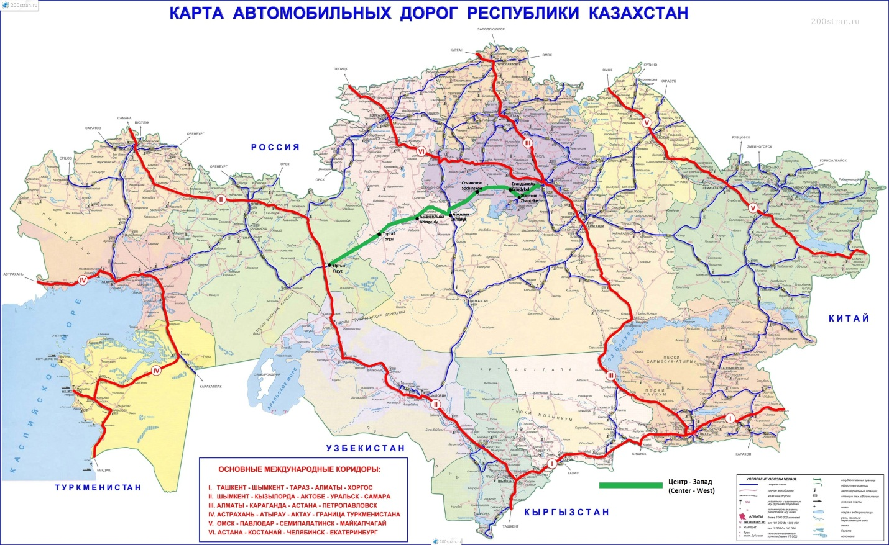
Figure 2.1 Map of the Astana-Arkalyk-Turgai Irgiz road section of Center-West project

Construction ofAstana-Arkalyk-Turgai-Irgizroad section as a part of Center-West Road Corridor Project includesreconstruction, modernizationand new construction ofabout 94kilometers offour-lane roadto the villageZhanteke, about 800km of 2-lane roadto the villageIrgiz. The project passes through various landscapes, types of land use, and (micro) climatic zones. The alignment passes through Tselinograd, Korgalzhyn, Egindykolskom, Atbasar, Zharkaiyn districts of Aqmola region, the town of Arkalyk, Amangeldy, Zhangeldy districts of Kostanai region and Irgiz district of Aktobe region. The total length is about 894km.

This project is quite large and significant, which will have environmental and social impacts; it shall be required land acquisition for road widening along the existing route, as well as by-passes. All of these sections will be determined after the completion of the detailed design. The above effects - are specific to a particular section; some effects, such as land acquisition for the new lane road and by-passes are irreversible; but in most cases it will be developed mitigation measures. With the introduction of the Environmental Action Plan (EAP), and compliance with the requirements of the Environmental Code of Kazakhstan the project's impact on the environment would be negligible.

2.2 PROJECT SPECIFICATION
Key features of the projected road:
- Road category – II;
- Length – 894 km;
- Grading width – 15 m;
- Number of traffic lanes – 2;
- Roadway width – 7.50 m
- Maximum width of way – 50 m;
- Maximum rated speed – 120 km/h;
- Estimated average speed – 80 km/h;
- Bridges and overpasses- will be determined upon detailed design of the each road section
- Culverts- will be determined upon detailed design of the each road section
- Rest areas – will be determined upon detailed design of the each road section
- Type of pavement and the type of coverage – asphalt concrete.
Estimated construction period: 3 years (36 months).
Construction works include:
- Site clearance and preparation;
- Establishment and operation of borrow pits;
- Construction and operation of camps, depots and workshops
- Construction of embankment;
- Construction of roadbed;
- Construction of road pavement;
- Construction of junctions and crossings;
- Construction of bridges and overpasses;
- Installation of traffic signs and fences;
- The application of road markings;
- Construction of drainage channels for the roadway and the bridges

The project maps in each area are shown in Figures below:

2.3 ROAD SECTION 1 – AQMOL REGION
Section 1 (19km – 364 km): This section of the road will pass through the existing Korgalzhyn route. By administrative division the road section will go through the territory of 5 districts of Aqmola region: Tselinograd district - between the villages of Aqmola, Otemis, Orazak, Korgalzhyn District - Sabyndy, Karaegin, Kargaly, Zhanteke, Egindykolsky district - Egindykol, Toganas, Burevestnik, Korzhynkol, Baumanskoe, Atbasar district - Sochi, Sepe and through Zharkayyn district- Shalgay and Shoiyndykol. The length ofroad sectionsby districtis given below:

- Tselinograd district –62 km.
- Korgalzhyn district –32 km.
- Egindikol district –135 km.
- Atbasar district –106 km.
- Zharkayin district –71 km.

The designedroute on this road section will be reconstructed on the existing road, expanding the existing right of way(about 10% of the route). It is also designed to build a new right of way (about 80%) on the existing grade road and (about 10%) of the new right of way on the off-road. Map of the road section is shown below in Figure 2.3with dark-red line.

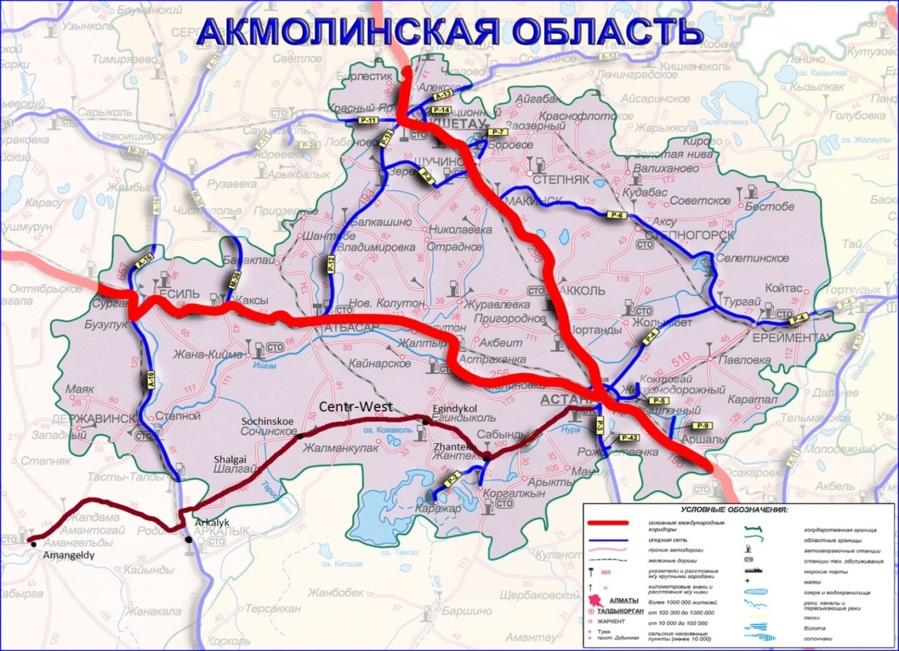
Figure 2.3 The road section in Aqmola region
Tselinograd district
Road sectionbeginson the Astana -Korgalzhyn route from 19kmoff the postof Astana.Project road will be followed along the existing national route Astana-Korgalzhyn, the length of road on the Tselinograd districtis 62km (from19km to 81km).
Korgalzhyn district
Road sectionfrom 81 kmto 113km will pass through the territory of Kurgaldzhin region.The route will pass along the village Zhanteke, at a distance of 25-30km from the Kurgaldzhin conservation area located in the Korgalzhyn district of Aqmola region. The impact on protectedorrare and endangered species is not expected.

Egindykol district
The project route from113kmto248 km will pass through the territory of Egindikol districton the old graded road. The road was built in the 60s of the last century. The road condition is unsatisfied.
There are several culverts on the existing graded passing through the territory of the region. During spring floods, it cannot cope with its function. Every year during the flood period, water overflow through the pavement, thus wash away and damage the road.

Atbasar district
The projectroute from248 kmto354kmwillpass the territory of theAtbasardistrictalong the old graded road. The road condition is less thansatisfactory. The old graded road is unsatisfactory. The inhabitants ofthe districthave to drive across country.About 30% of the project route will be followed the old graded road, and the remaining 70% across country.

Zharkayin district
The project route from354km to435kmpasses through the territory of the Zharkayin district. New road of about 42 km will be passed along the old graded road and about 29 km across the field roads. The project route will be passed through the farmland. It is basically aland forarable lands,pastures and haylands.

2.4 ROAD SECTION 2 – KOSTANAY REGION
Section 2 (km 435 –km 803): This road section will pass on the existing road (about 272 km), on the old graded road (about 75 km), and (about 21 km)across country. According to the administrative division the designed road section starts from the border of Kostanay region, will pass through the northern bypass of Arkalyk, then from Arkalyk on the existing route crossing the villages of Tasty, Amantogay, Karasu, Baigabyl, Kumkeshu, Amangeldy, Turgay, from the village Akshyganak in Zhangeldy district of Kostanai region across the country to the border of Aktobe region, Irgyz district partially across the country. The route crosses different areas, regions, climate zones, lands and plots.
The road section map is represented on the figure 2.4 with the dark-red line below:
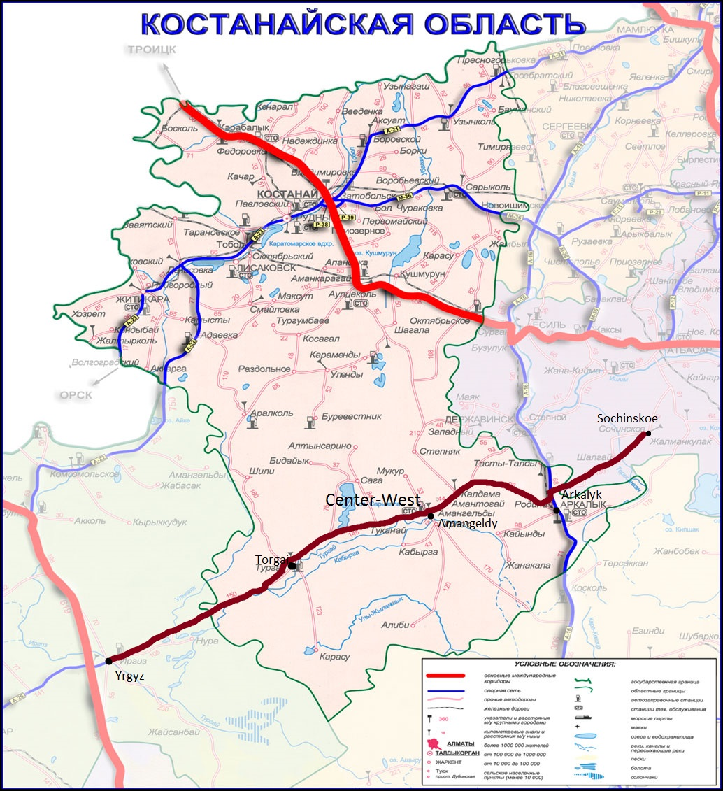
Figure 2.4 The road section in Kostanay region
The project road begins on the border of Kostanay region. The total length of the project road section in the territory of Arkalyk is about 38 km. About 234 km of the road section through Amangeldy and Zhangeldy districts will be laid on the existing road (from 473 km to 707 km). Condition of the road is satisfactory. In some sections where maintenance works were conducted using budget funds, the condition of the road is good. From 707 km to 782 km, about 75 km, the new road will be laid on the graded road, the road condition is unsatisfactory and in some parts it is completely destroyed and can be reached only by a field tracks. In autumn, winter and spring it is impossible to travel on these roads. There is no existing road between km 782 and km 803 . You can travel across these field roads only in warm and dry season.
The designed route will be reconstructed on the existing road by widening of the existing right of way (about 70% of all route), partially construction of the new right of way (about 19%) on the existing graded road and construction of the new right of way across the country (about 11%).

During the development of this section, some areas that should be bypassed were identified. At the entrance to the city of Arkalykthere might be a necessity to bypass it from the north side, as if the road will be followed along the existing route which may affect the existing engineering and communication systems and residential areas of village Rodina and Zapadny, which are the social-economic part of the city.
From 449 km to 479 km project route will be followed on the existing road of regional significance «Arkalyk-Turgay». The capital repair of this road section was conducted in 2011-2012 years using budget funds. The road plan is not a preserved area.
The designed road in Arkalyk is at distance of 140 km from the nature reserve "Altyn-Dala".
From 473 km to 608 km the designed road will pass through the Amangeldydistrict. On the territory of Amangedin and Zhangeldy districts there is the nature reserve "Altyn-Dala”, which is 75-80 km far from the designed road in Amangedin and 50-60 km in Zhangeldy district.
From 608 km to 803 km, about 195 km of the designed route will pass through the Zhangeldy region. On the territory of Zhangeldy district 97 km of road section will pass through the road of regional importance Arkalyk-Turgay starting from the village Tokanay to village Turgay. This stretch of road is fully asphalted, 97 nos. culverts were installed, there are no bridges, and the road needs a capital repair. The road of district importance Turgay - Shegen – Akshyganak is a graded road with a length of 71 km, there are no bridges, 21 culverts have been installed. It is an access to the western region of Kazakhstan, borders with districts of Aktobe region. The terrain in Zhangeldy region is mostly flat. The region is part of the Turgay trough, north to a small part of Turgay plateau along the river Turgay there are areas of sand dunes.

The designed route will be mainly laid through the lands for pasture and hay lands. In this area, along the road there are no buildings.

2.5 ROAD SECTION 3 – AKTOBE REGION
Section 3 (803 km –913 km): 71 km of this road section passes on the local old earth road and about 48 km will pass across the country. According to the administrative division project road section extends from the border of Zhangeldy area in Kostanai region through villages Nura, Mamyrand Duken till the village Irgizin the Irgiz district of Aktobe region.
The designed route in Aktobe region includes the widening of the existing graded road (about 60% of all route) and the construction of the new right of way across the country (about 40%). Irgiz district is located in the southeast of the Aktobe region. The district center Irgiz is at a distance of 450 km from Aktobe. Through the territory of the district in 23 kilometres from the district center there is a route Western Europe-Western China. The road section map of Center-West corridor in Aktobe region is represented below.
Along the existing route at km 35 from the Irgiz village about 90 km of the designed road will pass the territory of Irgiz-Turgai State Nature Zoological Reserve. Turgai State Nature Zoological Reserve is at a distance of 40-50 km from the designed road.
The designed route will be laid through the farmland. The breeding is developed in the area. There are no buildings and private properties along the alignment.
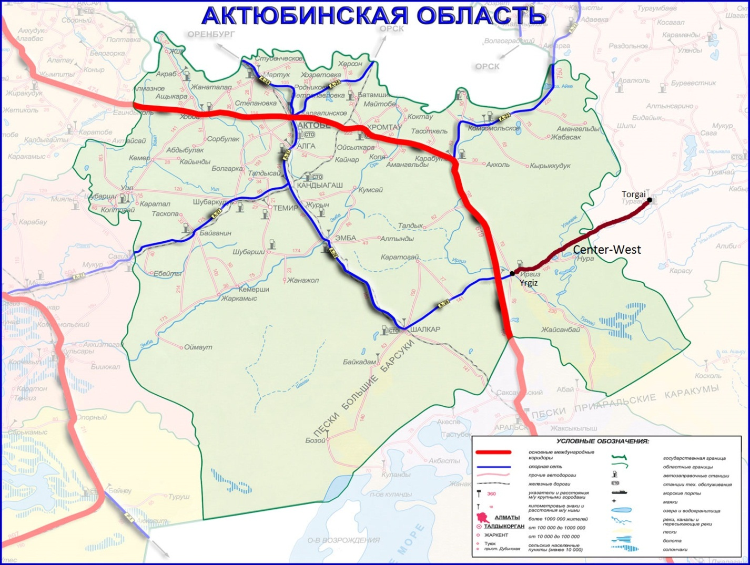
Figure 2.5 The road section in Aktobe region

2.6. RIVERS AND BRIDGES
The road passes through the territory with sparse network of river and crosses several rivers. Due to the fact that the detailed design for the construction of the road is on a development stage, this section provides only data on existing bridges. Data on designed bridge will be known after the completion of the detailed design, and design solutions for the bridges will be included in an updated ESIA and site-specific EMPs. Based on data obtained from local akimats, below are the rivers and the main technical characteristics of the existing bridge, located on the project plan for passing the road.
ROAD SECTION 1 – AQMOLA REGION
There are the rivers Ishim and the Nura on the territory of the Tselinograd district, rivers are one of the great waterways of the country, but with a project road, it will not overlap. The rivers Kozykosh, Karasu and Mukyr are crosses with road. Kozykosh river is the left tributary of the Ishim of length of 40 km. The only river in Kazakhstan, which connects the two great rivers - the Nura and Ishim. It starts on the right bank of Nura, flows into Ishim near the Talapker village.
There are the following existing bridges in the territory of the Tselinograd district on the route. In this section at 56.8 km road crosses the 1 bridge for the passage of the melt water. Also at 62.9 km there is a bridge for the passage of the melt water. Bridges for the passage of the melt water throughout the site mostly in disrepair, bridges worked their resources and do not provide the pass of melt water during flood periods. Existing bridges on the stretch of road in the Aqmola region are shown in Table 2.6.1.

Table 2.6.1 Bridges at the section 1

No. | River name | Length, m | Surface | Location andnote
1 | 2 | 3 | 4 | 5
1 | Bridge over Kozykosh river | 20 | asphalt/concrete | 21 km of Astana -Korgalzhyn,  built in 1966 ,  Dimensions - H 7.0+2х 1,0
2 | Bridge over Karasu river | 60 | asphalt/concrete | 23 kmof Astana -Korgalzhyn built in 1966  Dimensions- H 8.0+2х 1,0
3 | Bridge over Mukyr river | 50 | asphalt/concrete | 24 kmofAstana -Korgalzhyn built in 1968  Dimensions- H 8.0+2х 1,0
4 | Bridge over Shortanbay river | 30 | Concrete plates and gravel | 324 km of road, is in 4 km from v. Sochinskiy  built in 1978, width of 8-10m.

ROAD SECTION 2 – KOSTANAYREGION
There is the largest river Turgai. Plan of the route does not cross a river Turgai, but passes through the river Tasty and Karynsaldy. Karynsaldy river flowing in the eastern part of the land, has the nature of the wastewater is only in the flood period.
Based on data obtained from the local akimats, existing bridges are located on the stretch of road in the Kostanai region are shown in Table2.6.2below
River name | Length, m | Surface | Location andnote
2 | 3 | 4 | 5
Bridge over the rail road | 44,0 | asphalt/concrete | built in 1975, passes over the rail road in between the village of Rodina and Westdistricts.
Bridge over the Tasty river | 85,0 | asphalt/concrete | 67 km of Arkalyk-Turgay, built in 1961-1963, capital repair in 2011
Bridge over the Karynsaldy river | 136,0 | asphalt/concrete | 88 km of Arkalyk-Turgay, built in 1961-1963, capital repair in 2013

ROAD SECTION 3 – AKTOBE REGION

The main watercourse is the river Irgiz (length of 539 km), Telkara and Turgai. The river valleys of the main rivers are wide. Irgiz river is a transboundary river. At low flat spaces there are many small lakes, especially a lot of them in the lower flows of rivers, in Irgiz-Olkeyekskiy interfluves. Based on the data received from the local government offices it become known that in this sector the projected track will cross the existing bridges over the river Irgiz and Jaman-Telkara. The bridges on the road section 3 passing through the territory of Aktobe region are shown in Table 2.6.3

Table 2.6.3. Bridges on road section 3

River name | Length, m | Surface | Location
1 | 2 | 3 | 4
Irgiz | 90,7 | a/c | 0+421 kmof“Irgiz –Nura” road
Jaman-Telkara | 24,65 | a/c | 34+138 km“Irgiz –Nura” road

Irgiz District Akimat of Aktobe provided the following Technical Data Sheets for bridges that cross the rivers Irgizand Jaman-Telkara, they are listed below.

Technical Data Sheet for bridge №1 bridge over Irgiz river

- General

Road: |  |  | KD-IR-154 “Irgiz –Nura”
Bridge location (cross-over), km |  |  | 0+421
Nearest settlement, km |  |  | v. Irgiz
Name of barrier |  |  | r. Irgiz
State of barrier, (under, over) |  |  | under
Angle of construction slat, degree |  |  | 0
Radius of curve |  |  | –
Bridge layout |  | Before widening | 5×18,0m
 |  | After widening
Bridge length |  | Before widening | 90,7m
 |  | After widening
Dimension of bridge, m |  | Before widening | 6,7m
 |  | After widening
Underbridge dimension, m
Width of path, m |  |  | 2×0,75 m
Width of divider, m |  |  | no
Design work loaf | Before widening |  | А11,НК80,pedestrian
Design work loaf | After widening
Year of | Building |  | –
Year of | Repair |  | –
Year of | Last inspection |  | –
Presence of documentation | Design |  | on
Presence of documentation | Control |  | on
Presence of documentation | Operating |  | on
Operating entity |  |  | –

Technical Data Sheet for bridge 2 bridge over Jaman-Telkarariver

- General

Road: |  |  | KD-IR-154 “Irgiz –Nura”
Bridge location (cross-over), km |  |  | 34+138
Nearest settlement, km |  |  | Kolalykol v.
Name ofbarrier |  |  | Jaman-Telkara river
State of barrier, (under, over) |  |  | under
Angle of construction slat, degree |  |  | 0
Radius of curve |  |  | -
Bridge layout |  | Before widening | 4×6,0m
 |  | After widening
Bridge length |  | Before widening | 24,65
 |  | After widening
Dimension of bridge, m |  | Before widening | 7,8m
 |  | After widening
Underbridge dimension, m
Width ofpath, m |  |  | 2×0,75 m
Width ofdivider, m |  |  | no
Design work loaf | Before widening |  | Н30,НК80,pedestrian
Design work loaf | After widening
Year of | Building |  | –
Year of | Repair |  | –
Year of | Last inspection |  | –
Presence of documentation | Design |  | no
Presence of documentation | Control |  | no
Presence of documentation | Operating |  | no
Operating entity |  |  | -

2.7. QUARRIES AND BORROW PITS
Natural sources of inert materials suitable for road construction are available in sufficient quantities in the regions of the road passing. Location of the existing licensed quarries on each road section is determined by the designers.
Direct extraction of materials from the river beds is not permitted and is not approved by the Committee on Water Resources, Ministry of Agriculture of RK. Usually the quarries are not allowed to create at least 500 meters from any river.
For all of the proposed quarries the approvals and permits from the various competent authorities, including the inter-regional commission are required. The owner / operator should develop a project of EIA. When the contractor will submit the application, he should attach the EIA with all the documents and expert's conclusions at the Regional Department of Environmental Protection to obtain emission permits. The final approval process includes a requirement that the quarrying fertile layer to be restored after the closure of the quarry. The overall process of approval and negotiation for a new quarry on the regional and district competent authorities may take up to 2 years. Therefore, contractors are likely will be use existing quarries with the existing permissions. Permits from authorities for the protection of water resources are not needed, but the EIA should describe the impact on surface water and groundwater.
Several existent quarries were identified. They are presented in the tables 2.7.1, 2.7.2. They are not a part of the approved project, the final decision on a quarry choice is up to the Contractor. Possibly, additional new quarries are necessary.
Table 2.7.1Quarries in Road section 1 of Aqmola region

No. | Name | Material | Status | Distance from the road, km
1 | Quarry №1 | Sand | Existing | 1 km from the route Astana-Korgalzhyn
2 | Quarry №2-6 | Rubble stone | No legal status | Along the road Atbasar-Novomarinovka-Sochinskoe, after turn-off to the v.Sepe along the road at a distance of 3 km.
3 | Quarry №7 | Rubble stone | No legal status | At a distanceof 2 kmto the north of v.Sepe
4 | Quarry №8 | Rubble stone | No legal status | At a distanceof5kmtotheeast from v.Sochinskoe

Table 2.6.2 Quarries in Road section 2 in Kostanay region
No. | Name | Material | Status | Distance from the road, km
1 | Quarry «Akzhar» | Construction stone | Existing | In 24 km to the southwest from train station Arkalyk
2 | Quarry «Archalinskoe» | Sand | Investigated/ designed by designers | In 40 km to the northwest from train station Arkalyk
3 | Quarry «Angarskoe» | Ceramic clay | Investigated/ designed by designers | In 19 km to the southwest from train station Arkalyk
4 | Quarry «Tastinskoe» | Sand and gravel sand mix | Investigated/ designed by designers | In 40 km to the northwest from train station Arkalyk
5 | Quarry «Arkalykskoe» | Loamy brick | Investigated/ designed by designers | In 36 km to the southwest from train station Arkalyk
6 | Quarry «Rodina» | Loamy brick | Investigated/ designed by designers | In 7 km to the northwest from train station Arkalyk
7 | Quarry «Kovylnoe» | Sand | Investigated/ designed by designers | In 24 km to the southwest from train stationArkalyk
8 | Quarry | Construction sand | Investigated/ designed by designers | In 100 m from the road Arkalyk-Turgay

There are no quarries on the road section 3 according to preliminary data.
During the survey the design area will be surveyed for the presence of soils suitable for use in the construction of roadbed and road data on reserves of soil will be given in the working design.
Whichever quarries will be used the existing roads will be used as access to the road construction site and the Contractor shall be responsible for the maintenance of public and private access roads between the quarries and construction site.

3. Analysis of Alternatives
3.1 Alternatives of the alignment

During the conceptual design and feasibility study due to the presence of the existing road there were not considered alternative variants of road passage, except the sections without roads. It is believed that the expansion of the existing road and the construction of a new one, as defined in this report, is the most suitable in terms of road safety, environmental impact, which will result in the least negative impact on the environment and social aspects. The expansion of the existing road and the construction of new one have maximum social benefits.

The route doesn't pass close or through the existing or planned settlements, doesn't divide or isolates the existing settlements; mainly passes through farmlands or pastures and through some undeveloped lands. There are only few villages and settlement along the road, detailed investigation and design will identify the requirements of the by-passes. However proposed road mainly passes through the existing road which has rather wide right of way and does not touch natural protective area. The route passes across the suburb of various villages and settlement and was always a zone of influence of transport, business, roadside service and small enterprises that defines it as insensitive to noise and air pollution. Following the detailed design of the route section, after consideration of options of the route, the final version of the design will be approved by the State Expertise, Committee for Roads and regional akimats.
Six routes for the Centre-West corridor have been identified by GoK. These routes are shown on the map in Annex A. For reference, the map in Annex B shows the Central Asia Regional Economic Cooperation (CAREC) corridors. Four of the six proposed Centre-West routes can be loosely described as crossing through the centre of the country, with the two remaining routes traversing east-west through the north and south of the country respectively.

Route 1, proposed by CR, traverses Astana, Zhosky, Kostanay, Kurabutak, Aktobe, Dossor, Beyneu to Aktau.
Route 2, proposed by CR, traverses Astana, Zhanteke, Egindykol, Arkalyk, Turgay, Akshiganak, Yrgyz, Shalkar, Beyneu to Aktau.
Route 3, proposed by CR, traverses Astana, Atbasar, Arkalyk, Turgay, Akshiganak, Yrgyz, Shalkar, Beyneu to Aktau.
Route 4, proposed by KAZ, traverses Astana, Zhanteke, Egindykol, Arkalyk, Turgay, Akshiganak, Yrgyz, Aktobe, Dossor, Beyneu to Aktau.
Route 5, proposed by KAZ, traverses Astana, Zhanteke, Egindykol, Arkalyk, Turgay, Akshiganak, Yrgyz, Shalkar, Kandyagash, Dossor, Beyneu to Aktau.
Route 6, proposed by KAZ, traverses Astana, Atbasar, Arkalyk, Zhezkazgan, Kyzylorda, north to just east of Shalkar, then west to Shalkar, Beyneu and Aktau
Routes 2 and 3 differ only in the alignment between Astana and Arkalyk, while Routes 2, 4 and 5 only vary between Yrgyz and Beyneu.
Route 6 initially follows Route 3, but then diverts south before joining up with Routes 2 and 3 near Shalkar.
All routes use the recently rehabilitated Beyneu – Aktau highway. The central and southern routes (Routes 2 – 6) traverse some sections where existing road infrastructure is either non-existent or in very poor condition. For this reason, in general, through traffic between Astana and Aktau currently takes the northern route. The northern route not only provides a connection between Astana and Aktau, but also serves the important function of connectivity between the town and cities in the north of the country. In contrast, the central routes pass through very sparsely populated regions, and would do little in terms of advancing the regional connectivity and accessibility objectives.
An alternative to passing the road in the area from village Irgiz to village Akshyganak:
• Akshyganak-Duken-Irgiz.
• Akshyganak-Kazansalgan-Mamyr-Nour-Irgiz.
After the completion of detailed design of the road section, reviewing the options for the road, the final version of the project will be approved by the state examination, the Committee for Roads and the regional akimat.
It is believed that the route plan by which collected baseline environmental and social data, and which is described in this report, it is advantageous from the standpoint of environmental impact. This road plan did not pass through the territory of protected natural areas, as a result, compared to other alternatives will cause the least negative impact on the environment and social aspects
Environmental Impact in the event of a Do Nothing Alternativeproject”
Do nothing would involve no new capital investment in the road and the present road would take all future traffic flows. This would create significant environmental disturbance to the existing communities along the present alignment; number of communities are now located along the present road. There would be increased noise and vibration, air pollution, and significantly danger to local communities and road users, in particular pedestrians. Crossing the road would become more hazardous and the roadside communities would be physically segregated between the different sides of the road. Traffic congestion would increase and the economic disadvantages of this would be significant. Overall the quality of the environment and social conditions would deteriorate along the present road. Increased traffic volumes would also flow through the Astana – Almaty direction will increase, quality of atmospheric air will decrease and noise level will increase. On sensitive sites considerable impact will be made. In general, quality of ecological and social conditions will worsen along the existing road and will be short-lived, only during the construction period.

Environmental Impact in the event of project implementation
The alternative of project implementation includes widening of the existing road to 4-lane road to the village Zhanteke in the Korgalzhyn district of Akmola region. Further widening of the 2-lane road and the construction of a new road to the village Irgiz in Aktobe region. This generally means an increase in the lane of land acqusition. Environmental aspects are reduced to the impact of the work undertaken to the air and water, a large work of construction machinery, stone crushing and concrete plants, quarry work. The questions of potential negative impact are described in Section 6.
Conclusion
Both the do nothing and widening alternatives would have significantly larger adverse impacts on the environment and on the social conditions within the existing communities along the exiting road. Danger to local road users and pedestrians would increase, particular from the do nothing alternative. Danger to local road users will increase, especially at alternative of lack of implementation of the project. The selected alternative which involves proposed rehabilitation passing along the existing alignment avoids all settlements and impacts on local communities will be minimal. There will be some disturbance to agricultural activities during construction and some small long term impacts on agriculture. There are no impacts on natural habitats. Overall, it is considered that the selected alignment offers the best option from environmental perspective while encouraging better transport connectivity.

  - legal AND INSTITUTIONAL Framework

4.1 Overall legal Framework
Environmental protection is administered in Kazakhstan by the Ministry of Energy of the RK. This Ministry is made during reorganization of the Government of the RK in August 2014. The ministry has taken functions and responsibilities of liquidated Ministry of Oil and Gas of the RK, Ministry of Industry and New Technologies and the Ministry of Environmental Protection and Water Recourses. The Environmental Code was adopted in January 9, 2007 and is the basic legislative framework for environmental protection activity. Three main laws (the Law on Environmental Protection, the Law on Ecological Expertise and the Law on Air Protection) were abrogated subsequent to their integration into the Environmental Code. Moreover, some 80 normative legal acts were abrogated after the adoption of the Environmental Code.

4.2 Environmental Impact Assessment

All EIA requirements are included in the Environmental Code. The basis of EIA development is an “Instruction on conducting environmental impact assessment of designed economic activity when developing pre-planning, planning, initial project and project documentation, approved by the Order of the Minister of MEP, 28 June 2007, No.204-p”.

According to the instruction there are four stages:

- Review of Environmental Conditions;
- Preliminary EIA;
- EIA;
- Section “Environmental Protection”

The first stage of the EIA “Review of Environmental Conditions” includes general characteristics of natural and socio-economic environment of the area of designed activity, analysis of main trends of practical use of the territory and defining of principal positions of EIA. This stage of the EIA is based on the conceptual design, available materials, other special literature, project description etc. The purpose of this stage is to evaluate the environmental conditions, identify key environmental issues, choose the best option available for sitting of the development, and to define scope of work for the second stage.

The Second stage of EIA “Preliminary EIA” defines potential possible changes of components of nature, socio-economic environment and its impacts. The purpose of this stage is to assess baseline environmental conditions, identify potential impacts, and design mitigation measures to offset such impacts, which is then included as a chapter into feasibility study of the project. The results of this stage should be included in feasibility study of the project. All materials supporting decision-making on regulatory requirements (EIA study and statement, minutes of public hearings, permit applications and other supporting documents) must be reviewed by competent environmental authorities within a procedure known as “ecological expertise”. Ecological expertise (EE) is conducted by Ministry of Energy for projects of the I environmental category and by its territorial subdivisions for II and III categories, and from 2007 by local bodies (territorial subdivision on environmental safety) for IV category of the enterprise. Recourse to external experts can be made but they play only a consultative role. Services provided by these experts are paid by project developers, and the so-called public expertise may be conducted by independent experts. However, the final documents (expert opinions and permits) are not available to the general public and, sometimes, even to field inspectors.

According to Article 36 of the Environmental Code, “Development of Environmental Impact, assessment is obligatory for all types of activities that can have a direct or indirect impact on the environment or health of the people”. The procedure on public hearings is regulated by the 2007 ministerial order on Rules for carrying out public hearings. EIA and SEE (State Environmental Expertise) are two interconnected procedures. The developer has to conduct an EIA, which is being carried out by accredited private companies for the first category of objects, and is in charge of preparing the EIA report as part of the detailed design of the road section. The EIA procedure is a two-phase process: the proper EIA and then SEE. Once the EIA is approved, the developer should apply to the SEE. The competent authority checks the `consistency and the quality of documents, prepares own evaluation and returns to the developer. The evaluation takes into account the opinions and views expressed by the public and other authorities which have participated in the process. The EIA procedure is performed before the permitting procedure and the developer has to attach the EIA report and the competent authority`s statement together with the permit application. EIA procedure takes about two months and SEE up to three months. A post-project analysis by the authorities is mandatory and is carried out one year after the construction is completed. Experiences in other IFIs, financed projects in the country, shows that, the authorities, are proactive and compliant with regulations in their oversight of the projects with potential significant environmental aspects.

It is forbidden to implement the projects for economic and activities or to finance it by banks and other financial institutions without a positive resolution of the state ecological examination. The positive conclusion of state ecological expertise that is given to the project is generally valid for ten years from the date of its issuance.

In the case of green-field projects (i.e. new facilities), environmental authorities must be consulted on land allocation despite the fact that allocation as such is done by akimats (sub national administration). At this stage, project developers are obliged to assess baseline environmental conditions and to present this study, together with the Declaration of Intent, for ecological expertise. The Declaration should be discussed with the general public in hearings organized for this purpose. If environmental expert evaluation is positive, land maybe allocated according to the project design.

A “preliminary” EIA is required at the feasibility study stage in order to make assessment of technological solutions. For a large-scale project, field prospecting should be conducted at this stage. Impacts should be estimated but precise emission calculations are not expected. The feasibility study, including all environmental related documentation, is then presented to the EE. This EE is carried out by Ministry of Energy staff at the national or local level, depending on the importance of the project.

An approved “preliminary” EIA is a prerequisite to receive a budget for implementing the project. And as such, it may trigger a “yes or no” decision on the project feasibility. The next stage implies a “full-fledged” EIA. At this stage, very detailed information is required, including calculations of emission limit values (ELVs), an emergency preparedness plan, monitoring programs for all media, etc. Again, this documentation must be presented for review by authorities. If design documentation undergoes any changes at a later stage (e.g. adjustment in the technology), the developer is required to adjust the EIA materials accordingly. Such adjustments require review by authorities as well.

Finally, a “post-construction” EIA must be carried out for large projects with capital investments of over $50 million one year after the operation of the road starts. This is done to confirm the environmental safety of the economic activity and to correct the plan of environmental protection measures during operation.

Public hearings are required at all stages of ESIA. Minutes from these hearings are part of the ESIA documentation. Although the 1st public hearings` conducted and quality may not yet correspond to good international practice as promoted by international protocol (e.g. Aarhus convention) their wide application helps to advance the principle of public participation in Kazakhstan and to take root not only in procedural guidance but also in real practice. Second public hearing will be organized to meet the requirements for Category 1 projects.
Table 4-1 Legislation and Regulations Governing the EIA Process
Name of Law | Date and number of registration
Methodology for Determining Emissions Standards to the Environment | Approved by the Order of the Minister of MEP,  21 May 2007, No. 158-p.
“Instruction on Conducting Environmental Impact Assessment of Designed Economic Activity when Developing Pre-planning, Planning, Initial project documentation, | Approved by the Order of the Minister MEP,  28 June 2007, No. 204-p”
The Amendments to the Order of the Minister of Environment Protection of Republic of Kazakhstan on Approval of “Instruction on Conducting Environmental Impact Assessment of Designed Economic Activity when Developing Pre-planning, Planning, Initial project and Project documentation” | Approved by the Order of the Minister of MEP,  20 March 2008, No.62-p”.
Regulations on Conducting State Ecological Expertise. | Approved by the Order of the Minister of MEP,  28 June 2007, No.207-p”.
The Amendments to the Order of the Minister of Environment Protection of Republic of Kazakhstan on Approval of Regulations on Conducting State Ecological Expertise | Approved by the Order of the Minister of MEP,  9 October 2007, No.296-p”.
Rules for Conducting Public Hearings | Approved by the Order of the Minister of MEP,  7 May 2007, No.135-p”.
Instructions for Qualifying Requirements to Licensed Activity on Environmental Design, Regulation and Development of Environmental Impact Assessment | Approved by the Order of the Minister of MEP,  21 October 2003, No.239-p”.
Methodological Guidelines to the Licensed Activity on Environmental Design, Regulation and Development of Environmental Impact Assessment | Approved by the Order of the Minister of MEP,  10 February 2005, No.51-p”.
Final Environmental Supervision Experts Opinion on Definite Types of Licensed Works and Services | Approved by the Order of the Minister of MEP,  1 July 2004, No.192-p”.
The Rules for Licensing and Qualification Requirements to Work Implementation and Delivery of Services in the Field of Environmental Protection | Approved by the Order of the Government of Republic of Kazakhstan, 5 June 2007, No.457-p”.
Environmental Code of the Republic of Kazakhstan | 9 January 2007, No.212-p”.
Law of the Republic of Kazakhstan “On Amendments and Additions to Some Legislative Acts of Kazakhstan on Environmental Issues” | 9 January 2007, No.213-p”.
Law of the Republic of Kazakhstan “On Ratification of the Stockholm Convention on Persistent Organic Pollutants” | 7 June 2007, No. 259-p”.
The Concept of Transition to Sustainable Development for 2007-2009 (Action Plan) | The Order of the President of RK, 14 November 2006, No. 216-p”.
The Concept of Environmental Security of the Republic of Kazakhstan for 2004-2015 | The Order of the President of RK, 3 December 2003, No. 1241

4.3 TRANSPORT LAW

The Law of Republic of Kazakhstan ‘On the road’ dated 17 July 2001 laid out the basic legal, economic and organizational principles of governance roads in the Republic of Kazakhstan. The Road Law covers all aspects of the development and use of roads including design, engineering, traffic requirements and dimensions and providing land.
The size of the right of way for projected roads for common use depends on the road category and it is set under the rules of allotment of land for roads of public use. So, for road of I technical categories – 35 meters from the roads axis, for roads of II technical categories – 20 meters, for roads of III technical categories – 15 meters, for roads of IV technical categories – 13 meters, for roads of V technical categories – 12 meters. Road right of way lands are in the possession and use of road authorities or concessionaries, and are intended only for the development, improvement of roads and location of road services.

4.4 AIR QUALITY STANDARDS
The standards for air quality establish the permissible limit of the content of harmful substances both in industrial areas and in residential areas. The main terms and definitions related with the atmospheric air contamination, monitoring programs, behaviour of pollutants in the atmospheric air determined by the GOST 17.2.1.03-84; Environmental Protection, Atmospheric Air’ Terms and Definitions for Contamination Control.
The regulatory document containing information on harmful substances in the atmospheric air is the “Sanitary and Epidemiological requirements for the Atmospheric Air Quality” approved by the Order of the RK Government № 168 dd 25.01.2012.
The emission of hazardous substances (pollutants) in the atmospheric air by the stationary source is allowed only on the basis of the permit issued by the authorized state body in the field of atmospheric air protection or its territorial subdivisions in the manner established by the Government of the Republic of Kazakhstan. The emission permit is issued on the basis of the data provided by the applicant (the developer) and covers emissions only from stationary sources. But emissions from the mobile sources, such as individual vehicles are not covered by the permit. The procedure for emission permits issuance for operation of the motor vehicles or other transport facilities is defined by the Government of the Republic of Kazakhstan.
All motor vehicles of any type (including buses and trucks) are required to pass an annual roadworthy test, which also includes emission test and they shall comply with the requirements of regulations as follow below.
Table 4-2 Air Quality Legislation
Instruction on Agreement and Approval of the Design of the Maximum Permissible Emission (MPE) and Maximum Permissible Discharges (MPD) | The Order of the Ministry for Environmental Protection of the RK No.61-П dd24.01.2004
Collected Book of Methods for Calculation of the Atmospheric Air Pollution by Different Types of Production | The Order of the Ministry of Ecology and Bio resources 01.12.96.  Included in the list of the current regulatory legal acts in the field of the environmental protection, the Order of the Ministry for Environmental Protection No 324-п dd October 27, 2006
The Inventory rules for Emissions of the Hazardous substances (Pollutants), harmful Physical Effects on the Atmospheric Air and Their Sources | The Order of the ministry for Environmental Protection of the RK No.217-п dd. August 4,2005
The procedure of Calculation of the Hazardous Substances Concentrations Containing in the Atmospheric Discharges of the Enterprises.  Guiding normative document 211.2.01.01-97 | The Order of the Ministry of Ecology and Bio resources dd 01.08.1997.  Included in the List of the current regulatory legal acts in the field of the environmental protection, the Order of the Ministry for Environmental Protection No 324-п dd October 27, 2006
The procedure of Calculation of the Hazardous Substances Concentrations Containing in the Atmospheric Discharges of the Enterprises | Approved by the Order of Minister of environmental Protection No.100-n dd April 18,2008  (Attachment 18)
Recommendations on Execution and Content of the Design Standards of the Maximum Permissible Emissions (MPE) in the Atmospheric Air made by the Enterprises of the Republic of Kazakhstan.  Guiding normative document 211.02.02-97 | The Orders of the Minister of Ecology and Bio resources of the Road August 1, 1997 and Order of the Ministry of natural resources and environmental protection of the RK No. 156 dd 06.07.2001  Included the List of the current regulatory legal acts in the field of the environmental protection, the Order of the Ministry for Environmental Protection No.324-n dd October 27, 2006
Instruction on the Normalization of the Emission of contaminants in to the Atmosphere of the Republic of Kazakhstan | The Order of the Ministry of natural resources and environmental protection of the RK No.516-n dd 21.12.0  Included the List of the current regulatory legal acts in the field of the environmental protection, the Order of the Ministry for Environmental Protection No.324-n dd October 27, 2006
The Calculation Procedure of Motor Vehicles Emissions for Carrying Out of the Summary Calculations of Atmospheric Pollution  Guiding normative document 211.2.02.07-2004 | The Order of the Ministry for Environmental Protection of the RK No.324-n dd October 27, 2006  Included in the List of current regulatory legal acts in the field of the environmental protection, the Order of the Ministry for Environmental Protection No.324-n dd October 27, 2006
The Calculation Procedures of the Specific Emissions of the Atmospheric Pollutants and Damage Depending on the Type of Fuel Used in the Republic of Kazakhstan  Guiding Normative Document 211.3.02.01-97 | The Order of the Ministry for Ecological and Bio resources of the Road 09.07.97.  Included in the List of current regulatory legal acts in the field of the environmental protection, the Order of the Ministry for Environmental Protection No.324-n dd October 27, 2006
The procedure of Calculation of Discharge (Emissions) of Contaminants into the Atmosphere Caused by the Motor Transport enterprises | Approved by the Order of the Minister of Environmental Protection No.100-n dd April 18, 2008  (Attachment 3)
The Rules of Governmental Accounting of the Sources of Greenhouse Gases Emission into Atmosphere and Consumption of Ozone-destroying Substances | The Governmental Decree No 124 dd February 8, 2008
The Rules of Restriction, Stoppage or Decrease of the Greenhouse Gases Emissions into Atmosphere | The Governmental Decree No.128 dd February 11,2008

4.5 WATER QUALITY LEGISLATION AND STANDARDS

The main legislative act in the field of water resources protection and its use is the Water Code of the Republic of Kazakhstan No.481 dated July 09, 2003. According to the definition provided in this document “Protection of water resources” is an activity aimed at preservation, rehabilitation and reproduction of water bodies as well as prevention of water from detrimental effect.

- According to Article 112 of the Water Code water resources should be protected from:
- natural and industrial pollution by hazardous chemical and toxic substances and their compounds, as well as thermal, bacterial, radiation and other types of pollution;
- infestation (blockage) with hard, non-soluble subjects, production and household and other wastes;
- depletion.

- Water resources should be protected to prevent:
- disturbance of the environmental stability of the natural systems;
- causing harm to the lives and health of population;
- reduction of fishery resources and other water fauna;
- deterioration of the water supply conditions;
- weakening of the natural self-reproduction and cleansing functions of the water bodies;
- other unfavourable conditions that negatively affect physical, chemical and biological qualities of water bodies.

- Protection of water resources is carried out through:
- demands related to the protection of water bodies to all water users who use water for any purpose;
- improving and applying water protective activities/ measures with the help of new equipment and environmentally and epidemiologically safe technologies;
- water conservation zones and sanitary protection zones for protection of public (drinking) water supply sources;
- public (state) and other forms of control over the use and protection of the water bodies;
- sanctions for non-observance of the water protection requirements.

- Central and local execution authorities of the regions (cities of republican status, capitals), in accordance with the legislation of Republic of Kazakhstan, take measures in compliance with the principles of sustainable development towards water resources conversation, prevention of pollution and blockage.

- Physical and legal entities, activities of which affect the water bodies, are obliged to carry out managerial, technological, forestry, ameliorative, land treatment, hydro technical, sanitary-epidemiological and other activities, which ensure protection of water bodies from pollution, blockage and depletion.

Article 116 of the Code regulates issues related to the water protection zones: to maintain water recourses and water facilities in the status required by the hygiene and sanitary and ecological regulations; to prevent contamination, blockage and depletion of the surface water; to preserve flora and fauna water protection zones and belts are constructed.

In the development of any project that may affect the water system / resources, the project plan should be coordinated with local authorities for the protection of water resources.

In the development of the Water Code, the Government of the Republic of Kazakhstan approved the regulations on the procedures to authorize the use of reservoirs for special needs, according to the procedures for issuing permits for special use of water, on procedures for the use of water for fire fighting, according to the classification of waterways, on procedures for the use of water tanks for the needs of air transport. The Government has developed a list of water resources (groundwater) that have curative value in the Republic, and bodies of water that are of particular national importance or are of special value, which limits their use is either entirely prohibited.

As standards of air, maximum permissible concentration (MPC) was developed for water. As a rule, the MPC for fishing grounds is stricter than the MPC for drinking water. It must be emphasized that this is primarily related to the fishing industry and the protection of human health is likely there has been taken into account through the principles of the protection of water ecosystems. As is the case with the atmospheric air, different codes are provided for comparing the water pollution, which take into account the presence of several pollutants. The most widely used index is the water pollution index (WPI). The main document regulating the status of surface waters and concentrations of pollutants are "Sanitary requirements for the protection of surface water pollution." SanPiN No. 3.02.003-04.

The legislative, regulatory and procedural documents applicable on water protection are listed below:
Table 4-3. Water Quality Legislation
Recommendations on implementation and Content of the Design Standards of the Maximum Permissible Discharge (MPD) in the Water Bodies for the Enterprises of the Republic of Kazakhstan. | The Order of the Ministry of Ecology and Bio resources of the RK 1992.  Included in the List of the current regulatory legal acts in the field of the environmental protection, the Order of the Ministry for Environmental Protection No.324-n dd October 27, 2006
Instruction on the Normalization of the Discharge of Contaminants into the Water Bodies of the Republic of Kazakhstan  Guiding normative document 211.2.03.01-97 | The Order of the Ministry of Natural Resources and Environmental Protection of the RK No.516-n dd 21.12.00.  Included in the List of the current regulatory legal acts in the field of the environmental protection, the Order of the Ministry for Environmental Protection No.324-n dd October 27, 2006
The Calculation Procedure for Standards of Discharged Waters with Pollutants (MPD) into the Water Bodies, Disposal Fields and Relief of Land | Approved by the Order of the Minister of Environmental Protection No.100-n dd April 18, 2008  (Attachment 19)
The Procedure of Establishment of the Maximum Permissible Discharge (MPD) of the Pollutants onto the Disposal Fields and Natural Depressions of the Land.  Guiding normative document 211.3.03.03-2000 | The Ministry of Environmental Protection of the RK No.156-n dd 06.07.2001  Included in the List of the current regulatory legal acts in the field of the environmental protection, the Order of the Ministry for Environmental Protection No.324-n dd October 27, 2006
The Recommendations on Control over the Operation of the Treatment Facilities and Discharge of the Wastewaters. | The Order of the Ministry of Ecology and Bio resources of the RKdd 21.05.94.  Included in the List of the current regulatory legalacts in the field of the environmental protection, the Order of the Ministry for Environmental Protection No.324-n dd October 27, 2006
The Rules of Surface Waters Protection in the RK  Guiding normative document 01.01.03-94 | The Order of the Ministry of Ecology and Bio resources of the RKdd 27.06.94.  Included in the List of the current regulatory legalacts in the field of the environmental protection, the Order of the Ministry for Environmental Protection No.324-n dd October 27, 2006
The Guidelines on Application of the Rules of Surface Waters Protection in the RK | The Order of the Ministry of Ecology and Bio resources of the RK dd 12.02.97.  Included in the List of the current regulatory legalacts in the field of the environmental protection, the Order of the Ministry for Environmental Protection No.324-n dd October 27, 2006
The Procedural Definitions of Norms and Standards of Water Resources Use in the Various Natural Climatic Zones of the Republic of Kazakhstan During Carrying out of the Ecological Zoning. | Approved by the Order of the Minister of Ecology and Bio resources of the RK dd 1997

4.6 SOIL STANDARDS

New sanitary rules introduced in Kazakhstan based on the long-term scientific studies - SanPiN 2.1.7.1287-03. Sanitary and Epidemiological Requirements for Quality of Soil and Subsoil establishes requirements on soils quality in the inhabited localities and agricultural lands and control the observance of the sanitary-hygienic standards during engineering, construction, renewal (technical upgrading) and operation of the facilities of different purposes, including those which may cause the adverse effect on the soils status.

The GOST 27593-88 Soils: Terms and Definitions define main terms related to the chemical contamination of soils. The basic regulatory documents for control of the soil pollution is “Standards of the Maximum Allowable Concentrations of the Hazardous Substances, Harmful Microorganisms and Other Biological Materials Being the Soil Pollutants” approved by the Order of the Ministry of Health of the RK No.99 dated 30.01.2004 and Order of the Ministry for Environmental Protection of the RK No.21П dated 27.01.2004.

The maximum allowable concentrations (MAC) or allowable permissible concentrations (APC) of the chemical substances in soil are the principal criterion of the sanitary assessment of the soil contamination by the chemical agents. These standards are common to all types of land use. But there are some procedures for assessing soil contamination for residential and agricultural land. Determination of the maximum allowable concentrations of chemicals in the soil is based on4main principles of assessment.

4.7 NOISE STANDARDS

The level of the road traffic noise is determined according to the regulations of the SNiP (construction norms and rules) II-12-77 “Noise Protection”. The limit of noise generated by the motor vehicles in the distance of two meters from the buildings in compliance with the SNiP II-12-77 is 70 dB.

The maximum allowable noise level in areas neighbouring the residential houses, rest areas of the micro-districts and residential groupings, schools, play grounds is assumed as follows:

- for noise made by the motor vehicles - 10 dB
- for residential construction works- 5 dB
- for daylight time from 7 hour till 23 hour - 10 dB

4.8 HEALTH AND SAFETY DURING CONSTRUCTION AND OPERATION

During the works it is necessary to meet the requirements of SNiP 3.06.04-91 “Construction Safety”. Also there are other regulations such as the «Safety Regulations for Construction, Repair and Maintenance of the Automobile Roads», «Regulations for Safety and Production Sanitary During the Building of the Bridges and Pipes», that should be followed strictly. During road construction works it is necessary to use the «Safety Instructions» for each construction machine.
The personal protective equipment shall comply with the applicable GOST (special aprons under the GOST 12.4.029, rubber gloves under the GOST 20010, respirator "The Petal” under the GOST 12.4.028, gloves under the GOST 12.4.010, goggles under the GOST 12.4.013 and breathing mask of В type or В with filter, helmets).The site should be kept in safe, clean and good sanitary conditions. The Contractor shall bear the responsibility for cleanup of the site from garbage, construction waste and household rubbish and their removal to the municipal solid waste landfill (MSW). In this regard the Contractor shall be guided by the SanPiN №3.01.016.97

In addition, it is necessary to carry out regular inspection of the machinery and equipment and observance of the repair, training and instruction of the workers engaged in maintenance of the machinery, tools and equipment on safe methods and techniques of work. The protective measures with respect to the equipment are also important for prevention of injuries and accidents. Such equipment includes the following:
- motor vehicles;
- pumps, compressors;
- generators, crushing equipment;
- lifting equipment (cranes, hoists, wire ropes, loaders);
- electrical equipment.

For provision of the sanitary and living conditions for the workers it is necessary to establish a field camp; changing rooms, drying premises, wash rooms, shower rooms, warming premise for workers, dining facility with three meals daily, toilet facility, field office, rest room, machinery parking facility and household waste storage area. There shall be the information on safety, occupational health, production and household sanitary in the rest room. There shall be medicine boxes, first-aid outfit, drinking water and service water shall be kept in the separate containers, which will be provided in the construction sites and field camps. The drinking water should be located at the distance of maximum 75 m from the working area. Permits for water use should be obtained from the sanitary bodies and disease control authorities and comply with the requirements of the SanPiN of the RK No. 3.05.017.97.

It is allowed to perform works during the hours of darkness ensuring that artificial lighting is in accordance with the standards of the electric lighting for the installation and construction works. Irrespective of the lighting of the sites and working areas the machinery should be equipped with the independent (built-in) lighting of the working elements and control devices.

Fuel and chemicals should be handled according to HSE requirements. Specifically, it should be stored in the special place with the mandatory barbed wire fence. The storage area shall not be located near the water source. The filling and unloading of materials shall be strictly controlled and performed in accordance with the established procedure. To prevent any spill all valves and plugs shall be properly sealed and be protected against the undesirable interference, and be turned off and opened easily when used. The inner surface of the tanks should be clean. Measures shall be taken on preventing impact of moisture and water.

4.9 ARCHAEOLOGY AND CULTURAL HERITAGE

The main legislative documents on cultural heritage are the followings:
- The Law of the Republic of Kazakhstan "About Culture”, dated 15.12.2006 No.207-III
- The Law of the Republic of Kazakhstan “On Protection and Use of the Historical Cultural Heritage", dated 2.07.1992 No.1488-XII
- The Land Code of the RK, dated 20.06.2003 No.442-II

For the purpose of recording and protection the historical and cultural monuments they are divided into the following categories:
- Historical and cultural monuments of international status representing the historical, scientific, architectural, artistic and memorial objects included in the UNESCO World Heritage List;
- Historical and cultural monuments of national status representing the historical, scientific, architectural, artistic and memorial objects, having the special significance for the history and culture of the whole country;
- Historical and cultural monuments of local significance representing the historical, scientific, architectural, artistic and memorial objects, having the special significance for the history and culture of the region (city of republican status, capital), districts (centers of regions).
According to Article 39 of the Republic of Kazakhstan Law “On Protection and Use of the Historical Cultural Heritage”, development and use of any allocated lands should be made only after archaeological research. Any works that may endanger the existence of monuments are prohibited. Businesses, organizations, institutions, public associations and citizens in case of detection of archaeological and other sites of historic, scientific, artistic, and other cultural value, are obliged to inform the authorized body for the protection and use of historical and cultural heritage, and stop current works.

4.10 COMPARISON OF KAZAKH AND WORLD BANK ENVIRONMENTAL LAWS

An evaluation of the national environmental protection legislation and WB procedures and its meaning for the Project is presented in this section. Much of the environmental legislation of Kazakhstan has been developed to provide control for developments and control for adverse impacts on the environment and human health. The submission of EIA for Ecological Expertise does not accord with best international practice, which includes a significant component of ongoing evaluation in an iterative process. The EIA in Kazakhstan focuses more on the calculation of emissions, for which charges are levied and is weak on relevant analysis of avoiding or mitigating impacts. Data collection often cannot ensure full picture of the EIA goal and the project.

Public hearings are part of the EIA, and so in June 2015 in the course of environmental studies of KazdorNII and SAEN Engineering Group held public hearings in towns along the route plan. The first public hearings were held on 9-12 June and 29 June 2015 in 5 districts of Aqmola region, Tselinorgradsky, Korgalzhyn, Egindikolsky, Atbasar and Zharkayynsky districts in Kostanay region, in the town of Arkalyk, Amangeldy and Zhangeldi district, and in Irgiz district of Aktobe region. In June 29th, 2015 the repeat public hearings were held on the project with the participation of representatives of the Customer KazAvtoZhol JSC, designers, representatives of the PMC, the heads of local executive bodies and representatives of farms, and local residents.

Comprehensively discussed this situation with representatives of the local authorities, it was decided to re-call a public hearings in the settlements along the road. The next hearings on the EIA decision will be held in 30 days after the publication of the EIA draft. Changes made as a result of these public hearings will be included in the final version of the EIA. Preliminary public hearings were held successfully. General designers presented materials of a project road section, including, information on the main indicators, the map of project road section with the indication of junction and cattle crossing locations, and also information on the land plots getting to a zone of construction of the route with the indication of the area required for temporary and permanent land acquisition. According to the regular hearing optimum location for underpasses and junctions will be scheduled. The Minutes of these hearings are presented in the Appendix 2.

Routine procedures in Kazakhstan are not always adapted for monitoring during the project construction. For example, the Regional Department of Ecology should apply to the prosecutor's office to conduct an audit, and can do this only once a year, with the notification of the organization for 2 weeks prior to the audit. The content of environmental protection plans includes only the description of the overall mitigation and monitoring of impacts, without information on the place and the responsible people, focusing on references to regulations and standards, and of little use for contractors.

Standards are used as thresholds above which pollution is permitted so long as payments are made.

Overall, there are several governmental and public organizations involved in environmental protection. These include the Ministry of Agriculture, Ministry of Energy and Mineral Resources. There are special institutions in Kazakhstan such as the State Environment Expertise and several environmental non-governmental organizations.

Table 4.10 shows a comparison of the legislation

Table 4.10.Comparison of Kazakhstan EIA and Environmental legislation with World Bank Standards

EIA stage | Kazakhstan | WB
Reference | RK 2007. Ecological Code,  Ministry of Environmental Protection Order 204-п, 28 June 2007: “The Instruction of Conducting the Environmental Impact Assessment during the preliminary planning, planning, preliminary design and full design documentation” | World Bank Operational Policy 4.01
Basic Principles
Most sensitive component rule | There does not appear to be a ‘most sensitive’ rule. The sensitivity of project is measured by the Sanitary Epidemiological (SE) classes of dangers. There are four categories and within each, one or more levels of danger, a category 1 project has two levels of severity, either trigger a full EIA. A Category 2 project is considered a 3rd level severity and as such a lesser assessment is undertaken, although still referred to as an Environmental Assessment. A category 3 and 4 project are considered 4th and 5th level severity, respectively and as such generally do not require an assessment. | Projects are categorized according to the most sensitive component, e.g. if 6 of 7 components are not sensitive and one is sensitive the entire project becomes a Category A or B.
 | The planning and conduct of an assessment is the duty of the proponent, in this case Automobile road committee of MOTC. MOTC often retains a licensed consultant to do this work, and frequently a member of the team undertaking the Feasibility Study. The assessment must be preceded with a scoping study, which must be approved before the EIA can begin. The EIA process has 5 stages: 1) Overview of Environmental Condition; 2) Preliminary EIA 3) EIA; 4) Chapter of Project Documentation “Environmental Protection”; 5) Post-project Analysis. | Usually EAs are required to be prepared by the country, and donors will request this. Often the proponent’s EA capacity is not there or funds are scarce, or the EA prepared is incomplete or non-compliant, in which case consultants help fill the gaps, undertake new studies on behalf of the proponent or assist national specialist to fill the gaps and improve the documentation. This is a proponent focused activity, with the requirement for close collaboration and ownership. In the case of this project the existing EIA prepared by the Design Consultants have been refined and strengthened by International Consultants in accordance with World Bank OP to the Committee of Roads, Astana,
Document Preparation |  | When the donor funds are used to prepare IEEs, SiEA and EIAon behalf of the country, these documents are always the country’s documents, and as such must be presented as if the country were preparing them. Where consultant recommendations are included, this must be made clear.  Summaries of the IEEs and EIAs often contain review and comments by the donors or the donor’s consultants on behalf of the Banks
Document Ownership | Category 1 projects are assessed by the MOEP in Astana, Category 2 and 3 by the Oblast or Regional Environment Department, and 4 at the region level.
The Environmental Management Plan | As specified in Ecological Code Article 41 an environmental assessment documentation should include “10) Description of measures provided for preventing and mitigating impacts on environment, including proposal for ecologic monitoring”—more or less a partial EMP. This description does not comply with donor requirements and construction monitoring is far from rigorous. | The EMP is required by WB for A and B category projects, It is considered to be an integral but distinct part of the assessment document. It is not a separate document, but the key summary of the mitigation and monitoring measures to be applied should be extractable as a stand-alone g section or set of Tables.
Public hearings | Kazakhstan has a procedure of public hearings conducting, but it rarely involves state sector and common citizens. | Public hearings is a requirement for WB. The World Bank has a mandatory 2 sessions for full EIAs and 1 session for category B projects. For full EIAs the sessions are scheduled to coincide with early EIA planning and the preparation of the interim EMP or record of likely impacts. For the B -level projects a session during the impact definition stage is most useful, although exact timing is a function of the environmental issues emerging and the proponent’s wishes.  Consultations must be announces and for full EIAs advance notices of consultations and contact details must be published in the media for several weeks in advance of the session(s).
Classification | Projects are classified by the 5 danger levels of danger with 1 being the highest as defined by norms and standards developed by the Sanitary and Epidemiological Services, in relation to human health and safety. There is little reference to protection of the environment and e.g., forests and wildlife populations. As with the Banks, certain projects have been pre-classified, e.g. the road projects are mostly considered Category 1 project that requires a full EIA. | There is a classification of activities according to risk level from I (high) to V (low) in Kazakhstan. Depending on the risk level Environmental Category form 1 to 4 is assigned. Sanitary-Epidemiological Regulations specify Environmental Category through lists of activities by sector (e.g. chemical industry, metallurgy, agriculture, etc.) and by risk category (i.e. I - V). Environmental Category 1 covers activities of the I and II risk levels. This “dual” classification does not specify size of the facility or scope of production. The main purpose of Sanitary Rules is to establish sanitary-protection zone (SPZ), which for Category 1 facilities is not less than 1000 m for risk category I and not less than 500 m for risk category II.
Document Form | Nothing specified other than a ‘minor environmental statement’ | No specific documentation required
Summary | No requirements | Not required
Consultation &Information Disclosure Timing | No requirements | Not required
Disclosure | Not required | Not required
Document Form | All environmental assessment documents are several reports | A section of the Feasibility Study
Summary Document | Each assessment document as its final section “Main conclusions of the EIA”. No other summary was referred to in the Code or related standards | An executive summary—but with no special designation
Consultation and Information Disclosure Timing | Public hearings are not conducted | At least once during IEA/SiEA preparation
Disclosure | Not required | All environmental assessment documentation is available on World Bank Information Centre website and in the borrowing country office as well, but there is no formal public review.
Category A: EIA | EIA is required for projects of Sanitary and Epidemiological class 1, which will have significant impacts on the human safety. According to Section 26 of the EIA Instructions the third stage of EIA process – “Environmental Impact Assessment” requires detailed analysis in full volume on all aspects of environmental impact of the specified objects, and includes the following components: air, water, mineral resources, production wastes, physical impacts, soil, plants, animals, socio-economic condition, and ecological risks. The Category A is required to undertake the 5th stage of EIA process, Post-project Analysis, 1 year after the end of project. The 5th stage should be undertaken by different licensed organization than which conducted the EIA. | The World Banks Category A requirements includes environmental and social assessments. EIAs must also include a detailed analysis of alternatives, especially the “no project” alternative. This report is in accordance with this requirement.
Document Form | Each stage of EIA process has its own several document with prescribed format and the level of detail. | Several document with prescribed format and minimum level of detail
Summary Documentation | Each of 5 assessment stages has several document; and each has a “Conclusions” section, which acts as a summary. | An executive summary is prepared and is attached to the EIA but often used separately. An executive summary is included in this report.
Consultation and Information Disclosure Timing | No information on specific consultations, except for public hearing as part of the EIA – the Instructions for Public Hearing are published by the MOEP Order №135, 7th May 2007. | Minimum 2 are mandatory, with timing specified. Once with the TOR for the EIA, once to present the interim EIA. For the disclosure of the interim/ draft EIA, Category A projects must be allowed a 120-day period for stakeholder evaluation and comments between disclosure of interim /draft EIA/EMP and project appraisal. The 120 day rule will commence once this document has been completed in accordance with World Bank’s requirements.
Disclosure | Submission of a full environmental assessment to the local /oblast-level environmental authority and its review by the central government takes 60 days. During the first 30 days there is a theoretically a time for the public to comment. But since there is no real announcement this does not happen. Further, there is a ‘public debate/hearings are held as part of the final EIA approval. There is no other disclosure. This document when agreed by the Bank as suitable for public disclosure under the 120 rule will be put on the CR website in Russian. 30 days after its submission the next round of public hearings will take place. | The public must be informed about the availability of EIA documentation, which must be prepared in English and the local language (sometimes English, Russian and local language), and be accessible at convenient locations in country, at a published website and on the donors website (InfoShop) 120 days before project appraisal. Loan processing cannot proceed during this period. This document will be disclosed at WB website and CR website once agreed by the WB as suitable for public disclosure.
Land Acquisition and Resettlement | KZ land acquisition and resettlement policies. (see detailed comparison in RPF) | World Bank requests a review of resettlement, land acquisition and compensation payment to ensure all activities will be undertaken in all the sections in accordance with World Bank Guidelines OP 4.12. A Resettlement Policy Framework (RPF)) prepared by the KazdorNII on behalf of CR. The RAPs will be finalized upon completion of the detailed design.

4.11 Conclusions and Recommendations from analysis of difference

The following conclusions and recommendations address those issues where divergence of standards and subsequent practice between Kazakhstan and the World Bank may lead to shortages in compliance with these standards throughout the project, because local practice may be rigid and well established, and incorporating new elements or changing practices may need extra efforts during project supervision:
- Kazakhstan has not yet put into practice an iterative process to ensure that project design and environmental analysis have an actively managed interface, and that data and findings from either are incorporated into the other. Usually the design approval process in Kazakhstan is quite advanced when ESIAs are conducted, which may prevent recommendations for design changes based on the environmental analysis being implemented, as they would require a re-approval of the processes. Design changes may, however, be introduced during the construction design stage once a contract has been awarded with relatively minor review and approval requirements. This is the recommended approach to mainstream design changes based on environmental findings into the designs submitted by the Contractor to the Client for approval and construction. Such design changes are likely to mainly concern the number and location of under- and overpasses for animals, farm traffic and wildlife.

- Environmental protection is often seen as compliance with emission or pollution standards, while an understanding of environmental values such as fauna and flora, landscape, biodiversity, aesthetics and the priority in enforcement appears on compensation payments rather than preventive and remedial action to avoid. This will require enhanced capacity building and supervision efforts during project implementation, with practical, implementation-focused training's for Contractors, supervising engineers and environmental authorities (incl. those representing forestry, national parks, water). It is recommended to ensure the presence of a consultant with the best international practice experience in environmental site supervision and management during the first 6 months of project implementation (starting with Contractor's mobilization) to establish knowledge and compliance practice from early implementation stages onwards.

- Site-specific EMPs will be prepared and included in construction contracts.

- The competences and powers of Kazakh environmental authorities regarding site inspections are very limited, with visits legally limited in numbers and having to be announced several weeks in advance to the project owner. Though this practice is unlikely to be changed within the project context, a strong supervision system needs to be contractually embedded, with effective enforcement mechanisms including penalties and arrangements for required remedies (e.g. by third parties with costs deducted from the contracts). It is recommended to entrust a project management consultant (PMC) with enforcing mandate that together with the authorities would be implementing best practice in countries. Simultaneously, environmental authorities must be aware of all project activities and invite them to a program of training and capacity building.

5. ECOLOGICAL AND SOCIAL BASELINE DATA

5.1 SECTION 1 - AKMOLA REGION

5.1.1 General description
The length of Astana-Arkalyk-Turgai Irgiz road Center-West Corridor in Akmola region is approximately406 km.The road will pass through the territory of five (5) districts of Akmola region: Tselinograd area - between the villages of Akmola, Otemis, Orazak, Korgalzhyn area - the village Sabyndy, Karaegin, Kargaly, Zhanteke, Egindikol District - the village Egindikol, Atbasar district - the village of Sochi and Zharkayynskii district - the village Shalgay, Shoiyndykol. Location of the project site is shown in Figure 2.3.

Akmola region is located in the north on central part of the Republic of Kazakhstan within the Kazakh hills and Teniz plains. It was founded in October 14, 1939. It borders on the west with Kostanai, in the north - with North Kazakhstan, in the east - with Pavlodar and in the south – with the Karaganda regions. Astana is the capital of Kazakhstan is located in the center of the region. The administrative center since 1999 - the city Kokshetau, which was founded in 1824.The total area of Akmola region is 146 thousand sq. km. And there are 17 districts, 2 cities of regional importance, 15 towns, 245 rural districts. The population of the region amounted to 732 947 people, where the urban population as of 1 October 2009 amounted to 136 thousand people (18.4% of the total population of the region), a tendency to expand the market of products manufactured in the region.

The area is located close to the developed regions of Russia, as the Ural, Tyumen, Tomsk, Omsk and Novosibirsk regions, which have the long-established economic connections, which are producing new ones. Get further development of economic connections with neighboring regions of Kazakhstan.

Most of the territory is covered by steppe plains north of Upland included in the steppe landscape zone of the temperate zone. The central part is occupied - Atbasar plain, in southwest Tengiz-Korgalzhyn depression.

5.1.2 Climate
The climate along the propose route sharply continental, dry, with hot summers and cold winters. Daily and annual temperature amplitude is very large. Spring and autumn are mildly cloudy insignificant. The average temperature in January is -19ºS, in some years reaches -51ºC in the summer ranges between + 21 ° C to + 19ºC, 43ºC to + maximum absolute maximum air temperature - + 43 ° C, the absolute minimum (-51)°C. The average annual precipitation is 300-350 mm. Snow cover is installed in November and the snow cover is held an average of 150 days, the average height is 25-35 cm. In some snowy years, snow covers up to 50-60 cm. The snow cover protects the soil from deep freezing. Winds in Akmola region are quite strong.

The climatic characteristics of the main towns along the planned route are shown in Table 5.2.1.

Climatic indicators | Astana | Tselinograd district | Korgalzhyn  district | Egindykolsky  district | Atbasar district | Zharkayynsky district
The average annual temperature 0C | + 3,5 | +4,2 | +3,7 | 3,6 | 3,3 | 4,1
The average temperature of the coldest month (January) 0C | - 15,2 | -25,0 | -23,0 | -21,0 | -19,0 | -21,0
The average temperature of the warmest month (July) 0C | + 20,9 | +24,0 +26,0 | +24,0 | +23,0 | +19+21 | +28,0
The absolute minimum temperature of 0C | - 51,6 | -46,0 | -43,0 | -46,0 | -51,0 | -43,0
The absolute maximum temperature of 0C | + 41,6 | +41,0 | +39,8 | +42,0 | +43,0 | 43,0
The average rainfall in mm including winter | 320 | 360 | 334,0 | 330 | 300-350 | 270-310
Table 5.1.2 The climate along the route in the Akmola region

5.1.3 GEOLOGICAL STRUCTURE
The area has a complex geological structure. In the central part of the Earth's surface is exposed to the ancient Precambrian base around which the Caledonian folded structures with extensive development of the Early Paleozoic intrusions.
Akmola region occupies the western outskirts of the Kazakh folded country between the mountains Ulytau in the south-west and the north of Kokshetau heights. Total slope terrain - from east to west. In the same direction as the middle part of the Akmola region crosses the valley of the river Ishim, it turns sharply to the north not far from the western border region. By the nature of the relief Akmola region can be divided into 3 parts: the north-west- plain, south-west - with some plain and the eastern hills - hills of the Kazakh folded country. Northwestern part (adjacent to the valley of the Ishim River, at the site of her turn to the north) is plains plateau, dissected by dry ravines and gullies. By the valley of the Ishim plateau breaks off a ledge. In the southwestern part of the Akmola region (south of the river Ishim) extends elevated plain.

In the project area of Akmola region of Tselinograd district terrain is flat, in the western part of the district wavy and undulating plain in unconsolidated sediments in the eastern part of the wavy-hilly plain with low hilly island areas. By Atbasar district relief area is represented by the ground-denudation plain with frequent inclusions of elements Upland.

5.1.4 GROUNDS AND NATIVE ROCK

Soils are presented by ordinary black soil and chestnut, differing heavy mechanical structure, raised alkalinity and salinization, low water permeability. Especially,there are a lot of saline soils in Korgalzhyn area. On sloping hills and steep slopes lie undeveloped rocky and detrital soil type black soil and chestnut. Much of the area within the black earth zones and subzones dark chestnut soil belongs to the areas of development of virgin lands. Territory of Atbasar district is located within the width of two elongated soil zones - the black earth and chestnut, which are divided accordingly, subzone ordinary and southern black soil, dark-chestnut, chestnut and light-chestnut soils.

This section provides information on the passage of the soil along the route plan in the Akmola region, and the data on reserves of soil for use in the construction of the sub-grade of the road will be brought into operation at the end of the project survey work.

5.1.5 HYDROLOGICAL CHARACTERISTICS

Surface water

Following the development of a detailed design and agree on the relevant authorities to be the main sources of water intake for the construction. Water extraction is carried out with the permit of the Committee on Water Resources under the Ministry of Agriculture.

Akmola region is poor with the waterresources. The rivers are shallow, unnavigable, fed by snowmelt water and to a lesser extent - groundwater sources. In summer, the river often dry, the water in them becomes brackish. Major rivers - Ishim, Nura, and small rivers are Kozykosh and Karasu Mukyr.

Permanent and the nearest watercourse crossing the road are Kozykosh river, Karasu and Mukyr on the Tselinograd area. The Kozykosh River is the left tributary of the Ishim. The length is 40 km. It is the only river in Kazakhstan, which connects the two great rivers - the Nura and Ishim. It starts on the right bank of Nura Ishim River flows into the village Talapker, flood, rain, snow and groundwater. Dry river, used for irrigation. From the northeast rural district from the neighboring farms separated Shortanbay river, tributary of the river Kairakty. Shortanbay is a shallow river that dries out in summer in the many places. There is a dam, which forms a large reservoir. Fresh water used by the population for household needs, as well as for irrigated horticulture.

The Nura River basin contains shallow freshwater lakes. The largest of them are Zhalmankulak, Kozhakol, Korzhankol, Zharlykol. Zhalmankulak Lake area is​​15.8 sq.m. The catchment area of ​​1380 square meters, sloping shore, muddy bottom, around the lake, dark-brown, calcareous soils, which are growing forbs grass meadows reeds and rushes. The highest water level is in April, the lowest - in October, there are waterfowls which nest on Lake (geese, ducks, herons, swans). Lake Kozhakol is 60 sq.m., maximum depth of 3 m in wet years, and in the dry - 0.4 m, the catchment area 1380 sq.m. Lake beds height is 3 meters, the bottom is muddy and sandy coast, and it is a nesting place for migratory birds. Lake Zhosaly-undrained which is located in the western part of the region, the area of ​​7.1 sq.m. It feeds at the expense of small and groundwater. Along the shores of reed stands cane. Fresh water is used for livestock watering.

Groundwater Sources

Akmola region is part of the Central Kazakhstan hydrogeological regions. Based on the totality of the features of the hydrogeological conditions in the Central Kazakhstan hydrogeological area Ekibastuz-Kokshetau stand, Tengiz-Korgalzhyn and Sarysu-Tenizsky hydrogeological areas. The territory of the Atbasar district belongs to Ekibastuz-Kokshetau hydrogeological regions. The large area of ​​the hydrogeological and dissected topography close to the surface occurrence of fractured rocks create a favorable conditions for the formation of fresh groundwater,and is limited to the south side Sarysu Tenizskim-raising. Tengiz-Korgalzhyn hydrogeological district covers the territory of the area located south of the Ekibastuz-Kokshetau hydrogeological district, on the southern side is bounded Sarysu Tenizskim-raising.
Fresh water can be found in the form of individual lenses. Production rates of wells up to 0.5 l / s. They are used for rural water supply. In general, the area forecast operating reserves of groundwater mineralization up to 10 g / l are measured in the amount of 1733.3 thousand. M3 / day, including up to 1 g / L-916 thous.M3 / day. Proven reserves are running 250 thousand. M3 / day, including industrial categories 148.8 thous.M3 / day.

5.1.6 FLORA AND FAUNA
The methodology of the study of biodiversity along the route
Biodiversity along the route were studied based on the results of field studies of plants and animals in the region of the road. As a result of field research conducted by the representatives of "KazdorNII" PMC JSC and "SAEN Engineering Group" LLP, it has been determined that the alignment in the Akmola region does not pass through the nature protected area. The route will pass along Zhanteke village, 25 km from Kurgalzhyn protected zone. Korgalzhyn reserve zone is located on the territory of Kurgaldzhin district, Akmola region and covers an area of ​​543,171 hectares, including 199.2 thous. ha - the waters of Lake Tengiz and Korgalzhyn lakes that occupy 2/3 of the territory of the reserve.
There is no permanent or seasonal migration of animals in this area. At the same time, the bridges over the rivers, culverts, underpasses and agricultural crossings will be a potential route for the random migration of animals in the zone of the alignment. For more information on Protected Areas is provided in Appendix 4 of this report.

During the public hearing in June 2015, there was a discussion of the possible problems with wild animals on the road section.

5.1.7 LAND RESOURCES

The site of road runs through arable land, but during the pre-inspection of the road section representatives of "SAEN Engineering Group" LLP irrigation systems have not been found. The absence or presence of irrigation systems along the road will be refined during the detailed design of the road section.

The total area of land owned by the state, which will be removed for permanent use in the Akmola region, will be determined after the completion of detailed design, preparation of the list of affected people, and will be described in the project on land allocation and Resettlement Action Plan (RAP).

Additional land is required for mining quarries in the construction materials, as well as a temporary entrance to the construction site for the construction of warehouses, shops and housing for workers. In addition to these, additional land acquisition is required for the storage of building materials and quarrying, and quarries for road-construction materials.

Contractors will get access to all of the land required for temporary use solely through negotiations with the owner or user; In accordance with the requirements of the Land Code of the Republic of Kazakhstan is necessary to ensure that all the land used temporarily for the construction, will be returned to their original state through a program of recovery / reclamation.

According to the project route of the road which is represented by pastures and rangeland. The land required for acquisition on a permanent basis for the construction of the road, access roads and junctions. Additional land required for building quarries and bases, workshops and camps for the workers for temporary use during the construction period. The area of land needed for construction of the road will be calculated in the detailed design of the project road for land allocation.

5.1.8 PHYSICAL CULTURAL RESOURCES

Archaeological examination conducted in accordance with the methodology of the archaeological examinations by the preliminary work with archival and bibliographic data, analyzing images from the space. Examination carried out without the full-scale survey of the construction site of the road.

In the course of the examination all objects ofhistorical and cultural value have been recorded (hereinafter the "Monuments") within the area of ​​expertise (200 m to the right and 200 m to the left from the axis of the route of the road). The study identified 8 HCH facilities in the area of ​​road adventures in Akmola region, which are presented in the table below.

Table 5.1.8.1 HCH along a section of road in the Akmola region

№ | The name of the object* | Geographical coordinates (width/lengthM. s.) | Location
1 | Earth house | N51 11 47.3  E71 40 54.5 | Astana
2 | Earth house | N51 13 08.4  E71 38 58.7 | Astana
3 | Earth house | N51 14 36.5  E71 35 10.8 | Astana
4 | A group of 5 burial mounds | N51 17 02.7  E71 25 12.1  N51 17 03.1  E71 25 12.6  N51 17 03.4  E71 25 15.2  N51 17 03.8  E71 25 15.4  N51 17 03.2  E71 25 16.3 | Astana
5 | Settlement | N51 16 48.6  E71 15 32.3 | Astana
6 | Ethnographic farmstead time | N51 22 22.2  E71 07 53.4 | Astana
7 | Ancient generation | N51°02'49,21» E71°42'01,37» | Astana
8 | Burial Mounds | N50°55'09,38» E70°29'03,06» | Sabyndy vil.

And in the course of an inspection by representatives of "SAEN Engineering Group" LLP along the route have been found the monuments to the victims of road accidents. Most of these monuments are installed by relatives of the victims. Distance from the road about 50-70 meters. 19.5 km of the highway on the right side along the road is a cemetery area of 5 hectares.

In Tselinograd district were discovered 7 modern unmarked graves along the route Astana-Korgalzhyn. They are presented in the table below:

Table 5.1.8.2 Cemeteries for victims of road accidents

№ | HCH Object | Geographical coordinates of UTM | Location relative to the axis of the route
 | Starting point of the Cemetery 1 | 43 Т539648.57  4908051.01 | Km route
1 | Modern unmarked grave |  | Left from the road by 34 km of Astana - Korgalzhyn
2 | Modern unmarked grave |  | Left from the road by 34 km of Astana - Korgalzhyn
3 | Modern unmarked grave |  | Left from the road by 30 km of Astana - Korgalzhyn
4 | Modern unmarked grave |  | Left from the road by 29 km of Astana - Korgalzhyn
5 | Modern unmarked grave |  | Left from the road by 21 km of Astana - Korgalzhyn
6 | Modern unmarked grave |  | Left from the road by 16 km of Astana - Korgalzhyn
7 | Modern unmarked grave |  | Left from the road by 10 km of Astana - Korgalzhyn

The conclusion of the preliminary archaeological investigation of the construction site of the road is presented in Appendix 2. When carrying out the construction work in the event of a finding of archaeological objects, the “chance finds” procedure will be followed. The “chance finds procedure” is described in detail in Appendix B of the archaeological record.

5.1.9 SOCIAL-ECONOMIC CHARACTERISTICS

Akmola region is located in the northern part of the republic within the Kazakh hills and Tenizskoy plains, which was found in year 1961, territory of the region is 146.2 thousand km2. The regional center is Kokshetau city, which was found in year 1824. The capital of the country is Astana city which is located in the Akmola region.

Natural resources

In the territory of the region there are unique composition of resources such as gold, silver, uranium, molybdenum, technical diamonds, kaolin and muscovite, and also iron ore, coal, dolomite, widespread minerals, mineral waters and therapeutic muds. Along the route of the Tselinograd area at a distance of 19.5 km there is an existing sand pit. Near the Karaotkel village there is another sand pit.

The economy of the region of the route
Akmola region - one of the main agricultural regions of the Republic of Kazakhstan. The main trend in the field of agriculture is the grain production. Livestock is an additional branch of agriculture. The area, which is one of the leading regions of the country for the production and processing of agricultural products, also has a significant industrial potential, which is represented mainly by mining industry, mechanical engineering, non-ferrous metallurgy, processing of agricultural products.

Along the passage section of the road in Tselinograd area 26 km from the left side of the road at a distance of 0.5 km from the highway, there is JSC "Akmola Electricity Distribution Company." At the 34.5 kilometers along the road there is a gas station "Bakhyt" and a hotel complex "Bakhyt" and in the village there are Akmol poultry farm JSC "Akmola - Phoenix" and LLP "Shanyrak". In Korgalzhyn area Sabyndy village, which is located 0.5 km from the road there is a meat-packing plantation "Astana Agroprodukty", which has been operating since 2010 and it has a significant proportion of the volume of agricultural products in the area of ​​the enterprise.

Administrative divisions and population

In Akmola region, there are 17 rural districts, 10 small towns, 5 villages, 664 rural villages, 253 rural and aul districts, where the urban population is 333.6 thousand people (44.6%), the rural population - 413.9 thousand people (55.4 %). The route will pass through rural areas with low population density. Total population of the 5 areas: Tselinograd, Korgalzhyn, Egindykolsky, Atbasar and Zharkayynsky area through which the road segment is shown in the table below.

Table 5.1.9 The population of the area through which the road passes in Akmola region on March 1, 2015

Districts and cities | The population as of 1 March 2015 (thousand)
Districts and cities | Total | including
Districts and cities | Total | Urban areas | Village areas
Tselinograd | 65,2 | 0 | 65,2
Korgalzhyn | 9,4 | 0 | 9,4
Egindykolsky | 6,3 | 0 | 6,3
Atbasar | 49,9 | 29,6 | 20,2
Zharkayynsky | 15,0 | 6,3 | 8,7
Total population (along the alignment): | 145,8 | 35,9 | 109,8
Since main road passes through the open area, the level of population living directly next to the road is very low.
Tselinograd region
Tselinograd area (up to 1961 - Akmola region) was founded in January 1928, which is located in the southeastern part of the Akmola region, bordered on the north by Shortandy, on the east by Yereimentau and Arshalinskiy, on the west by Korgalzhyn and Astrakhan regions, the south bordered with Karaganda area. The area is 788,785 hectares, including 602,536 hectares of farmland, of which 305,344 hectares of arable land, hayfields and pastures 28,742 ha 246,530 ha, 21,870 ha of deposits.

After the exit of the post of Astana city, on the highway Astana - Korgalzhyn at the right side of the highway at a distance of 0.8 km there is a village Karaotkel, which has the number of the population of 15 000 people, and also there are two schools №2, and №6. Under the program "Balapan", there are six private kindergartens, and 97 enterprises which operate privately and also the private enterprise "Astana Ormany", and all of them provide jobs for the residents of the village. As the village is located very close to the city of Astana, most residents work in the city.

The following villages are located along the route of the Tselinograd district:

Name of village | At km | Population of the village | Remarks
Karazhar | 19.50 | 9850 | High school №5, kindergartens "Zhuldyz" and "AltynBalyk", Tselinograd district clinic
Otemis, | 40.30 | 486 | Village has 2 privately owned companies, which provide jobs for the local people.
Orazak. | 58.6 | 2160 | Village has organizations like Zhasyl - Orman "," Zelenstroy "," Akmola - Phoenix ", the NEA Health workers, school number 27, an elementary school number 28 of Birlik.

Korgalzhyn district
The district was formed in 1932, under the name of Korgalzhyn as a part of Karaganda region; it was part of the Akmola region starting from year 1944. The name of the district has changed to Korgalzhyn in 1997.
Korgalzhyn district is located in the southern part of the region. It borders with Egidykol and Astrakhan districts in the north, and the east and the south with Karaganda region. The administrative center - the village Korgalzhyn.
The villages along the route of the above district are presented below:
Name of village | At km | Population of the village, ppl. | Remarks
Sabyndy | 75 | 1114 | The village has a meat-packing plantation "Astana Agroprodukty", which has been operating since 2010 and this enterprise composes a significant volume of industrial production in Korgalzhyn district.
Karaegin | 87 | 403 | -
Kargaly. | 95 | 74 | The population of the village consist of 45 men and 29 women
Zhanteke | 105 | - | The plan passes along the Korgalzhyn protected area, at a distance of 25-30 km from the route.

Egindykol district

Egindikol district was established in 1970, which is located in the southwestern part of the Akmola region, and bordered with Astrakhan in the north, on the east and south with Korgalzhyn, and on the west with Atbasar district. The surface of the area is 541.185 hectares. The projected route passes along the small populated rural districts, through farmland. The distance from the route to the crops is about 15-20 meters on both sides.
The villages along the route of the Egindykoldistrict are presented below:
Name of village | At km | Population of the village, ppl. | Remarks
Toganas | 125.8 | 250 | The structure of Uzynkol rural district. There are 28 farms and one company in the rural area. There is a lake Uzynkol at a distance of 700 meters from the village.
Uzynkol | 141.3 | 318 | The structure of Uzynkol rural district. There are 28 farms and one company in the rural area.
Burevestnik | 149 | 109 | The population of the village is mainly engaged in agriculture and farming. There is a Zharlykol lake at a distance of 700 m from the earth road, and in a 1000m there is a Lake Koskol. There are also works of culverts along the road. The condition of the culverts is poor.
Korzhynkol | 158 | 375 | The village has a company LLP "Korzhinkol-A." The number of employees is 49 people, including livestock complex where 5 people work. There are 3 peasant farms, which are registered in the administrative boundaries. There are 5 individualentrepreneurs,3 engaged in trade,1 does a private carting, and 1 deals with cargo transportation. Employees of the public sector - 16 people.
Bauman | 195 | - | In this village there are two lakes and four reservoirs covering an area of ​​137.0 hectares. And there are two reservoirs, which are located at a distance of 150 meters from the road.

Atbasar region

The territory of the Atbasar district is located in the central part of the Akmola region and borders with Sandyktau District in the north, in the east with Egindykol and Astrakhan districts, on the west side with Zhaksynka and in the south with Karaganda region. The center of Atbasar town is located in the northern part of the district. The distance from Atbasar city to the regional center of Kokshetau is 200 km, and to the capital city Astana - 260 km. The area includes 10 rural districts and 5 villages. The number of settlements - 34, including: 1 - Atbasar city, and 33 - rural settlements. The district has 13 schools (7 averages, 4 main and 2 primaries), district hospital, and 11 health centers (10 AF 1 outpatient clinic), House of Culture, 2 rural clubs, sports complex, and 13 libraries.
The planned road will pass through the land of agricultural land (arable land, pastures and hayfields). The population of the district is mainly engaged in agriculture, cultural cultivation of cereals (wheat, barley, etc.) and farming.
The projected route from Astana to Arkalyk will be laid on the territory of the Atbasar district, on the lands of rural districts Sepe and Sochi. The length of the route along the area of Sepe will be 26 km.
The villages along the route of the Atbasar district are presented below:
Name of village | At km | Population of the village, ppl. | Remarks
Sepe. | 265 | 483 | Established in 1929, located at 82 km from the center of Atbasar. The workable population is 293 people ,221 of them are constantly working, 65 of them are unemployed, and 7 people are with disabilities,38 retirees, and 152children. In the territory of the village, there is LLP«Sepe-2012», 2 farmers, and 4 individual entrepreneurs. Main business in the village is agriculture.
Sochinskoe | 324 | 906 | In the territory of the village there is LLP “Sochinskoe”, 3 farms, and 15 individual entrepreneurs. Sochi secondary school (107students), VA, rural library, House of Culture. The able-bodied population of the village is 587 people,90 of them are at retirement age, 11disabled, 216 children under the age of 16.
Zharkayin district
The district was formed in 1955, under the name of Barankul, in 1997 it re-entered in the Akmola region under the name Zharkain again. Administrative center - the city Derzhavinsk. At 384 km of the planned route the road will pass along the liquidatedarea Shalgay across the Tersakkan River. Landis included in the Shoyyndykol rural district, which is the administrative center of the village Shoyyndykol, which is located 98 km from the district center. The Shoyyndykolvillage has a population of 253 people. The working population is mainly engaged in Agricultural production - livestock and crop production. There is a Shoyyndykol village, which is located at 420 km distance. The Shoyyndykol village has a population of 253human. The working population is mainly engaged in agriculture production - cattle breeding and agriculture.

5.2 SECTION 2 – KOSTANAI REGION
5.2.1.GENERAL DESCRIPTION
The Kostanay region is located in the north part of Kazakhstan. An administrative center — the city of Kostanay. The area borders with four regions of the Republic of Kazakhstan (Aktyubinsk, Karaganda, Akmolinsk and North Kazakhstan) and three regions of the Russian Federation (Orenburg, Chelyabinsk, Kurgan). Total area is 196,001 sq.km (7.7% of the total area of Kazakhstan).

5.2.2 CLIMATE
Climate in the Kustanay region is sharply continental and extremely dry. Winter is long, frosty, with strong winds and blizzards, summer is hot and dry. In the winter the minimum temperature falls to 35-40 degrees, and absolute minimum is at least 50-53 degrees. Absolute maximum temperature is equal to 41-43 degrees Celsius. The warm period with an average daily temperature above zero degrees lasts 195-201 days.
The annual rainfall of 250-300 mm in the north region and 240-280mm in the south.The vegetation period is 150-175 days in the north and 180 days in the south.

5.2.3 GEOLOGICAL STRUCTURE

For the Central Kazakhstan, the regional scheme of quarternary deposits is based on data of "Tsentrkazgeologiya" ("The regional strategic scheme of the Central Kazakhstan"). The territory is characterized by a relatively flat relief. It occupies the northern part of the south-eastern edge of the West Siberian Plain, in the south of it, there is Turgai plateau; in the west of the area - undulating plain Transural plateau, and in the south-east- Sary-Arka. Along the central part of the plateau from north to south there is 750 km wide fall - Turgai hollow. Road section in the Kostanai region goes throughthe Turgay hollow, also called Turgai Straits or gates of Turgai. They named it aStrait, because it joinedthe West Siberian Sea with Turgay Seain Cenozoic era. The western and eastern falls–are much dismembered and cracked plain. Plateau is mainly composed of marine and continental sediments (clay, sand, marl). Their thickness (layer thickness) reaches 5 km.

5.2.4 SOILS AND NATIVE ROCK

Soils of the region are presented with chernozems and chestnut, differing with heavy mechanical structure, raised alkalinity and salinity. In relation with development of virgin lands the entire area is almost under cultivation. The total land area of the region is 19,600 thousand hectares, the area of farmland - 18122.5 thous.ha. In relation of soil, the northern part belongs to a subband of dark-chestnut soils. To the South, the subband of dark-chestnut soils passes into a light brown subband. Among dark-chestnut soils, there is typical dark-chestnut (not solonetzic), dark-chestnut solonetzic and dark-chestnut carbonate and solonetzic soils are widespread. And two last versions predominated.
Only a northern part of the region belongs to a subzone of dark-chestnut soils, which is agricultural. In other parts, it is stock-raising.

5.2.5 HYDROGEOLOGICAL CHARACTERISTICS
Surface water
Torgay River is the nearest constant source of surface water along the alignment.(length of 827 km). The river is formed at confluence of rivers Zhaldama and Kara-Torgay, originating from the western suburb of the Kazakh hills, and flows on the Torgay hollow, breaking into a wide floodplain on the sleeve to form a plurality of lakes. It lost in the drainage basins of Shalkarteniz. Mostly,power is generated by snow (the annual drain is formed mainly in the period of a spring floods). In summer, in lower reaches water becomes salty. Length is 825 km, the area of the pool is 156 thousand km., and water consumption on average flow is approximately 9 m³ / s. Inflows: Irgiz, Saryturgay, and Kayyndy. It freezes in the first half of November, and opens in the first half of April. The river valley is wide. In summer, the river turns into a chain reaches. At low flat spaces, there are many small lakes, mostly endorheic.
The river network is sparse. The largest waterways are Ashutasty Rivers, KaraTorgay, and Tersakkan. The area of Arkalyk not very rich with the river network, itis rare. After a flood Zhosala's stream breaks into a set of small stretches. Fresh water is replenished mainly by atmospheric precipitation.. There is a network of reservoirs (former bauxite quarries filled with water) and some small lakes.
River network in the Amangeldy area is also verysparse.The rivers within this area are Zhylanshyk, Torgay, Zhaldama, Tasty and Karynsaldy. The river Karynsaldy flows through the east part of the area. The main sources of the surface water in the territory of rural district are the rivers Torgay, Sara-Ozen. Length of the Torgay river in the Amangeldinsky area is about 40 km. There are some channels which are separated from the riverbed: on the right side is Tokanay, Krys, on the left is Tenteksay and Kabyrga. Sara-Ozen's river flows into Sarykop's lake. There are ponds and earth reservoirs on pastures in this area. Many of them are filled with water in the spring, and dry in the summer.
The ground water
Ground waters lie at a depth from 4 to 10 m. Arkalyk, represents part of extensive area of the Kazakh low hills. The district represents the part of the water separate plain, between the rivers Tersakkan in the east and Ashutasta in the West, with a flat inclination towards a Torgay deflection. Neighbor lands hasa hilly district with heights of 320 — 360 m., north of the town of Arkalyk it reaches to 390 m. The largest waterways are rivers Ashutasty, Karatorgay, and Tersakkan.

5.2.6 FLORA AND FAUNA

In the territory of the Amangeldy and Dzhangeldydistricts, there is a natural wildlife reserve "Altyn dala", which is in the southern part of the area at distance of 140 km from the Arkalyk city, at 75-80 km from the projected road in areas Amangeldy and 50-60 km from Zhangeldy. The territory of the wildlife reserve is 489766 hectares, and it includes steppes, sandy sites and wetlands which are important habitats for many wild animals, especially for saigas. The areas of the the Kostanai region broadly are habitats for saiga, boar, hare, wolf, fox, jackal, korsak (steppe fox), the groundhog, a gopher, a muskrat, a jerboa, ducks, geese, swans and other species.

More information on nature protected areas is provided in Appendix 4 of this report.

5.2.7 LAND RESOURCES
The total area of land to be withdrawn for permanent use during the construction of roads in the Kostanai region, will be determined after the completion of the detailed design, preparation of the list of affected people, and will be described in the project on land allocation and Resettlement Action Plan (RAP).

5.2.8 NATURAL AND CULTURAL RESOURCES
As a result of Archaeological Examination on the road section 2, which passes through the territory of Kostanay region, the object TSC was discovered. They are presented in the table below.
Table 5.2.8 Object TSC on the road section at Kostanay region
№ | Name of the object* | Geographical coordinates (width / longitude m. sec.) | Arrangement
1 | Neolithic site | N50°21'50,86" E67°24'29,73" | Arkalyk city
The conclusion of the preliminary archaeological investigation of the construction site of the road is presented in Appendix 2. During the construction work, in the event of a finding of archaeological objects, the procedure for "coincidental findings" is used, which is described in detail in Appendix B of the archaeological record.

5.2.9 SOCIAL ECONOMIC FEATURES
Kostanay region was formed on July 29, 1936. It is located in the northern part of the country, in the watersheds of the upper Tobol. The area is196,001 sq.km. The population is 880,776 people (2014). The Kustanay region is located in Zauralie, mainly in a steppe zone. The most part of area is located in the Turgai and Zaural plateau, with height of 200 — 300 m, with the steep slopes,dissected by ravines, alternating with extensive hollows and wide valleys; the largest of them: The Turgay hollow that is extended from the North to the south, with river Ubagan and a chain of lakes, and the west — deeply incised valley of the Tobol River. Northwestern part of the Kustanay area is occupied with foothill plains and spurs of the Ural and northeast —inclined to the North of Predturgai plain (southwest part of the West Siberian Plain) with height of 120 — 150 m, with a flat relief and an abundance of small lakes.
Natural resources
The territory is rich in minerals, especially iron ore (deposits of magnetite ore are - Sokolovsky, Sarbaiskoye, Kachar et al., and brown oolitic iron ores - Ayatskiy iron pool, Lisakovsk deposits, etc..), there are also deposits of bauxite (Verhnetobolsky and Ubagan bauxite areas) nickel, titanium; there are large reserves of non-metallic minerals: asbestos (Dzhetygara), lignite (Kushmurun District Lake) and construction materials. Near the town of Arkalyk, there are 6 deposits of bauxite - the raw material for the aluminum industry: Arkalyk, Lower Ashutinskoe, Ushtobinskoe, Northern, Upper Ashut, and Aktas. These reserves are associated with the deposits of refractory clay. The bauxite has a component of gallium, which has reserves of 761 kg. At 100 km from the town of Arkalyk, there is Akzhal nefrotoidov field, which was mined with ornamental stonesin 1997; in the 70-100 km from the Akbulakcity there are manifestation of white marble, with reserves of 3-6 million cub. meters., and Agyrzhal has a manifestation of black marble with reserves of about 8 million. cub meters.
The Zhetygarin deposit is the only place in Kazakhstan, which develops chrysotile asbestos, which goes for export.
The economy of the region of the route
The main direction of the economy is in the agriculture area. The economic structure of the area consists of agriculture and the cultivation of wheat and livestock.
Dairy farms and meat cattle are developed in the area (cattle livestock); horse breeding and the development of the poultry industry is also developed. On the territory of Urpek rural district, there is Zhylanshyk oilfield that has the estimated reserves of 40 million tonnes.

Administrative divisions and population
In the area, there are 16 areas, 5 cities, 3 settlements, 686 villages, and 260 aul (rural) districts. The population of the area is 894,2 thousand people. The center of area is located in the city of Kostanay, which is located on the Tobol River and was founded in 1879. The number of urban population is 431,4 thousand people (48,2%), rural-462,8 thousand people ( 51,8%). Population density - 2.6 people per square kilometer. Plan of the route will pass through the northern, further it bypasses the Arkalyk town, and further to the town of Arkalyk, crossing the existing road of Tasty village, Amantogay, Karasu, Baigabyl, Kumkeshu, Amangeldy through Turgai village, from Akshyganak of Zhangeldin area of the Kostanai region.
Arkalyk city
The territory of the region is 15,580 square kilometers. The city is bordered with Amangeldy district of Kostanay region, Zharkain District of Akmola region, and Ulytau district of the Karaganda region. The administration of the town consists of 19 rural settlements: 2 rural districts and 15 separate villages. Distance to Kostanay - 454 kilometers, to the city of Astana – 611 kilometers, and 309 kilometers to the Zhezkazgan city. As of April 1, 2015 the population of the city was 41973 people, or 100,7% by the corresponding period of 2014 (41685 people). Population density - 2.6 people per square kilometer.
The characteristic feature of the small city Arkalyk is the presence of basic industries and the predominance of urban development and lifestyle. The economic status of the city of Arkalyk is defined by 2 city-forming enterprises:
- branch of JSC “Aluminium of Kazakhstan” the Torgai Bauxite Mine Group (partially functioning). The number of workers at the enterprise, as for January 1, 2015 is 882 people. The enterprise is engaged in bauxite mining and refractory clay. The raw materials are delivered: bauxites on Pavlodar Alumina Plant, refractory clay - to Russia (position of the enterprise considerably worsened due to decline in production because of exhaustion of reserves of minerals, decrease in demand for production).
- LLP “Alyuminstroy” (the regional enterprise having the developed construction base with a number of the working 509 people).
Agriculture – the second leading branch of production of goods in the city. There are 30 limited liability partnerships, 346 country farms and 4 state enterprises are engaged in production of agricultural production.
Amangeldydistrict

The Amangeldydistrict is located on southeast part of the Kostanay region, and was formed in 1936. The area borders with five areas (Zhangeldy, Naurzum, Zharkain, Arkalyk, and Ulytau). The regional center – the village Amangeldy, the population of the regional center – 8,1 thousand people. Distance to the regional center - 420 kilometers. Administrative division of the area: 9 rural districts, 2 villages, rural settlements – 30. For January 1, 2015 the population was 17,2 thousand people, including economically active – 10,4 thousand people. The main income of residents in the area comes from the agriculture and trade sphere.

Agriculture – the leading branch of production of goods in the district.

As of 1.01.2015, 391 country farms and 27 limited liability partnerships are doing agriculture in the area. For 01.01.2015 the number of a livestock of cattle made: KRS - 26002 heads, including cows 12810, horses - 12264 heads, sheep and goats -62962 heads, and birds - 142029 heads.

In 2015 all cultivated area ofagricultural crops will be 94258 hectares, including grain 91886 hectares, olive 1720 hectares, potatoes of 61,5 hectares, vegetables of 64,1 hectares, melon cultures of 67 hectares.

Gross output of agriculture for 01.01.2015 made – 6927,3 million tenges including vegetation-3502,5 million tenges, animal livestock – 3424,8 million tenges.423 subjects of small businesses are registeredin the area. 397 subjects are engaged in individual business activity(93,9,0 %).

In the territory of the Aksaysky rural district, there is an Orlov field of brown coal that has an estimated reserves of 1 billion tons. For implementation of this investment project in SPK Tobol, the works are carried out with investors represented by LLP "Assets Koal».

Works with investors are carried out by NORTN OIL LLP. For preservation the biodiversity ecosystems of semidesertic steppes and northern deserts of the central Kazakhstan, preservation of key places of an okot, concentration of wintering and a way of migration of the largestbetpakdalinsky population of saigas, works the natural state of wildlife reserve "Altyn dala" with an area of 489776 hectares. The territory includes steppes, sandy sites and water marsh grounds which are important habitats for many wild animals, especially for saigas.

There are many historical heritagesare available in the territory of the area (mausoleum of Khans, places of national- liberation revolution of 1916 and so on). There are hunting places as well.

Automobile route passes through territories of 6 districts of the area.

Tastyvillage– locatedin the North East of the Amangeldinsky area. The village of Tasty borders with Arkalyk and two rural district of the area (Karynsaldinsky, Amantogaysky). The population of the village – 515 people. Number of the self-employed population is 80 people, the unemployed – 9 people. In the territory of the village of Tasty lands of a stock, there is a pit for production of construction sand.

The Amantogaysky rural district - located in east and northeast part of the Amangeldinsky area. The Amantogaysky rural district borders twith five rural districts of the area (Ushtogaysky, Karasusky, the village of Tasta, Urpeksky, Amangeldinsky) and with the village of Aktas of Arkalyk. The center of the village – the village of Zhaldam. Population of the district is 1440 people. Number of the self-employed population -309 people, the unemployed – 78 people.

The Karasusky rural district - located in east and northeast part of the Amangeldinsky area. The Karasusky rural district borders with three rural districts of the area (Ushtogaysky, Amantogaysky, Amangeldinsky). The center of the village – the village of Karas. Four settlements are a part of the rural district: village of Karas, village of Sat Esenbayev, village Abu Syzdyk and village of Agaydar. The population of the district – 1130 people. Number of the self-employed population is 312 people, the unemployed – 61 persons.

The Amangeldinsky rural district - located in the central part of the Amangeldinsky area. The Amangeldinsky rural district borders to a five rural districts of the area (Ushtogaysky, Karasusky, Amantogaysky, Urpeksky, Baygabylsky) and the lands of the Kaiyndinsky rural district of Arkalyk. The center of the village – the village of Amangelda. Five settlements are a part of the rural district: village of Amangelda, village of Esir, village Akkisi, village of Kemer, village of Kogalykol. The population of the district – 9117 people. Number of the self-employed population is 2216 people, the unemployed – 159 people.

The Baygabylsky rural district - located in the western part of the Amangeldinsky area. By the Baygabylsky rural district of the area borders with four rural districts (Amangeldinsky, Urpeksky, Kabyrginsky, Kumkeshusky). The center of the village – the village of Baygabyl. Three settlements are part of the rural district: village of Baygabyl, village Zhanaturmys, village Zhetibay. The population of the district – 948 people. Number of the self-busy population is 265 people, the unemployed – 43 people.

The Kumkeshusky rural district - located in northwest part of the Amangeldinsky area. The Kumkeshusky rural district borders with three rural districts of the area (Amangeldinsky, Baygabylsky, Kabyrginsky). And lands of the Zhangeldinsky area. The center of the village – the village of Kumkesh. Two settlements are a part of the rural district: village of Kumkesh, village Aytbay. The population of the district – 722 people. Number of the self-employed population of 205 people, the unemployed – 35 people.

Dzhangeldinsky area - The Dzhangeldinsky area, 37,6 thousand sq.km, is located in 565 kilometers in the southwest from the regional center - the city of Kostanay on the river Torgay, founded in 1928. Borders with Amangeldinsky, Kamystinsky, both Naurzumsky the Areas of Kostanay regions, and regions of the Karaganda and Aktyubinsk areas. The center of the area – the village Torgay, is located on the river Torgay.

7 villages and 6 aul of rural districts are a part of the Dzhangeldinsky area.
In the territory of the area the main prevailing population Kazakhs, also Russians, Ukrainians, Germans, Armenians, Azerbaijanians, Tatars Population density – 0,4 persons on one square kilometer.

In the area, the main direction of the economy is agriculture. In structure of economy of the area the specific weight of agriculture - cultivation of wheat and animal livestock.

5.3 SECTION 3 –AKTOBE REGION

5.3.1 GENERAL DESCRIPTION
The Aktobe region is located in the western part of Kazakhstan. Road section in Aktobe region goes only on the territory of Irgiz area, so data on the road section 3 includes only the data of Irgiz area. The area is located in the southeast part of the Aktobe region. The total area of district - 41.5 thous. Km2. The area on the north-east is bordered with Kostanai region (length 240 km),on the east Karaganda region (170 km), in the south of the Aral district of Kyzylorda region (140 km), on the southeast Shalkar district (220 km), on the north with Ayteke Bi District (300 km). The total length of the external borders of the district is 1070 km. The Irgiz district center is located in 450 km from the regional center of Aktobe.

5.3.2 CLIMATE
The climate along the passage of the roads in the area Irgiz is dry continental; winters are cold and summers are hot and dry. There are frequent summer droughts and dust storms;there are snowstormsin the winter. The average July temperature is +25 ° C, the highest recorded temperature of absolute heat is 44°C. The average annual humidity is 102-183 mm. The lowest temperature is observed in January-February. The average temperatures in these months are - 12 ° C to -17 ° C. The lowest recorded absolute temperatures are -39° C to -42° C below zero. The vegetation season start from 175 days in the northwest to 190 days in the south-east.

5.3.3 GEOLOGICAL STRUCTURE

Main part of the territory is hilly and has steeply sloping plain. Road section is in Irgiz district of Aktobe region held by Turgay hollow as well as the section of road in the Kostanai region. In this regard, the geological structure along the section of road in Irgiz district of Aktobe region is similar to the geological structure of the section of road in the Kostanai region which is described in Section 5.2.3.

5.3.4 GROUNDS AND NATIVE ROCK
The soil forming rocks of breeds in Aktobe region are various. Soil formation generally happens on quaternary deposits of various mechanical structures. In the central and especially southern parts of area quaternary deposits of easy mechanical structure are widespread.

Further to the south the subzone of dark-chestnut soils is replaced by a subzone of light brown soils. All of them solemnized, which lies down in a complex with solonetzic soils. The mechanical composition of the soil in the Irgiz area is heavy. The planned route will pass through the pasture of Irgiz area.

5.3.5 HYDROGEOLOGICAL CHARACTERISTICS
In the Irgiz region, the main waterway is the Irgiz river (length of 539 km), Telkara and Torgay. River valleys of the main rivers are wide. The river Irgiz is the transboundary river. There are many small lakes at low flat areas, especially in lower flowrivers, in between lakes Yrgyz-Olkey, and in the downstream of the Torgay.Waters of the rivers in the spring and in the summer becomes fresh, but in the spring salty.

5.3.6 FLORA AND FAUNA
The projected plan of the road passes near the territory of the state Irgiz-Turgai’s natural wildlife reserve, at a distance of 40-50 km. Saiga migration mainly runs in two routes Irgiz and Turgai. First in the area of 55-60 km of Irgiz-Nura, and second in the road of Nura – Akshyganak at 15-20 km. Irgiz Turgai State Nature Reserve is located 35 km from the village Irgiz and covers an area of 763,549 hectares. More information about the Reserve is presented in Appendix 4 of this report.
5.3.7 LAND RESOURCES
The total area of land owned by the state, which will be removed for permanent use in Irgizkii district of Aktobe region, will be determined after the completion of detailed design, preparation of the list of affected people, and will be described in the project on land allocation and Resettlement Action Plan (RAP).

5.3.8 PHYSICAL CULTURAL RESOURCES
During field surveys, no historic or cultural sites were not found along the alignment which passes through the territory of the Irgiz district of Aktobe region. However, during an implementation of the project “chance finds”might be discovered. In these cases, " chance finds" procedure will be used. Results of a archaeological surveys (Conclusion of Archaeological Examination) is presented in Appendix 2.

5.3.9 SOCIAL- ECONOMIC FEATURES
Irgiz area is located in the southeast of the Aktobe region. Road section in Aktobe region passes through the village of Nura, Mamyr, Duken and to the Irgiz village located in Irgiz area. The following are socio-economic characteristics of localities; there are Nura villages, Mamyr, Duken and Irgiz that are located along the route plan.
The economy of the region of the track
The main activity of the area is the production of agricultural products and its processing. The number of employees in the branches of material production is dominated by agriculture, and among the non-production sectors - education.
Administrative divisions and population
The territory of the area includes the regional districts, 7 rural districts, and 20 settlements. Population is 15.2 thousand people, including number of the men – 7,6 thousand, women – 7,6 thousand, retirees – 1,1 thousand, youth from age 16 to 29 – 4,0 thousand, children of preschool age -1,2 thousand, studying – 3,0 thousand, the working people –3,1 thousand, the self-occupied –4,2 thousand and jobless –0,3 thousand people.
On the area, 2676 yardsare registered andthere are 3004 families. The infrastructure of the Irgizsky area is presented by the following objects:

- state institutions (akimat of the area, akimat of the rural district, departments of akimats, district maslikhat, Department of justices, |Employment center, regional prosecutor's office, district court, center service population, pay center, management of treasury, internal revenue service, archive, territorial inspection, sanitary, veterinary station, department of defense, and department of an emergency).

- agricultural organizations ( 194 KX, 22 LLP, 10 PK, 262 IE);

- maintenance facilities (total 126 objects: trade objects- 100 units., household service objects are 16 units., catering facilities 10 units);

- education facilities (22 schools, 13 kindergartens for 730 seats, 16 mini centers for 370 seats, a school of art, and an art school);

- health facilities (the central regional hospital, 14 health centers, 5 rural health clinics) ;

- cultural facilities (2 House of Culture, the central district library, the museum, 14 rural clubs, 14 rural libraries).

Irgiz village was established in 1845, which is located at 450 km from the regional center, and its takes 156 km to the nearest railway Shalkar station. It is a center of Irgiz district. The total area of the village is 196 952 hectares, out of which the residential areas - 39,435 ha, and agricultural land destination - 157,517 hectares. The village is bordered with Shalkar district and Aytekebi district of Aktobe region. The population of the village is 6056 people, including men - 3035, women - 3021, retirees– 502, youngsters from age 16 to 29 – 1546, pre-school children-510, students – 1348, employees - 2758, self-employed - 1302 and unemployed - 110 people. There are1154 yards and 1296 families are registered in village.

There are 2 settlements around v. Irgiz (Akshi, Kalalykol) that has about 618 people.These towns are closely linked economically with c.Irgiz, as it is located very close to the international highway Western Europe-Western China.
The infrastructure of the village Irgiz is represented by the following objects:
- state institutions (akimat of the area, akimat of the rural district, departments of akimats, district maslikhat, Department of justices, |Employment center, regional prosecutor's office, district court, center service population, pay center, management of treasury, internal revenue service, archive, territorial inspection, sanitary, veterinary station, department of defense, department of an emergency).
- agricultural organizations (26 КХ, 19 LLP, 4 PK, 165 IE);
- maintenance facility (sewing shop, hairdressers);
- education facilities (school named under Y.Altynsarin, Kazakh school №1, Russian school, Irgiz gymnasium sanatorium group "Akbota" with 25 seats, a kindergarten "Baldyrgan" with 140 seats, a kindergarten "Akkayyn" with 125 seats, a kindergarten "Balapan" for 50 seats, school of Art, art School);
- Central District Hospital;
- objects of culture (Cultural House "Arai", the central district library, museum).

The main focus of v. Irgiz is agricultural production and it’s processing.
The number of employees in the branches of material production is dominated by agriculture, and among the non-production sectors - education.

Nura village is located 90 km from the district center, along the river Turgai and the center of Nurinsk rural district of Irgiz area. The total area of the village is 319 079 hectares, the residential areas take - 22,249 ha ,and agricultural land destination - 296,830 hectares. The village is located in the north-eastern part of the district center, bordered with Zhangeldy area of Kostanai region. The population of the village is 706 people, including men - 344, women - 362, retirees- 68, children under school age- 32, students – 132, working -139, self-employed – 206, and unemployed - 20 people. The village has 117 registered households, and 138 families. There are 3 settlements around v. Nura (Mamyr, Duken, and Belsher) that has 664 people. The infrastructure of the village of Nura is represented by the following objects:

- State institutions - the rural district akimat, department of "Irgiz Turgai nature reserve."
- Agricultural units (13-CH);
- educational objects (high school named after T.Zhurgenov with a boarding school, kindergarten "Bobek" for 30 seats);
- Rural outpatient clinics;
- Cultural facilities (rural club, rural library, and mosque).
- other (departments of mailing, communications, power lines)

Mamyr village islocated at 110 km from the regional center; it is part of the Nura rural district of Irgiz region. The total area of the village is 80 002 hectares, including the territory of the village - 5949 hectares, and agricultural purposes land - 74,053 hectares. The village is located in the north eastern part of the district center, bordered with Zhangeldy area of Kostanai region. The population of the village is 207 people, including men – 101, women – 106, retirees –17, youth from age 16 to 29 – 39, children under age -16, students - 43, working – 43, self-employed – 55 and unemployed – 18 people. There are 31 households and 33 families are registered in the village. The infrastructure of the Mamyr village is represented by the following objects:

- Agricultural units (1 CH, 6 IE);
- Objects of education (main school, mini centers for 20 seats)
- Medical center;
- Objects of culture (club and library).

Duken village is located at 70 km from regional center; it is part of the Nura rural district of Irgiz region. Total area of the village is 132778 hectares, including the territory of the settlement – 19118 hectares, and agricultural purposes land –113660 ha. The village is located in the north eastern part of the district center, bordered with Zhangeldy area of Kostanai region. The population of the village is 184 people, including men – 92, women – 92, retirees – 11, youth from age 16 to 29 –25, under age children- 15, students - 47, working –33 , self-employed –33, and unemployed – 5 people. There are 28 households and 28 families are registered the village. The infrastructure of the Duken village is represented by the following objects:

- Agricultural units (4 CH, 1 IE);
- Objects of education (main school, mini centers for 15 seats);
- Medical center.

More details are presented in the volume ‘Social Impact Assessment’

6. Environmental Impact Assessment

6.1 INTRODUCTION

The section of the roads of Astana-Arkalyk-Torgai-Irgiz Center-West Corridor goes through the Akmola, Kostanai and Aktobe regions. The environment as well as the technology, methods used in road construction is the same in the whole road section, thus Environmental Impacts are generic for the whole territory of the planned road section.

During the construction of roads the main types of environmental impacts normally are:
- air pollution caused by exhaust gases of various construction vehicles and various moving and stationary equipment;
- noise caused by machines and equipment and other various construction activities;
- contamination of food production activities in the production of road-building materials, the development of soil sub-grade device and road pavement;
- possible contamination of agricultural food production activities during the extraction of road building materials, dredging, and new construction activities;
- possible depletion of resources and reserves of ground water Disturbance to nesting birds and the habitats of animals;
During operation phase impacts such as air, noise, etc. depends on the distance from the carriageway:
- Air pollution and noise from all vehicles passing along the new route;
- contamination with dust and wear products pavement and erosion of soil contamination adjacent road by dumping of industrial and household waste;
- Cases of deaths of birds and animals on the road;
- Interruption of random movement routes;
- Potential pollution of surface runoff from the roadway;
- Potential contamination of air, water and soil as a result of filling stations, and shops the along the road;
Zones of Impact
For roads, depending on the category, theareas of influence are distinguished below:
- Influencing area: more than 3000 meters, which may be the effect of the road (eg, noise, dust, air pollution);
- Protection zone:the territory that borders with the right of way has a quite significant impact. In some cases, the impact can be very significant; noise and air quality, drainage, soil pollution, etc.
- Reserve zone: road is adjacent to the territory, which is needed for emergencies, has the potential future use for roadside service, cut and fill. Significant impact and environmental changes will occur during the construction period

Table 6.1- Estimated size of the zone of impact, the protection strip and reserve strip
Impacted zones | Distance from road, m.  for different categories of roads
Impacted zones | I | II | III
Zone of Impact | 3000/1500 | 2000/1000 | 600
Protection strip | 250/150 | 150/90 | 60/30
Reserve strip | 30 | 12 | -

6.2 AIR IMPACT

Construction and Operation Period
Planned economic activity on the construction and further exploitation of the road section will be accompanied by emissions of air pollutants and then spread them in the surface layer of the atmosphere during operation of construction equipment (emissions from construction activities and from the engines and machinery) during the construction period, and emissions from the engines moving vehicles on the track during operation.
In table 6.2.1 there are lists of work, name and description of sources of allocation of emissions to the atmosphere during the construction and operation of the highway.
Table 6.2.1 - Characteristics of emission sources
Types of work | Name and characteristics of emission sources | Name of potential air emissions
1 | 2 | 3
Road Construction | Isolation of soil dust and construction materials during the work of machines and machinery | Inorganic dust
Road Construction | Isolation of products of combustion in engines and machinery | Nitrogen dioxide, soot, carbon monoxide, benz(а)pyrene, carbohydrates
Road Construction | Welding | Iron oxide, manganese and its compounds, hydrogen fluoride
Road Construction | Paint works | White spirit, xylol
Operation of the road | Isolation of products of combustion in fuel engines of vehicles | Nitrogen dioxide, soot, sulfur dioxide,  Carbon monoxide, carbohydrates С12-С19, lead compounds

Assessing the level of impact on adjacent residential areas and sensitive uses is based on modeling of emissions in the atmosphere, according to “Methods of calculating concentrations of air pollutants contained in the emissions of businesses. RND 211.2.01.01-97”. In calculating the dispersal of emissions from vehicles and in determining the concentration of toxic substances at a distance of 20 meters from the road, the Gaussian model is used by distributin the pollutants in the atmosphere at low altitudes. Calculations have been made for a single concentration (MPC) in accordance with SanPiN Requirements for atmospheric air of populated areas, developed in accordance with the laws of the Republic of Kazakhstan for each section of the projected road.
Conclusions on the construction and operation period:
Construction period: the results of calculations of air emissions in the construction and operation period must be within the value of the applicable laws of the Republic of Kazakhstan. As the road passes through open land with only a few residential areas, the harmful effects on health of the people will be minimal. It is very important that the organization of building warehouses or construction sites is located far from the residential areas. During the construction period, it is necessary to carry out a constant monitoring in accordance with Kazakhstan and international standards (eg WHO), except the parameters are not regulated by local standards. The Contractor will be responsible for monitoring, which will be accountable to the consultant to oversee the construction and local environmental authorities.

Operating period: Emissions from transport should not exceed the maximum permissible concentration at a distance of 20 m from the nearest lane. The concentrations of toxic substances contained in the exhaust gas within the area adjacent to the road - a reserve-technological strip, it will be within the allowable during the period of maintenance, and will not have a negative impact on the environment and health of human.

6.3 Noise and Vibration Impact
Construction Period
The various mechanical processes during the construction of roads are a source of intense noise, which can adversely affect human. The intensity of the ambient noise of the road machinery depends on the type of machinery and equipment, and the distance from the workplace to residential development. Especially the noise is created by the work of bulldozers, vibrators, compressors, excavators, and Diesel Trucks. The noise produced during construction is temporary and localized, but can still create an annoying impact.
According to GOST 12.1.003-83 Section “Noise” standards for noise level have been adopted of 70-80 dBA. The zones with noise level above 80 dBA must be marked with safety signs. In order to ensure acceptable levels of noise, building plan should be excluded with the works at night.
Conclusion: Construction Period
Given that the route plan will take place within the existing road, it can be assumed that the impact of noise on residential houses will be negligible. Based on the experience of road construction on similar projects can be assumed that the noise level is below the recommended level in the regulations mentioned above. Due to the construction, the intensity of traffic on the existing road will slightly increase and in the access and adjoining roads leading to the highway project.
The designer will identify the possible location of quarries along the transmission route plan. Location pits will be approved and the selected contractor, in consultation with engineers and local authorities on environmental issues, which will offer the most suitable locations to begin operational activities. However, no matter what career is used, the existing secondary roads will be used for the passage of the track to the project.

On the main road it is unlikely that the construction traffic will have a significant impact on traffic flows and noise disturbance to the existing communities. Nevertheless, this will need to be reviewed by the contractor, to be monitored in detail prior to the commencement of the construction period. For the minor roads that cross the new alignment and for any access routes, construction traffic will significantly increase traffic flows and potential noise disturbance. A traffic count on all possible access roads to road construction site together with a regular monitoring program will be prepared prior to the commencement of the construction period as part of the environmental due diligence and management measures.
Operation Period
Operation noise levels are influenced by traffic volume, fleet composition, speed, vehicle operating condition, age of vehicle, and condition of the road. Sources of noise on the car are the engine and the tire noise hitting the road surface. The noisiest are heavy trucks and trailers with diesel engines; the most “quiet” are new and more expensive cars.
Maximum permissible noise levels (MPL) – this is the factor level, which is in daily work (during the working experience) should not cause annoyance, distress or cause or worsen health of the present or future generations.
Calculated MPL are adopted in accordance with the “Standard Specifications of noise levels in residential and public buildings and housing areas» № 841 dated from December 3, 2004, by the Ministry of Public Health of the Republic of Kazakhstan.
Permissible maximum levels of noise, caused by vehicles, are adopted in accordance with the above standards- 70dBA.Analysis of the results obtained from noise level calculations show that the distance from the road for the 70dBA standard is approximately 20 meters without installation of any noise barriers, and 10 meters with the installation of appropriately designed barriers.
Conclusion for the Operation Period:
From experience and engineering judgment, it is still predicted that noise levels will remain below the levels recommended in the regulations referred above.
In conclusion, during the operation period the predicted noise impact to any residential or sensitive uses will be minimal, and if necessary it can be reduced by engineering tools, such as noise protection barriers, green areas and landscape elements. It is necessary to monitor the noise level, characteristics along the alignment and the adjoining roads regularly. If the additional measures are needed to reduce the noise level, they will include it in the budget of the contract for the maintenance and repair roads and implement within the framework of this contract.
6.4 HYDROLOGICAL IMPACT
This section covers: 1) the availability of water for the construction and operation of the road, and 2) the potential impacts, including contamination impacts that the road will have on water resources in the areas: surface and groundwater.
Water Needs for Construction Period
In the process of construction of the facility, water is used for domestic needs, production needs and for drinking needs of workers involved in the construction. The use of surface water and groundwater in the construction of roads is permitted only with the consent of the Committee for Water Resources under the Ministry of Agriculture of RK. Sources of water for construction purposes will be determined after the completion of the design and obtaining a permit for special use by the Committee on Water Resources under the Ministry of Agriculture of RK.
The scale of water consumption for construction needs is insignificant. Water is used only for the preparation of concrete and mortar.
Calculation of drinking water consumption is carried out taking into account the number of workers and the duration of the construction period. The calculation of water consumption in the construction period for the entire section of the road will be made in the site-specific EIAs/EMPs, in accordance with regulations of RK.
Conclusions on water resources in the construction period
In the course of construction, water is used for domestic and production needs (preparation of mixtures, makeup wheel washing system, out door irrigation). Safety and qualities of water will be provided according to “The instruction of quality and safety of food products”, approved by the Government resolution of the Republic of Kazakhstan, from November 29, 2000 №1783.
Technical water supply is scheduled to be received from the rivers, which are close to the road and with the approval of the Committee on Water Resources under the Ministry of Agriculture of RK. Drinking water will be imported and will be supplied by the contractor.
According to information, the results of the research section of the road, the representatives of "KazdorNII" and LLP "SAEN Engineering Group" the region is rich in groundwater. Surface water is sufficient to meet the needs of water during construction. It is assumed that the reserves of water will not be depleted in construction activities.
Water Needs for Operation Period
Water intake for various purposes related to road maintenance will be undertaken by road maintenance companies. Both drinking and non-drinking water is also needed for rest/service areas.

Conclusions on Pollution of Groundwater Resources: Construction and Operation Period
Based on the groundwater levels which are available along the road section and the characteristics of the project, it is expected that risks of contamination of groundwater during the construction and operation period are minimal. Significant work which is less fertile layer, such as dredging and drilling is not expected. Water for construction work and for the camps will be taken in small quantities from existing wells, or existing water supply system. In general, water availability is not a problem in the project area. Also, the top water level is not used as a source of drinking water, and it will not be disrupted.
During the operation period, pollution of groundwater will not occur, provided that the provisions of good practice are reflected by the designer and properly implemented.
Pollution of surface runoff from the roads
Assessment of pollution runoff from the roads and identification of needed mitigation is done by calculation of maximum allowable discharge (MAD) of pollutants into the water body. The detailed design is recommended to calculate the maximum allowable discharges for bridges located in areas of the projected road. The calculation of the MAD will be made in accordance with the "Recommendations on accounting requirements for the protection of the environment when designing roads and bridges"
Conclusion on Pollution of Surface Water: Operation Period
Discharges to water should be within the MAD, and thus – if complied with - the project will not have major negative impacts on the water sources during the operational period.

Quarries
Potential quarry on sites will be known after completion of project works. However, the final choice is up to the quarry contractor.
Existing career must be approved by the EIA from the competent authorities, and thus, it can be assumed that they will not affect the aquifers that are used as a source of drinking water. Moreover, apart from the occasional spill (unlikely, that is no coincidential) quarrying has a slight risk of contamination. The greatest risk associated with improper closure and reclamation of quarries can lead to their transformation into illegal landfills, which already have a significant risk of contamination. An important part of closing of quarry, thus, it is the dismantling and / or blocking all access roads.

Construction camps
Construction camps will generate sanitary waste from workers and staff, who work and will live close to the alignment. At this scale of construction, the number of workers will simultaneously reach several hundred in the area. At this stage, it is impossible to determine the location of the workers' settlements. As part of the road mainly passes through the agricultural land, it is necessary to prevent the contamination of soil and groundwater. Therefore, it is necessary to provide an apparatus of sewage treatment systems and garbage removal, which should be provided in the draft workers' settlements.
Hydrology Conclusion
Overall, the impact on groundwater and surface water is expected to be low. Streams and rivers will be crossed by bridges, with appropriate dimensions. In the sub-grade, a sufficient number of culverts are established to prevent congestion of the water and subsequent water logging.

6.5 SOIL AND LAND IMPACT
Soil Damage
Cleaning the area, excavation and backfilling of the mound, the subgrade device usually gives a major impact on soil and subsoil. A substantial amount of topsoil will have to be removed for the construction of roads and detours, quarrying, construction camps and other construction activities. In those areas, there is a possibility of contamination, disturbances and damage to the soil cover. In particular, the soil may be compacted and damaged along the temporary access roads and on construction sites. Violation of soil is inevitable, and it will be more critical in areas with high soil humus content, which are very fertile. However, this can be minimized during the construction work with requirements of environmental protection.
Soil Contamination
There is a potential for contamination of soil during construction, as a result of the oil spill on quarrying along the route. Such contamination can then move on to the surface and underground water and agricultural activities in the vicinity of the alignment. Some contamination can occur during normal construction work, but the most serious contamination can occur during theaccidental fuel spills,and during the prolonged storage of building materials without precautions.
During the construction phase the most important potential for contamination will be on the sub soil, which will be exposed after the removal of fertile layer.
Soil contamination may also occur during the operational period. The main criterion for evaluating the hygienic danger of soil contamination by chemicals is (MPC) - the maximum amount of this substance in mg / kg of absolutely dry soil, which guarantees the absence of a negative direct impact on human health. Hazardous assessment of the effects are made on lead, it is an indicator which has a presence in the soil of other toxic elements. Maximum permissible concentration of lead in soil (MPC) in the Republic of Kazakhstan according to the "standards of maximum permissible concentrations of harmful substances, harmful microorganisms and other biological pollutants in the soil," is approved by the joint Order of the Minister of Health from 30.01.2004 №99 and Minister of Environmental Protection of 27.01.2004 of №21-p, and is set at 32 mg / kg.
According to the calculations of lead level at a distance of 20 meters from the road 14 to 47 mg / kg the lead in the soil is 32 mg / kg. Accordingly, at a distance of 20 meters, measured lead in soil in some areas is quite higher than the MPC. Where there is a waste, broken pavements and tires, broken exhaust pipe of a vehicle, leaking fuel and lubricants, and negligent actions of drivers and maintenance staff, and other poor management and maintenance of roads, there may be other additional pollution and lead levels may occur.
De-icing materials, especially salts of falling precipitation and melting snow from the road at the roadside, are less dangerous than other toxic materials. With significant accumulation, they can change the biological composition of roadside soils.
Soil Impact Conclusions: Construction and Operation Periods
Based on the research and the characteristics of the territory, it can be concluded that, subject to the appropriate construction technology, the harmful effects on the soil and subsoil during construction and operation period, such as pollution, erosion and landslide, will not arise. Similarly, during the operation period, there won’t be any adverse impact on soil and subsoil.

6.6 FLORA AND FAUNA IMPACT
One of the main problems in the design and implementation of the route project is the protection of the natural ecological systems, including plants, animals and natural landscapes. Rare or endangered plant and animal species should be specially protected.
The plan route of Astana-Arkalyk-Turgai Irgiz passes through Akmola, Kostanai and Aktobe regions, and passes close to the territory Kurgalzhyn protected zone, which is located on the territory of Kurgalzhyn district of Akmola region. The route will pass along Zhanteke village, 25 km from Kurgaldzhyn protected zone. The Nature Reserve "Altyn Dala", which is located in Kostanai region, is located in 140 km from the town of Arkalyk, in the 75-80 km from the proposed road in Amangeldy and 50-60 km in Zhangeldiy areas. About 90 km of the projected road will pass along the territory of Turgai state nature reserve. According to the data received from the local akimats, Irgiz Turgai areas nature reserve is located at a distance of 40-50 km from the proposed road. Due to the fact that all of these natural protected areas and nature reserves are located far away from the planned route of the road, there is no impact on animals and plants on the reserve.
In general, the construction of the road and its operation may affect flora and fauna 1) during construction through the loss and habitat destruction, or 2) during the operation of the effects of pollutants on flora and fauna. Transport emissions in the air can cause destruction of the pigments, the suppression of the synthesis of proteins, enzymes and disrupt other functions of plants. The track can also impact on certain types of animals that pass through the route or live near it, because of the separation of populations of some animals in small unstable group.
Contamination of flora can lead to impaired growth and development; accelerate the aging process, especially for perennials. Pollution of surface and vegetation transport emissions occurs gradually, and is directly dependent on the distance from the carriageway of the road. For some sensitive plants the pollution by exhaust gases of vehicles is higher than for humans and animals. Among inorganic contaminants that can have a significant impact on the environment, it should be noted a variety of anti-glaze chemicals, mainly salt. Salts have a negative effect on the road adjacent to the territory, the soil, plants, insects, animals and birds. Additionally, under the influence of the salt, the structure and physico-chemical properties of soils worsen, and adversely affecting all plants.
The harmful effects of salts on the greenery and plants occurs both in direct contact with the aerial parts, and through the root system. Direct contact with salts leads to the destruction of plant tissues, especially the cortex. Concentrated in the soil sodium ions interfere with the absorption of the root system of the plant nutrients.
During the operation stage, as a result of roadside pollution by heavy metals, salts, oils and other harmful substances, animals and birds may be poisoned through direct contact or through eating vegetation in the vicinity of the road. However, the new planting and landscaping may minimize pollution impacts in the immediate vicinity of the road.
Dust, depending on the chemical composition has a specific effect on plants caused by the penetration of harmful compounds into the leaf tissue. This accumulation of compounds in plant tissues causes a disturbance of metabolic functions of the body, reducing the amount of absorbed leaves photo, synthetically active energy and results in the acceleration of the aging process.Hedgehogs, foxes, rats and mice often die. The total number of animals killed on the road is not so high.
Conclusion on Flora and Fauna Impact: Construction and Operation Periods
In conclusion, the natural flora and agricultural fields close to the road may be potentially adversely impacted by the construction and operation activities; however, these impacts are unlikely to be significant.
According to the preliminary calculations made by the designer an insignificant number of tress will be cut within the row.
Based on field research and discussions, there is no evidence that the project will have a significant impact on the animals, or any rare, threatened or vulnerable species. The negative impact on animals would be short and mild. Changes in living conditions will not cause the deaths of animals.
In conclusion, it should be noted that birds and mammals and plants of high importance are far from the road and the existing plan is not expected to impact by the project on their habitat.

Given the existence of the road for quite a long time, before the reconstruction of the established way of wildlife habitat in the surrounding area, it can be marked as a minor additional impact.

Overall assessment of the impact of the proposed project on vegetation and animal life is characterized as acceptable. The development of the territory, is subject to all the rules of operation, and will not have a negative impact on the environment.

6.7 WASTE GENERATION
Estimated generation of waste during construction

During construction and operation of the road a number of waste streams will be generated:

- Inert materials such as crushable material, scrap iron and steel, ash of welding electrodes, sand and gravel, crushed stone from crushing plants, concrete, crushed stone, which must be recycled and used as a construction material for filling, forming and landscape..
- Household waste, as well as harmful and dangerous substances such as waste from construction camps, container out of fuel, lubricants and construction chemicals such waste will be disposed according to Kazakh standards.
- Remains of trees and shrubs, and other organic matter from the clearing of land for construction.
Waste Estimates during Operation
Waste during the maintenance period will be mainly from sludge ponds for water waste from the road surface, the asphalt, the remnants of concrete and gravel materials after the repair and maintenance of roads. These wastes are not dangerous and can be transported on existing municipal landfills, in landfills for inert materials (gravel, rubble), or recycling plants (cement and asphalt). The annual amount depends on weather conditions (duration and severity of wintery conditions) and volume of maintenance works. Volume varies from hundreds to thousands of m3 per year.

In addition, waste and garbage will be generated by road users as a result of various activities in the areas provided for recreation / roadside service. The volume of such waste can be significant if all areas of services will operate, but most likely all of these areas will work for a long time.

6.8 SOCIAL AND ECONOMIC IMPACT
Overall, construction and operation, noise and air pollution, water pollution may affect the nearby residents and in extreme conditions could impact on people’s health, particularly on vulnerable groups; the old, those already sick, and children. However, as referred to above, noise, and air pollution and water pollution are not predicted to be a significant impact for this road project.
The road development will also require the acquisition of some land which may affect people’s income and livelihoods particularly in the short term. Land acquisition is discussed in the Resettlement Policy Framework (RPF) and detailed social impacts in the volume “Social Assessment.”
The road development may have some impact on the economic activities of the local communities on the present road. However, it should be noted that there are only few small businesses near the alignment near the villages, which are not expected to be relocated and the negative impact is expected to be minimal.
The highways Committee considers, that it is important to consider of service improvement in the areas, and according to the project, the possibility of resettlement potential recreation areas / service. .Normally these areas will provide facilities for resting, for buying petrol, for buying other goods and for eating and possibly overnight accommodation. These service areas could accommodate areas for local traders and farmers to sell their products. Although there may be some local economic adverse impacts on overall economic of the road, it will bring significant benefits to the local, regional, and national economy. A fast, safe and all weather roads will allow the efficient and rapid movement of goods between Astana and Irgiz. goods manufactured within all the linked cities will benefit the fast route. Agricultural production from the area, which is a major employment sector and a significant part of the local economy, can be transported rapidly to a wider market. Labor will be able to move more freely between the countries, and most important for regional and international economies tourism will be encouraged and the natural and social features of Kazakhstan can be exploited sustainably. On a regional basis, the larger communities along the alignment will benefit from faster travel times between the towns and to other urban centers in the south and south west of Kazakhstan. More opportunities for employment and business will be opened.
Conclusion on Social and Economic Impact: Construction and Operation Periods
There can be some negative impacts on the socio-economic environment, including possible losses in trade and business on the existing road, but in general the construction of the highway have a positive impact on the socio-economic environment in the Akmola, Kostanay and Aktobe regions of Kazakhstan.

6.9 NATURAL AND CULTURAL RESOURCES IMPACT

A detailed study of the territory in the vicinity of the road section was carried out by means of work with archival and bibliographic data, and topographical maps and satellite images. During the study, historical and cultural monuments in the area of ​​the passage of the road were found. In order to ensure the conservation of the property TSC, which are identified in the area of ​​expertise, it is recommended to agree on security measures against them during the construction of the road to the local executive bodies.

More detailed report on the archaeological and cultural heritage of the problems given in Appendix 2, in the conclusion of the preliminary archaeological inspection.

6.10 ROAD SAFETY AND AESTHETICS IMPACT

Road Safety
Road safety and possible accidents involving pedestrians and road users is an important issue for all new road developments. It is expected that the existing route traffic flows, particularly for long distances (trucks and buses), are expected to reduce and the incidence of traffic accidents should also be reduced. Correspondingly, hazards to pedestrians and non-motorized traffic along the existing route should also decrease.
Traffic on the highway project will be much safer because of the improvement of the project (such as optimized turning radius), separated carriageways in both directions, visibility and limited local access. Cross movement, slow and motorized movement will be excluded.
Nevertheless, there will still be a residual element of danger for pedestrians. Farmers, people working in the farm and herdsmen may need to cross the road at certain points and there will be some pedestrian trafficnear the settlements. There is a range of engineering and organizational measures available to slow down motorized traffic and improve traffic safety for pedestrians, animals, animal-powered carriages and cyclists. This includes signposting and speed enforcement with speed cameras; pedestrian crossings, if required with traffic lights; rumble strips and speed bumps to force speed reduction; light signals to warn drivers of crossings or non-motorized traffic participants. The design already foresees anumber of these measures, the final scope, layout and locations will be decided in consultation with the affected communities prior to construction.
Aesthetics
The proposed route passes through the Turgai hollow. The draft of the proposed route will ensure that there is no negative impacts on the landscape, and will not reduce the beauty of the landscape.

6.11 Cumulative Impacts on Environment

Cumulative influences include direct and indirect impacts on construction of the road. The following table presents cumulative impacts on the project of road construction

Type | Characteristics | Examples
Simultaneous cumulative impacts from multiple sources | Frequent, repetitive and simultaneous impact on environment | The growing noise from the construction of various facilities
Delayed impact | Lag of time between the cause and effect of the impact on other elements of nature | Changes in the surface of the water leads to changes in the environment in shoal
The transboundary movement | Impacts occur at a large distance from the source | Transfer of air pollutants over long distances
Fragmentation | Changes in the landscape | Separation of woodland into parts resulting in the separation groups of animals, eco systems
Synergistic effects | The effects occurring as a result of the fusion of several influences the nature of which differs from the original sources | Combination of NOx and SOX which as a result forms a smog
Indirect effects | Indirect effects occur from direct exposure | Construction of commercial and residential properties in connection with the construction of roads, which entails exposure to the elements of the environment
Initiators | Causes fundamental systemic or structural changes | The deterioration of the water system due to chemical pollution from wash roads and siltation
Admission effects in small quantities | The increasing or decreasing influences | Gradual disappearance of natural places such as the woods in consequences of development of infrastructures

Impacts on the atmosphere, water objects, on the soil, noise pollution in total can make considerable impact on a landscape, and an eco-system.The influences associated with implementation of the project such as development of pits, a water intake from a surface water or underground waters for construction and drinking needs will be included in working drafts, and also in EIA, the road developed for each site according to are applicable laws and normative documents of RK.

Influence from the road construction project can be insignificant, but in a combination with implementation of other projects around passing of the plan of the route of influence can have essential impact on environment. According to applicable laws and normative documents of RK regulating development of ecological projects for conducting economic, industrial activity of EIA for each project it is developed separately. Therefore, influences from projects which aren't connected with construction of the road and which it is planned to realize in the future around passing of the plan of the route are unknown. For implementation of each project responsible for implementation of projects get ecological permissions. For reduction of load of an ecosystem in a certain area the Committee of Ecological Regulation, Control and the State inspection in an oil and gas complex at the Ministry of Energy of RK can refuse delivery of permission to implementation of other projects around passing of the road and demand to change a place of implementation of the project.

Cumulative influences of the road construction project will be insignificant when monitoring and introductions of the nature protection actions given in the following section.

7. MEASURES FOR MITIGATION OF ECOLOGICAL AND SOCIAL IMPACT OF THE PROJECT. ENVIRONMENTAL AND SOCIAL MANAGEMENT FRAMEWORK

Road sections Astana-Arkalyk-Torgai-Irgiz of the Center West Road Corridor passes through Akmola, Kostanai and Aktobe regions. Environment as well as the technology, methods used in road construction is the same thus Environmental Management and Mitigation Measures are generic for the whole territory of the planned road section.

7.1 AIR QUALITY MITIGATION

Mitigation measures during the construction period

The concentration of pollutants for each source of contamination when working on the reconstruction of the road shall not exceed the maximum allowable limits set by the Kazakh standard SanPiN RK № 3.03.015-97. Various measures to ensure accordance with this requirement and to reduce the intensity and toxicity of emissions during road construction can be summarized as follows:
- Ensuring that all construction vehicles and equipment are maintained in accordance with manufacturers’ recommendations and that any repairs are carried out immediately in accordance with manufacturers recommendations;
- Systematic monitoring of the technical state of fuel equipment of diesel engines, the exhaust gases of which are prone to contain significant amounts of soot;
- Ensuring the uniform and proper operation of paving machinery, sealing equipment and asphalting machines that will help prevent unacceptable concentrations of pollutants (e.g. aliphatic and aromatic hydrocarbons, including carcinogenic benz-a-pyrene, PAH)the working area and the surrounding areas.
- Due to the fact that there are no roads near the natural protected areas, there is no need to limit the works at night or in the placement of the construction depot and shift camp in places that will not have an impact on residential areas
- Must be performed regular monitoring of air pollution during the construction period, to monitor and, if necessary, take action to mitigate the impact on communities and workers involved in the construction
- Control dust and gas contamination of the working area (concrete plants, crushers, places with heavy dust formation and work with bitumen and others. Corrosive substances). Protective measures for people working in these zones

Mitigation during Operation Period
- Improving the design of highways. Reduced longitudinal slopes, improved visibility in the horizontal vertical curves, increase in their radius leads to ensure a higher operating speed of traffic flow and reduce toxic emissions. These requirements are incorporated into the design of this alignment.
- Proved in the projected road passes through flat terrain, the longitudinal slope does not exceed 10% of the radii of curves and visibility on the road comply with the technical categories, thus providing the highest operational condition of the road, giving significant reductions in emissions of toxic pollutants. These requirements are incorporated into the design of this alignment.
- Construction of road with signs, markings, and fences will provide non-stop and reduce% of emissions in the exhaust gases (EG) vehicles. These requirements were included in the draft of the proposed road.
- Recent legislation has established the requirement for every motor vehicle to be inspected and checked once a year for basic technical functionality, including emission standards. The inspection certificate has to stay with the vehicle at all times and is checked by road police during routine traffic controls.
- The use of unleaded gasoline is increasing in Kazakhstan and leaded gasoline will be phased out, which will progressively reduce lead emissions into the environment. Regular monitoring of air pollution should be carried out throughout the operation period and focusing specifically, close to the communities.

Dust Mitigation during Construction and Operation
Dust can be a major problem during construction and is caused as a result of preparation and construction activities, including site preparation where the soil is disturbed, during aggregate and cement handling for concrete production, from the transportation of materials particularly cement, and transport generally on unpaved surfaces.

To reduce dust pollution during construction and repair work on the road during operation the following mitigation should be carried out:

- Maintaining, cleaning and watering of road sections where there is intensive dust formation.
- Periodic watering of dirt roads at a rate of 2 l/m² per watering cycle;
- Set and enforce speed ​​limit on sections of roads subject to intense dust formation;
- Ensure that the transport of all potentially dusty materials is done in covered trucks or the material is contained in secure bags.

7.2 Quarries and Borrow Pits Mitigation

Quarry sites which have been identified during the Consultant’s site visit and will be identified in the on-going detailed (In order to reduce impacts associated with quarry activities and borrow pits, contract documents will specify only licensed quarrying operations to be used for material sources). If licensed quarries are not available the contractors will be responsible for setting up dedicated crusher plants at quarry sites approved by the MoID. Further, for all borrow sites, contractors will ensure that they acquire appropriate environmental permits from the relevant authority before sourcing the material.

The contractors will be required to prepare a plan to identify the sources of material and that will be used for the embankments. The plan will be agreed with the engineer of the construction works supervisor and submitted to MoID, which will ensure that the plan is implemented. The materials and spoil plan should show the location of any borrow pits to be used and the measures to be taken to rehabilitate these pits upon finalization of the project. MoID will approve and monitor implementation of the plan.

Prior to the start of the construction, the contractor should also prepare a borrow area operation plan indicating the borrow area, access and departure road, proposed area for extraction of material, and geological cross section.

However, no quarry shall be located within 500m of any urban/built-up area, protected area or sensitive receptor. In addition, Contractors should ensure that quarries and crusher plants are:

- located at least 500 meters from urban areas to prevent noise and dust impacts;
- located outside of agricultural land; and
- where possible located on government owned lands.

The following good practice for excavation, material storage and transportation is recommended:
    - top soil must be stored separately, covered and used for re-vegetation of borrow area or slopes at the construction site
    - material has to be excavated only in designated areas in coordination with Construction Supervision Consultant (CSC)
    - excavated material has to be stored at designated areas in coordination with CSC
    - excavated material should not be stored in the vicinity of open water courses to prevent siltation or obstruction of water ways
    - The contractor has to wet unpaved routes which go next to settlements to suppress dust pollution when hauling material from borrow pits
    - Crashed-stone material (sand) has to be covered with tarpaulin to prevent dust generation and contamination of transport roads
    - Aggregate load has to be wetted by the contractor to reduce potential dust emissions
trucks must not be overloaded to prevent road accidents

To mitigate the impacts from quarry sites and borrow pits, it is recommended that in addition to the preparation of the materials and spoil plan, that bid and contract documents specify that (i) pit restoration will follow the completion of works in full compliance all applicable standards and specifications; (ii) arrangements for opening and using material borrow pits will contain clauses mandatory for implementation by contractors; (iii) the excavation and re-cultivation of the borrow areas and their surroundings, in an environmentally sound manner to the satisfaction of the Construction Supervision Consultant (CSC) Site supervision by CSC will be required before final acceptance and payment under the terms of contracts; (iv) topsoil from borrow pit areas will be saved and reused in re-vegetating the pits to the satisfaction of the CSC. Extraction of construction material from the river bed should be avoided to prevent erosion and destruction of the river banks including alongside infrastructure (roads, settlements).

7.3 Noise and Vibration Mitigation

The level of traffic noise at any sensitive point generated by vehicles traveling on the highway, shall not exceed the values ​​set in, SanPiN № 841 from 12.03.2004, Republic of Kazakhstan, at 70 dBA.
Mitigation of Noise during Construction Period
Level of the noise is high at traffic on the road and can be caused by a range of equipment and by vehicles transporting goods and equipment. Significant noise can be created by bulldozers, scrapers, pneumatic hammers, vibrators, cutters.
Reducing construction noise is achieved through the following activities:
- Impose a speed ​​limit of traffic during construction to 60km/h. This can reduce noise by 7 dB (as compared to 80 km/h);
- Undertake construction work during the daytime to reduce any potential impact on sensitive uses particularly in construction access roads;
- Effective soundproofing of all vehicles and equipment by the use of foam, rubber and other soundproofing materials, as well as through the use of hoods with multilayer coatings; ensure that Contractors either have modern equipment that fulfill noise reduction norms, or that equipment is retrofitted to meet the required standards;
- Stationary units (e.g. aggregates or compressors) shall be placed in sound-absorbing areas or tents, which can reduce the noise level by up to 70%.
- The definition of road construction zones with high sound levels above 80 dBA must be designated with safety signs, and workers in this area should be provided with personal protective equipment (ear mufflers of plugs).
- All depots, special working areas, batching or mixing plants should be located at a distance from any sensitive areas
- Due to the fact that natural protected areas, reserves are located far away from the road would not be necessary to limit the works at night or in the placement of the construction depot and shift camp
- There should be regular monitoring of noise levels near natural protected area to make sure there are no impacts on residents and workers involved in the construction
Operation Noise Mitigation
The calculation of noise during the operation period indicates that traffic noise does not exceed the maximum permissible at any location along the alignment. However it will be particularly important to monitor operation noise levels along the built-up areas to determine whether noise levels are exceeded or whether the community is disturbed by the noise.
Vibration Mitigation
Vibration normally occurs when piling takes place. This may only occur at a number of locations mainly at bridge construction. If it does not take place near the sensitive uses the impacts on the community will be small. The most important impact will be the impact on workers on the construction site. All workers exposed to vibration should be given special clothing, earplugs and given regular breaks.

7.4 Hydrological Mitigation
Construction
Overall the impact on groundwater and surface water is expected to be low. The impact on groundwater levels is likely to be minimal and contamination will be unlikely. It is unlikely that any groundwater resources will be impacted by the construction activities. Embankments will have sufficient culverts to prevent damming of surface runoff and subsequent water logging.
During road construction in order to control and prevent pollution watercourses must be constantly monitored.
Discharge of Waste Water from Construction

Chemical composition of the wastewater must comply with sanitar7y norms (SanPiN Protection of surface waters from pollution, № 3.02.002.04).The discharge of wastewater to water courses is only allowed based on a permit of the sanitary-epidemiological service and authority on fishery.

The operational period

Potential pollutants include: heavy metals from fuel combustion, cancerogenic dust from wear of car tires, oil products, deicing salts and other substances. Gas stations and roadside servicing stations which are located within the right of way are potential sources of pollution. Detailed mitigation measures will be prescribed in the site-specific EMPs.

Surface and Groundwater Protection
In order to prevent negative impacts on the water objects in the river set water protection zone. Dimensions of the water protection zone on each side of the middle of summer the water's edge for small rivers with the length of 100km up to 200 km; for the rest of the big rivers with the length more than 100km - 300 m:
In water protection zones is prohibited pollution of the earth's surface, especially landfills, waste production, as well as parking, fueling, washing and repair of motor vehicles and road equipment. For the pollution and contamination of waters, commissioning works without devices to prevent pollution and contamination of water, wasteful water use, violation of water protection regime at watersheds and other violations, the perpetrators are liable in accordance with legislation
According to the instructions on the approval and issuance of permits for special use of water in the Republic of Kazakhstan the Contractor should during the work on reconstruction of the road to get permission for use of water.
Works within the water protection zone can be allowed under special permit by territorial departments of the Committee on Water Resources, Ministry of Agriculture.
Specific Mitigation during Construction should include:
Department of Roads, regional departments of the Committee of Water Resources and local authority in consultation with Contractors to ensure all water extraction for construction and workers only takes place from sustainable resources from wells (for construction activities) and from piped supply system (for domestic use in camps etc). The contractor shall be responsible for obtaining all permits required for use of surface and groundwater resources from the akimats and local authorities. No water shall be used without specific permits.

- Good housekeeping of all areas of the construction site to ensure no flooding occurs.
- Good management of all areas of the construction site to prevent contamination from construction activities .
- All surface water courses in the area of construction will be protected by settling ponds and filters.
- Waste water from construction camps to be treated on site before discharge into surface rivers;
- Septic sludge from toilets to be taken to offsite treatment plants.
Operation
During operation to prevent contamination, the road will include drainage channels and culverts for removing storm water from the carriageway of the road outside. Water from road bridges passes to the paving blocks and curbs along the borders assigned to drainage cradles at the beginning and end of the bridge, and then enters the water receiving wells, where the filtering occurs.
To ensure the removal of pollutants from the roadway of the bridge sidewalk concrete curbs are located along the entire length of the bridge. Rain water on the pedestrian part of the bridge is protected from harmful toxic substances from the roadway of the bridge by a continuous barrier so there is no threat to the ecosystem. On small bridges pollution is also excluded from entering the surface water by a continuous curb railing.
Discharge of water from the carriageway flows by longitudinal trays along the edge of the roadway, and then cross-trays, arranged on the slopes of the embankment height greater than 4 meters, with a longitudinal slope of a slope of 0.03, as well as for concave curves. The ends of the trays are arranged along the slope embankment to prevent erosion of the sub grade.

7.5 Soil Erosion and Contamination Mitigation
Soil Contamination
During the construction period it is important that the contractor undertakes all activities in accordance with contract specifications and manages all site activities in an environmentally sustainable manner.
During the construction of the road to the number of priority works should include the elimination of pockets of erosion and the elimination of the causes of its occurrence. Due to the characteristics of the landscape and design solutions, even in extremely dry or humid conditions, landslides or erosion is likely will not occur. In spite of this, all construction work must be carried out with the prevention of erosion.

To ensure soil is not polluted it is essential to undertake the following activities:
- Ensure, through proper construction management, that oil and other spills do not occur, and that if they do immediate action is taken to minimize impacts on the soil.
- Storage of construction materials only takes place in properly prepared locations;
- Immediate sorting and removal of construction debris to an offsite landfill;
- Cover the fertile layer after the open excavation sites to prevent contamination of soil layers of earth.
Soil Reclamation
The Construction of the road will require the use of land for a temporary period for construction activities and it is a legal requirement that all land used for a temporary period for construction must be reclaimed and returned to the original users and owners in a condition suitable for its original agricultural use. Any use of land that involves the removal of any soil creates instability to the local environment and wider environment and it is essential to preserve the natural topography and existing vegetation.
According to the Land Code of the Republic of Kazakhstan from 20.06.2003 and "Guidelines for the assessment of proposed economic and other activities on the environment in developing predesign and project documentation", Astana, 2007 all land used must be returned in a condition suitable for agriculture.
Biological reclamation allows for the planting of grasses to encourage the restoration of fertility. Land reclamation should be done during or after the completion of the construction activities. It is important to reclaim in all place where soil and sub soil has been disturbed by construction and associated activities.
Remediation of activities to reduce loss and erosion of soil during construction includes the following:
- Removal of sand and detritus mixture (20 cm) from the surface of the road with a bulldozer moving into piles up to 50m, followed by loading an excavator to dump 0.65 m2 to transport up to 1 km (35,000 x 0.20);
- The preparation of the road surface by bulldozer;
- Deep subsoil loosening by bulldozer;
- Backward sliding of topsoil from the dumps to the prepared surface layer by the bulldozer

Activities on the site after construction should include:
- Use of tillage cultivator;
- Mechanized sowing of perennial grasses as follows: alfalfa - 25% of 18 kg / ha 30% perennial ryegrass - 75% of 35 kg / ha of 30%.
- After sowing, rolling the surface by a ring-roller

The best perennial grasses are wheatgrass and sainfoin. Wheat has a high resistance to drought. The wheat grass grows equally well in early spring and autumn. Sainfoin - a long-standing drought-resistant and extremely valuable winter-hardy legume crop is sown in wide aisles with 30-60cm. It is planted mainly in the early spring period and the green mass is eaten by cattle, and also provides excellent hay.
Immediate and proper reclamation of land reduces the adverse impact of disturbed land on the environment. It will reduce dust and pollution, can have a beneficial impact on human health and eliminates environmental damage.
Operational period
During operation it will be important that all pollution is minimized and managed. All liquid wastes of any kind must be taken from the road and disposed of in an approved landfill. It will be the responsibility of the road agency to ensure speedy and full clearance of all waste from the road and from its vicinity.

7.6 Mitigation of Impacts on Flora and Fauna s
Air pollution, noise and vibration, flooding, wind and water erosion can potentially have negative environmental impacts.

The mitigation methods referred to above for air pollution and noise and vibration impacts will also benefit the flora and fauna. Specifically to reduce the negative impact on flora and fauna the following environmental protection measures are proposed:

- Ensuring high quality condition of the road surface throughout the operation period to minimize noise and particularly air pollution which has adverse impacts on fauna and can also impact sensitive flora;
- Reduce the use of salt and chemical materials used to disperse snow and ice in winter so that soils, plant tissues, animals and birds are not adversely affected or killed. An alternative is to replace salt and other chemicals with friction materials such as sand or gravel;
- Use de-icing materials that are less toxic to the environment including anti-HCF-type materials (calcium chloride, inhibited phosphate) or MRA (potassium-magnesium acetate), which do not lead to irreversible changes in photosynthesis and the subsequent destruction of plant tissues and animal death;
- Reduce the incidence of dust pollution by good maintenance of the road, regular cleaning and watering to reduce negative effect on vegetation.

Additionally all transport and haulage vehicles using the road, including construction traffic, should use dust protection tarpaulin or other suitable cover.
Temporary or longer term localized flooding and water logging shall be prevented by culverts and drainage systems to ensure flora and fauna are not affected. Cutting down of trees and landing of new trees in this project isn't provided
The ability to filter the green zone is observed not only with dust, but also reduces the noise impact of motorways. Green plants contribute to the enrichment of air with oxygen. Gardening helps to fight erosion and loss of soil at the site.
Compensatory measures are - planting at least the same number of trees, and the additional provision for non-germinated seedlings. These activities are provided for planting in a separate contract and will not be part of the contract the construction of roads.

Specific Fauna mitigation during Construction:

As a result of the meeting with the planners and the locals, the underpasses will be built according to the regulatory requirements applied in Kazakhstan. More information on underpasses will be available after the completion of the detailed design for the all sites and it will be described in the PMP.

The Contractor shall ensure that no excessive and/or unnecessary disturbance to fauna within or close to the alignment takes place. Game hunting by the contractor’s personnel will be forbidden in the project area. The Contractor and Supervision Engineers will strictly enforce these requirements.

7.7 MITIGATION OF IMPACTS OF WASTE
Waste during the construction period
Inert materials, such as sand and gravel, concrete, crushed stone, which must be recycled and used as a building material for filling, forming and landscaping. These types of waste are disposed in accordance with sanitary regulations and the Environmental Code of the Republic of Kazakhstan. Timber from felled trees and other organic matter from the clearing of land for construction should be collected and stored in special places outside the construction zone, it can also be sold to the public as firewood.The project preparatory work should be provided special places for temporary storage of waste, indicating the methods and the ways of their removal to the place of burial, processing or marketing. Export of wood and waste from clearing vegetation should be carried out during the season of felling and winch works (preferably in the winter).Contractors should have separate containers for collection of waste metal, plastic, construction materials. Wastes classified as secondary raw materials (scrap metal) to be stored separately. Waste for recycling and re-use at the construction site should be clearly marked. In all cases, the storage should be done in designated areas and removed from the site if necessary. For all questions of waste should be consulted for the control of waste. The Contractor is responsible for garbage removal, which should be in accordance with regulations. Hazardous waste must be disposed of in accordance with local and national regulations. Garbage collection in the surrounding areas, with or without the owner's permission, the construction site is prohibited so long as these areas will not be approved as a place for waste disposal. Burning of any waste is prohibited.all waste in urban settlements and the locations of office are taken by the contractor to landfills that have the appropriate permissions. Solid waste will be transported to the landfill.Waste in the form of construction of the electrode stubs, metal fittings and pipes will be sold to specialized companies for receiving the wastes.Unauthorized burning of waste at the construction site is prohibited. There will be temporary place at the site to be marked appropriately for collection of garbage.

Upon completion, all the waste, as well as temporary construction and installation, unused materials will be removed from the site. No rubbish should be left at the site of any construction activity.

Waste Estimates during Operation
Waste generated during operation will mainly be gravel and salt remnants from winter care, sludge / cake from settling ponds for storm-water, and asphalt, concrete and gravel from repair and maintenance works. None of these wastes is very hazardous and disposal pathways will either be existing municipal waste management facilities, landfills for mineral materials (gravel, rubble) or recycling facilities (cement kilns or asphalt plants). The annual quantities will fluctuate depending on weather conditions (length and severity of wintery conditions) and volume of maintenance works. The range is expected to lie between a few 100s to a few 1,000s of m³ per annum.

Control over the export of waste is the responsibility of the akimat. DEU agrees on the content of waste for disposal. The exports of waste to other places have to be agreed with the regional Akimat. Any hazardous or medical waste transported separately agreed to landfill. DEU is responsible for garbage collection within the territory of the road and service areas and its export in the appropriate places. Garbage dump on the road and service areas is prohibited. Do not dispose trash on the road or in the field of service, unless it is permitted by local and national regulations.
The question regarding the places of moving cattle and agricultural equipment as discussed in the SRL.

7.8 SOCIAL AND ECONOMIC MITIGATION
Local Businesses
The road development may have some impact on the economic activities of the local communities on the present road alignment. Alongside the present road there are various permanent and temporary commercial activities including restaurants, convenience stores, car repair establishments, and temporary stalls selling local fruit, vegetables and other local produce. These businesses rely predominantly on passing traffic for their customers.
Mitigation approaches for impacts would be:
- Providing sites for local businesses and farmers to sell their produce to travelers using the new road. Recommended the design should include sites for local farmers and business as a means to ensure that the local community can benefit from the new road and as a means of offsetting potential losses to existing businesses on the present road.
- Good signage on the new road and at junctions to show the location of the nearest petrol station, shops, market, restaurants etc. located on the original road. This will enable users of the new road to make easy access to the local commercial uses on the original road. \
- After the construction of the road and prior to opening of the Service/rest areas to allow small traders to set up at vacant sites at some interchanges. This would need to be in accordance with road safety regulations and should only occur at specific approved sites where space is available of the road for parking and visibility is good. Signs informing roads users of these locations should be incorporated into the proposed road signage.
Livestock crossing points
During the first consultation many farmers were concerned about ensuring that sufficient livestock and farm equipment crossing points were included in the design. This is particularly important where a farmer’s land is along both sides of the road alignment. But it is also an issue where the road blocks traditional routes for farmers moving livestock and machinery. As a result of public hearings as required to be included in the project of livestock and place of travel for agricultural machinery. It is desirable that the decision to deploy additional underpasses were taken before construction.
Land acquisition mitigation aspects are covered in the Resettlement Policy Framework. Any objections and complaints should be in accordance with the Grievance Mechanism included in the RPF for the completion of the land acquisition and for the construction period.
Potential Bypasses
On the section of the road Astana-Arkalyk-Turgai Irgiz may require potential detours along the settlements. The need to build bypasses will be determined during the detailed design and this will be reflected in the working design.

7.9 MITIGATION MEASURES TO PROTECT CULTURAL HERITAGE

All the historical sites and memorials found in the pre-inspection of the archaeological sites of the planned passage of the highway will be protected, in order to provide protection during the works and memorials will be moved in coordination with local authorities.
For any findings FCR during construction shall apply the procedures described in paragraph 2 of Article 39 of the Law on "the Protection and Use of historical and cultural heritage of the Republic of Kazakhstan": "In the case of detection of objects of historical, scientific, artistic and cultural value, Individuals and legal entities are obliged to suspend the further conduct of work and inform the competent authority."
Require one field season for the study and collection of the excavations in the mounds, which will be taken into account in the construction schedule. It is unlikely that the ancient settlements to be found. two field seasons will be required to undertake archaeological surveys in the event such ancient settlements are found.

7.10 ROAD TRAFFIC SAFETY MITIGATION

The project will have a temporary impact on access and movement in the areas of rehabilitation during the construction of detours and traffic inconvenience, and local roads may be damaged during transport of building materials and construction equipment, or the movement of abnormal amounts of transport, and this issue has been raised at the hearing. Mitigating the effects of the above will include:

- The contracts will include a clause stipulating that during the construction violations of traffic rules are minimized. The Contractor shall ensure that the roads will remain open to traffic during construction;
- The contractor will prepare a Traffic Management Plan (TMP) , which must be approved by the Supervision Engineer. The plan will include temporary routes, access roads to quarries, traffic control devices, temporary fencing, barriers and obstacles, detours, road signage and speed limits and provisions for safe passage of pedestrians;
- During preparation to works start the contractor will install all the signs, barriers and control devices required to ensure the safe use of the road by vehicle traffic and pedestrians, in accordance with the TMP;
- Signs, transitions, and other appropriate security measures to be included in the rail and road crossings;
- Before installing the detours and making any changes will be consulted with local authorities and with residents of the project area;
- Footpaths and roads will remain clean from waste and other materials during the construction period;
- Designated recycling and routes will be defined and agreed with the local authorities; and
- Construction vehicles will use temporary roads constructed for this purpose, in order to minimize damage to agricultural land and access to local roads. Where use of local roads, they will be restored to its original state after the completion of the work.
At junctions it is necessary to provide the warning and information signs, lighting and safe crossings for pedestrians and non-motorized transport movement. The project may include speed cameras at intersections connected to a central control system. The project will provide the band "comb" of thermoplastic material at the entrance to the contiguity and elsewhere to warn drivers of the closures and the need to reduce speed.
Pedestrian crossings
If necessary, pedestrian crossings in areas of frequent movement of pedestrians will be organized. Pedestrian crossings should include white markings (zebra) on the roadway, signs and advance warning signs.
At junctions and access roads adequate warning and information signs, and street lighting will be provided, if necessary. ,

Aesthetics
Aesthetic requirements are needed to avoid negative visual impacts on landscape and project territory broadly.
This can be achieved through the following design and operational requirements:
- The design of the road and its construction should take into account preservation of landscape characteristics and features, pleasant to the human visual perception;
- Where possible, the road must be designed in harmony with the natural landscape in a way that deep pits and embankments are less visible. ;
The above two requirements will be included in the project route.
Landscaping and planting of trees and vegetation, which are characteristic and suitable for harsh climatic conditions of Kazakhstan will be required . Signs, kilometer post and all other road accessories should be designed and installed in harmony with the landscape.All elements of the road, especially the adjacent elements of the surrounding landscape should be properly maintained. This will be operational requirements for road maintenance organization.

8. Institutional Requirements
The following section presents a description of the environmental management activities that will be undertaken as part of overall project implementation. The roles and responsibilities of various organizations in carrying out these activities are defined and the institutional strengthening activities that are required to allow those organizations to achieve their nominated roles and responsibilities are determined.
An environmental monitoring program will be prepared and the expenditures, associated with its implementation will be included in the Civil Works Contracts and consultancy supervision service project.

8.1 ORGANIZATIONS INVOLVED IN PROJECT
The institutions to be involved in the environmental management of the project are the following:
- Government of Republic of Kazakhstan(RK)
- Ministry of Investment and Development (MoID)
- Committee for Roads(CfR)
- International Bank for Reconstruction and Development (IBRD)
- Committee of Environmental Protection of the Ministry of Energy of RK
- «KazAvtoZhol NC» JSC – National Operator responsible for management of republican roads
- «KazakhAutoDor» RSE - Enterprise on roads operation and maintenance
- Project Management Consultant (PMC)
- Construction Supervision Consultant (CSC)
- PMC – Environmental staff
- Contractor
- Regional and local administration
- Affected communities

8.2 INSTITUTIONAL OBLIGATIONS
MoID bears responsibility for preparation, implementation and financing of environmental management and monitoring tasks as they pertain to the project. MoID will implement its functions through PMC which will be responsible for general project execution, and which will be tasked with day-to-day project management activities, as well as monitoring.
Specialist staff will be assigned to the PMC to perform all tasks related environmental assessment. The PMC environment staff will be supported by the CSC (Construction Supervision Consultant). The CSC’s team is necessary to provide an environmental monitoring specialist and social impact monitoring specialist. At the present time there are no permanent workers in the PMC, assigned to environmental assessment, management or monitoring. Such tasks will be implemented on each project basis by Consultants.
At the implementation of environmental management and monitoring tasks specific technical assistance will be provided by:
    - Environmental specialists, which are part of supervision consultant’s andall included into project contracting organizationsteam. The specialists will assist in all aspects of environmental planning and implementation, internal monitoring and evaluation and training of PMC staff and relevant government establishment on environmental assessment and World Bank’s Environment Policy questions;

    - An independent monitoring agency (IMA) could be hired to (I) conduct periodic monitoring and evaluation, (II) check implementation of the IEE and EMP activities by third person, and (III) to ensure that all the identified adverse effects at this moment have been mitigated.
The consultation with Committee of Environmental Protection (CEP) under the Ministry of Energy of RK will be conducted during the feasibility study and detailed designing and also it will be required to confirm the project category. The CEP will be suggested to review the EIA and confirm the project for its environmental importance. Ongoing consultation with CEP will be required during the implementation of the project.
The rural communities and village leaders and organizations will assist in arranging meetings and submit information about affected communities and environmental impacts. An account of the process will be an integral part of the internal monitoring, prepared by PMC.
Responsibilities for the implementation of the monitoring requirements of this EIA are shown in Table 9.1 and Table 9.2 in accordance with the Environmental Management Plan, Monitoring and Institutional Responsibility of Chapter 9.
Implementation of mitigation measures during the construction stage will be the responsibility of the Contractor in compliance with the contract specifications and loan requirements. The Environmental specialists of project supervision consultant will supervise the monitoring of implementing of mitigation measures during the construction stage. The local ecologist will coordinate together with the international environmental specialist for resolving complicated issues that arise in this field and provide continuously updated information in order to submit reports to PMC and WB.
After project completion, MoID will be in charge of the operation and maintenance of the roads. PMC in cooperation with the district/regional administrations will conduct regular and occasional monitoring and sample analysis in CEP’s analytical control laboratory in Astana as scheduled in the monitoring plan.
Conduction of periodic environmental monitoring of fauna after road construction completion is recommended. It is desirable that work acceptance after completion should include a full examination of the contractor’s compliance with the specified requirements for the protection of the environment. This should include verification of the proper clean-up and restoration of all temporary work sites (quarries, camps, etc.) and of the proper landscaping, planting and draining of all borrow pits and spoil areas.
In the longer term, it is essential that the authorized bodies of road maintenance monitor the effectiveness of the erosion protection measures. Some form of reporting should be implemented to ensure that information regarding defects in design or construction methods is fed back to the centre and to the Road Maintenance Units.
Carrying out by СSC periodic assessments of the fatality rate of livestock and migratory herds and migratory animals especially at new alignments if it is necessity to build due to traffic impact is also recommended. Corrective measures should be taken if the frequency of such occurrences increases significantly. The different phases of the implementation of the EIA on separate road sites are as follows:
- Planning of the road project with special account being taken of:

- areas with large excavations (cuttings) and embankments, and quarries for construction materials,
- soil reserves for embankments and dumping areas for spoil,
- storage areas for toxic waste and garbage,
- locations of temporary concrete plants and other material processing plants,
- contractors’ camps,
- sources of water for construction purposes,
- temporary access roads and other temporary constructions,

(b). Obtain written agreement from local administrative authorities concerning spoil dumps, burial of garbage, contaminated soils and toxic substances.
(c). Obtain written permits (from local authorities, representatives of the environmental protection authority and sanitary inspector) concerning permanent and temporary land acquisition for road construction, quarries, spoil dumps, contractors’ camps, concrete plants and other materials processing plant.
(d). Agreement of any changes with local institutions, responsible for irrigation system, if they are touched upon by the project.
(e). Agreement of the planning requirements for bridges and other structures in rivers or other water bodies with the agencies responsible for fisheries and the local representatives of the environmental protection authorities.
(f). Monitor (by measurement) emissions to the atmosphere and discharges into the ground during construction.
(g). Monitor (by measurement) vehicle emissions during the operation of the road.
(h). Monitor (by measurement) noise levels in towns and other settlements during construction, and the subsequent operation of the road.
(i). Monitor effects of construction-related vibrations, contractor to be responsible for any avoidable damage caused by himself. Contractors who do not comply with the legislative requirements must be held responsible for the violations and required to compensate for any damages caused.
After EIA document confirmation, a copy of confirmation and a summary of the document will be sent to all relevant communities and villages. Information regarding the approved project and the proposed environmental management measures will be posted in appropriate locations on the project site.

9. Environmental Management, Monitoring Plan and Institutional Responsibility

9.1 Environmental Monitoring Plan
Environmental monitoring is a very important aspect at project realization taking into account requirements on environment protection to safeguard the environment. During construction, landslide monitoring, side slope monitoring and embankment monitoring will be conducted for the purpose of timely prevention of potential erosion. Borrow pits restoration, quarry activities, material storages, locations of asphalt plants, community relations, and safety provisions are described within the EMP.

In response to the environmental impacts identified during the study, an environmental monitoring plan has been developed and is presented in Table 9.1 and Table 9.2. The contract documents will contain a list of all required mitigation measures and a timeframe for the compliance monitoring of these activities. The monitoring will include supervision to check the Contractor’s execution of Contract provisions during construction period.

The construction supervision consultant (CSC) in cooperation with MoID during project implementation will be required to:

    - The Contractor will develop appropriate EMP. The CSC will use this monitoring plan as a basis for supervision of the Contractor's compliance with these EMP.
    - Regular control for environment monitoring conducting, and submission of quarterly reports: the main parameters to be monitored are outlined in Table 9.1 and 9.2. Usually the CSC provides an Environmental Specialist as part of the CSC team.
    - Regular control of the subproject roads, and submission of quarterly reports based on the monitoring data and laboratory analysis report. The Contractor and the Supervision engineer will be responsible for data collection of environmental monitoring.

A lump sum budget is allocated to cover monitoring cost during construction phase of the project. PIG will hire a consultant for environmental monitoring and ensure that the road is monitored regularly during construction works.

The following measures will be taken to provide an environmental compliance monitoring program during project implementation:

    - The tender and contract documents will clearly determinate the contractor’s obligations to undertake the environmental mitigation measures as set out in chapter 7 of this EIA and which shall be stipulated as enclosure to specifications;
    - The recommended environmental mitigation cost should be included as an item in the Bills of Quantities. It will guarantee of specific environmental mitigation budget available, which will be conducted as required. During the procurement, Contractors will be encouraged to include these costs in their rates and present the mitigation cost as an item in the Bill of Quantities
During construction, the Construction Supervision Consultant (CSC) in accordance with the Project Management Consultant (PMC) will control over construction, compliance with the requirements of safety, health and environment.
9. EMP: MONITORING AND INSTITUTIONAL RESPONSIBILITY: ASTANA– ARKALYK – TORGAY – IRGIZ ROAD SECTION
Table 8.1 PROJECT IMPACT, MITIGATION MEASURES, MONITORING AND RESPONSIBILITY
CATEGORY | POTENTIAL IMPACT | SIGNIFICANCE | LOCAL IMPACTS | MITIGATION | RESPONSIBILITY | MONITORING | RESPONSIBILITY | LONG TERM IMPACT
1. Air quality | Air pollution:  emissions from construction machinery and equipment, emissions from cement-concrete, asphalt-concrete plants, crushers, etc.  Dust:  from construction activity  borrow pits and crushers  transportation of materials | Potentially significant, especially during dry season | Generally in the main area of construction, the existing roads or bypass roads;  Potential impact on adjacent villages  Local influences on sites in Akmola, Kostany and Aktobe aren't predicted | All vehicles and the equipment used in construction have to be modern, be appropriately maintained and used according to recommendations of manufacturers.  All access and bypass roads have to be watered.  All plants/dust-generating equipment should be in good repair and be located at distance from all sensitive zones. | The contractor shall bears the responsibility for implementation of mitigation measures.  Supervision Engineer monitors the compliance with mitigation plan. | Regular (monthly) monitoring by licensed laboratories at designated sampling points and on-site compliance checks by Construction Supervision Consultant (CSC), Engineer and local environmental protection authorities | Contractors  Construction Supervision Consultant (CSC)/Engineer | Long term impact is limited
2. Noise and vibration | Noise from construction machinery and equipment  Noise from cement-concrete and asphalt concrete plants, crushers, etc.  Transport noise on the access roads | Potentially significant | The area of construction, access and bypass roads.  Potential impact on nearby residential areas.  Potential impact on the settlements and villages  Local impacts onAkmola, Kostany and Aktobe sections are not predicted. | All vehicles and the equipment being in use in construction have to be modern, regularly maintained and used according to recommendations of the manufacturers.  All plants/noise making equipment have to be in good repair and locate at distance from settlements.  Any types of works during night time near residential areas of the villages/settlements of on Akmola, Kostany and Aktobe should be prohibited.  Speed limit of 60 km/h for all construction equipment shall be enforced. | The contractor shall bears responsibility for implementation of mitigation measures.  Supervision Engineer monitors the compliance with mitigation plan. | Regular (monthly) monitoring, implemented by certified laboratory in specified places of selection of tests and Construction Supervision Consultant (CSC), Engineer and local authorities (bodies on EM). | Contractors (through licensed laboratories)  Construction Supervision Consultant (CSC)/Engineer | No long term impact
3. Water, drainage system and floods | Pollution by a runoff from the construction sites in the areas of bridge construction is possible  Infiltration of the polluted water in the water-bearing horizons  Pollution of underground waters at pits/quarries (accidental spills)  Pollution of surface and underground water sewage from camps. | Influence is from moderate to insignificant. Places of water intakes from wells (drinking water and technical water) will be agreed with Committee on Water Resources.  Pollution of underground waters is unlikely as deep soil excavation isn't planned.  Pollution from rotational camps can be from moderate to significant | Potential impacts in the area of surface water, located along the alignment (bridge construction).  Potentially – all alignment  Areas of location of the construction camps | CfR, Committee on water resources and Akimats of districts in consultation with contractors. The contractor shall provide water intake only from designated sources.  Good management at construction sites.  Areas of potential pollution of rivers will be designed to prevent accidental spills and runoff and protected by sediment basins.  Sewage at construction camps will be collected in septic reservoir and transported/discharged at wastewater treatment plants. | CfR, Regional Departments of the Committee of water resources (permits for water intakes) and Akimats of districts in consultation with contractors.  The contractor shall bears responsibility for implementation of mitigation measures.  Construction Supervision Consultant (CSC), Engineermonitors the compliance with mitigation plan. | Regular (monthly) monitoring by licensed laboratories at designated sampling points and on-site compliance checks by Construction Supervision Consultant (CSC), Engineer and the Committee of Water Resources of RK implements control on site. | Contractors (through licensed laboratories)  Construction Supervision Consultant (CSC)/Engineer  Committee of water resources | Long-term impacts are possible in case of not execution of mitigation measures
4. Erosion and pollution of soils and subsoil layers | Soil erosion (wind and water) due to removal of vegetation and topsoil.  Pollution of the soil and subsoil layers as a result of construction and accidental spills. | Potential impacts are low to medium (earthworks on the alignment and operation of borrow pits). | Local impacts are expected only in the areas of borrow pits and earthworks on embankment along the alignment. | All recommended methods on reduction and elimination of an erosion were included in the program of construction  Construction methods on reduction or elimination of pollution of soils and subsoil layers.  All temporarily used lands have to be restored and returned in an agricultural turn according to the legislation | The contractor shall bears responsibility for implementation of mitigation measures.  Construction Supervision Consultant (CSC)/Engineer monitor the compliance with design impact reduction plan. | Contractors  Construction Supervision Consultant/the Engineer | Contractors  Construction Supervision Consultant (CSC)/Engineer, the Committee for Roads | Erosion is possible if there is no proper management and prevention during construction.
5. Flora and fauna and the sensitive and protected territories | Impacts on vegetation along the alignment.  Disturbance of fauna in the area of influence of the construction works | Potential impacts are Low to Medium  Temporary disturbance of birds and animals in the immediate proximity to the construction sites, concrete plants, crushers or borrow pits is possible. | Moderate loss of planting.  Illegal hunting is possible | Culverts, cattle underpasses and bridges will serve as crossing points for wild animals.  Hunting by workers around the project area will be prohibited. | The contractor shall bears the responsibility for implementation of themitigation measures.  Construction Supervision Consultant (CSC)/Engineershallmonitors the compliance with design impact reduction plan. | Regular monitoring of proper vegetation and topsoil management shall be carried outby the Contractor.  Construction Supervision Consultant (CSC)/Engineer shall monitor the compliance with design impact reduction plan. | Contractors  Construction Supervision Consultant (CSC)/Engineer  Committee of forest management and wildlife | No significant long-term impact on flora and fauna is expected
6. Social / Economic / Farmers | Land loss/ land acquisition .  Possibility of employment during construction  Inconvenience for farmers (cattle crossing the road)  Loss of trade along the road | Potential impacts are low to moderate  Employment opportunities emerge for local population  Potential impacts on farmers (animal husbandry) | There are cases of land (open space land) acquisition along the alignment | Land acquisition will be carried out according to the legislation of Kazakhstan and Resettlement Action Plan (RAP)  Encouragement of hiring of local labor  Consideration with local population on additional cattle crossings as required  Compensation for loss of income should be paid or other appropriate mechanisms will be put in place according to the legislation of Kazakhstan and RAP | Contractors  Akimats | CfR, Akimats/local authorities and contractors | Regular monitoring of possible impacts on farmers shall be carried outby Construction Supervision Engineer  Committee for Roadswill monitor the compensation payment to the affected persons. | Long-term consequences are possible if cattle crossings are not built
7. Historical and archeological monuments | There are no historic or cultural monuments observed along the road sections | Potential indirect impacts on burial ground along the road | Potential indirect impacts on archaeological monuments if they are found | Archaeological monuments should be fenced to secure protection if they are found adjacent to the road  Memorial place marks will be relocated in coordination with local authorities. Other historic places outside Right of Way, but within 2 km from the route have to be protected from plunder and destruction.  Contractors shall observe the appropriate procedures in case of findings. According to the state procedures, works will be immediately stopped, for studying, record and excavation. | The contractors will be responsible for fencing of the archaeological monuments, burial grounds if they are available.  In case of findings appearance, the Contractor should immediately inform the Department of Cultural Heritage and Art of the Ministry of Culture and Sport on any found artifacts or remains, and stop all construction works and notify the authorities on cultural heritage.  Protection of other monuments on Section 1 is responsibility of state institutions on protection of cultural and archaeological heritage (i.e. Ministry of Culture and Sport) | Construction Supervision Consultant (CSC)/Engineer, local authorities and authorized representatives of the Department of Cultural Heritage and Art of the Ministry of Culture and Sport will check compliance with this plan and procedures in case of findings appearance. | Construction Supervision Consultant (CSC)/Engineer and authorized representatives of the Department of Cultural Heritage and Art of the Ministry of Culture and Sport | Provided that all laws will be observed and the specified archaeological sites will be fenced and memorial place marks relocated, long-term influence is not expected.
8. Traffic safety | The intensity of traffic on the main road can affect the traffic safety. | Potential impact is from low to medium | Road sections, located close to settlements and places of access/bypass roads joining the main road | Speed limit enforcement  Correct road marking and signage shall be erected  Informing of local population.  Responsible actions of the contractor.  Organization of additional crosswalks, if necessary. | Committee of road traffic police | Regular monitoring and reporting of any accidents and complaints | Construction Supervision Consultant (CSC)/Engineer  Committee of road traffic police MIA RK | No long-term impacts
9. Waste management | Generation of the construction debris and household wastes which are subject to landfill disposal. | Potential impact is low to medium | Potential impacts near construction camps | Construction debris will be used (if technically possible) for construction of embankments.  Household waste regularly to be disposed at designated landfills | Contractor together with local authorities | Construction Supervision Consultant (CSC)/Engineer should carry out regular monthly monitoring of sites and activities on waste management | Construction Supervision Consultant (CSC)/Engineer and local authorities | Provided that all waste will be taken out to designated landfills, long-term impacts aren't expected
10. Borrow pits/quarries and access roads | Quarries/Borrow pits:  Local violations in environment, especially dust and noise from equipment and vehicles.  Inconveniences for agricultural activity  Access roads:  Inconveniences for agricultural activity | Potential impacts are possible. Existing pits have been already defined, but additional borrow pits will be needed.  Location of access roads have to be coordinated with local authorities within 2 weeks after the beginning of works. | Considerable local impacts near pits and access roads are possible. | Location of borrow pits and access roads have to be coordinated prior to commence the works  Only approved pits can be used, together with the plan of works on closing and reclamation | Contractors  Territorial administration Committee for construction, housing and utilities infrastructure and land management of RK | Regular monthly and special monitoring of any influences, cases and complaints | Construction Supervision Consultant (CSC/Engineer ), and local authorities | Provided that impacts are mitigated properly, long-term influences aren't expected.

10. DISCLOSURE OF INFORMATION, CONSULTATION AND PUBLIC HEARINGS. PARTICIPATION OF PARTIES AND GRIEVANCE MECHANISM

During collecting the basic data for an ecological and social assessment, executed by «KazdorNII» JSC and «SAEN Engineering Group» LLP for consultations with local residents the public hearings were held. Public hearings dates were advertised in the newspapers. Copies of the announcement in newspapers are attached in the Appendix 3. JSC «KazdorNII» JSC and «SAEN Engineering Group» LLP carried out the public hearings in the settlements located along the plan of the road alignment. The first public hearings were carried out on June 9-12, 2015 in 5 regions of Akmola oblast, Tselinorgrad, Kurgaldzhin, Egindikol, Atbasars and Zharkaiyn regions, in Kostanay region, in Arkalyk town, Amangeldy and Dzhangeldy regions, and also in Irgiz region of Aktobe oblast. On June 29, 2015 repeated public hearings were held in Akmol, Zhanteke, Egindikol, Sochinskii villages. The carried out public hearings gave the opportunity to local residents and to the parties involved into the project to get acquainted with the general details of the project and to discuss the effective points concerning ecology and social aspects, to express the wishes and recommendations which have to be included in ESIA and RAP.
The next public hearings and consultations of stakeholders will be held on the draft of the ESIA report with participation of people from the nearby settlements and local settlements located along road site. Thus, upon completion of ESIA project preparation (and also after Bank comments), the ESIA document will be published and the public hearings will be organized by it.
Consultation at a stage of preparation was carried out in the form of interview with local residents, discussions and meetings. The following persons were involved in process of consultations during preparation of the project:
- Head of households likely to be affected
- Household members
- Community
- Local Akimat
- Major project stakeholders such as women, highway user groups, health workers

During public hearings information brochures were distributed. Brochures were developed by PMC consultant and it includes the general description of the project, the general explanation of processes, the rights of owners and land users, the list of category of compensation, payment and grievance mechanism, and also contact information. These brochures and other information, concerning the project, will be available in all oblast and regional akimats where each stakeholder can visit and receive the information of interest.

At a design stage and project implementation more informal consultations will be held by:
- The preparation and distribution of brochures both in Kazakh and Russian, with project description, worksand supposed timing of works execution; and
- Setting up a formal Grievance Redress Committee with a representation from the local community. The Project supervision Consultant in association with the Contractor will be responsible for managing the effective grievance redress program.
At the designing stage, the Committee for Road of MoID RK and Akimats of Akmola, Kostanai and Aktobe oblasts and the PMC consultant will consult with the potential affected land owners of the various villages along the proposed route of Astana-Turgai-Irgiz alignment.
During the consultations of designers with local habitants all technical parameters of the road, drawing of the proposed works, the expected benefits, expected impacts, including the expected mitigation measures, the number of underpasses, design solutions for abutment design of bypasses, junctions and underpasses for the needs of owners of land and farms, the placement of production base and a testing ground for debris removal is determined, the possibility of the use of water for technological needs of the nearest water bodies, information on land set aside for farms within the area of construction of the road have been considered.
Upon completion of design on road sites taking into account design decisions the site-specific Environmental Management Plans (EMPs) will be developed for separate sites / lots. The EMP will determine terms, frequency, duration and cost of actions for mitigation of impacts on environment schedule and will unite these actions with the overall plan of project implementation. EMP will include the Monitoring Plan by means of which control of impacts on environment and introduction of mitigation measures during construction will be executed. Site-specific EMP for each of sites/lots will be translated both into Russian and Kazakh languages and published on the website of the project, Committee for Roads and available in hard copy at offices of the relevant regional akimats. EMP will be published in English on the WB site. Also, each EMP will be consulted upon in the project region.

10.1 INSTITUTIONAL RESPONSIBILITY AND GRIEVANCE MECHANISM

The Project Management Consultant (PMC) will play a key role in the organizational setup for Resettlement and Lands Acquisition Management during Project implementation. According to the PMC’s Terms of Reference (TOR) there will be two social safeguards specialists (One International and one National) working in the PMC for the duration of the Project. Part of their duties and responsibilities will be the management of implementation of this ESIA and RAP.
The PMC will carry out an independent assessment of the land acquisition process to inform the Committee for Roads and World Bank and prepare one final report on external monitoring and evaluation of resettlement and submit to the World Bank.
10.2 GRIEVANCE REDRESS MECHANISMS INCLUDING GRIEVANCE DURING CONSTRUCTION
Guideline on Grievance Redress Mechanism (GRM Guideline) is designed and approved in 2014 by Committee for Roads MoID RK for all road sector projects. GRM Guideline is intended to be used as a guidance document for stakeholders involved in design, preparation and implementation of road projects, and complements grievance redress requirements incorporated in the loan agreements, as well as environmental and social safeguard documents (in case of projects funded by IFIs).
The overall objective of the GRM Guideline is to establish an effective communication channel among the stakeholders for providing a timely and efficient two-way feedback mechanism to address any complaints made about the project, including those from members of the communities, local businesses and other stakeholders, as well as raising public awareness on the projects and on the availability of a GRM mechanism. The Grievance redress procedure suggests resolution of grievances in the spirit of mediation between the parties, and should comply with the spirit of IFI standards and practices.

The GRM will be available for those living or working in the areas impacted by the project activities. Any person impacted by or concerned about the project activities will have the right to participate in the GRM, will have easy access to it, and will be encouraged to use it. The proposed GRM does not replace the public mechanisms of complaint and conflict resolution envisaged by the legal system of the RK, but attempts to minimize use of it to the extent possible.

10.3 GRIEVANCE REGISTRATION

Complainants or stakeholders may visit Akimats, call or send a letter or e-mail or fax to grievance focal point, at CSC, GRC Coordinator and CfR MoID RK to register their grievances related to road sector projects. Receipt of grievances received through a letter or e-mail or fax shall also be acknowledged through a letter / e-mail / fax within 3 working days upon receipt by GRC coordinator at regional level. Receipt of grievances lodged in person or via phone will be acknowledged immediately.
Complainants or stakeholders may visit, call or send a letter or e-mail or fax to community Akimat, grievance focal point at CCs and CSCs, GRC Coordinator at CoR MoID RK to register their grievances related to road sector projects. Receipt of grievances received through a letter or e-mail or fax shall also be acknowledged through a letter / e-mail / fax within 3 working days upon receipt by GRC coordinator at regional level. Receipt of grievances lodged in person or via phone will be acknowledged immediately.
Each project level party participating in the GRC at regional level shall maintain a record-book to register the complaints, and regularly share the grievance details with GRC coordinator at regional level, in order to keep the track of grievances and the status of their resolution. The GRC coordinator at the regional level shall coordinate with each member of the GRC on a weekly basis, collect relevant documents, maintain a consolidated registry of complaints received, follow-up on the status of resolution of each complaint received, maintain an up-to-date grievance database and provide relevant reporting.
Whichever method is used for receiving the grievance (e.g. e-mail, mail, fax, call, etc.), its registration will be made by the GRC coordinator at the regional level, who will acknowledge receipt and follow up with the grievance investigation and consideration by the GRC at regional level. All the grievances will be recorded in a standard format, which will include but not limited to the following details:
- Contact information of the affected party;
- Date, time, and place where the complaint was received;
- Name of the person who received the grievance;
- Details of the grievance.

The project will pursue a participatory approach in all stages of planning and implementation. This is expected to ensure that the affected people have nothing or little to complain about. However, some people may still remain dissatisfied for some reason or the other. Many grievances arise due to inadequate understanding project policies and procedures, and can be promptly resolved by properly explaining the situation to the compliant.
In case the complainant refuses to provide contact details or no contact information is available in the grievance received by e-mail / mail / fax, the GRC at the regional level will consider the anonymous complaint. In such cases, the printed response will be posted at the information board of the KazAutoZhol’s respective regional branch, as well as at the information board of the relevant Akimat, so as the complaining party can approach and get familiarized with the feedback.
The GRC coordinator at regional level will collect the data on grievances and centralize the grievance registry to assure that every affected person, group or community has an individual registry number and that follow-up and corrective actions are implemented as per resolution provided, or if the issue was not resolved at regional level, it is passed for consideration at the central level. The grievance database will be maintained and updated on a bi-monthly basis by the GRC coordinator at regional level for each project. The database will be designed to make it simple and easy to input data, provide information on grievance and status of its resolution, timeline for resolution and level at which the issue was considered and resolved, track individual grievances, etc. The grievance database will specify details of grievance resolution and include information on satisfaction of complaining party by the resolution provided (excluding the cases of grievance lodged anonymously). Where it will not be possible to resolve grievances to the satisfaction of both parties, appropriate information will be reflected in the database. The GRC coordinator at regional level for each project will share the grievance database with the safeguard specialist of KazAutoZhol central office / GRC coordinator at central level, who will maintain and update the centralized grievance database for all road sector projects.

10.4 GRIEVANCE PROCESSING

Depending on the nature of grievance, this step may include verification, investigation, negotiation, mediation or arbitration, coordination with appropriate agencies and decision-making. Verification includes gathering of documents, proofs and facts, as well as clarifying background information in order to have a clear picture of the circumstances surrounding the grievance case. Verification will be undertaken by members of the GRC at the regional level, and overall coordination of activities will be ensured by the GRC coordinator on regional level. Results of verification or fact-finding activities will be presented at the meeting of the GRC at regional level, where the issue will be considered and resolution will be sought.
The GRC at regional level will discuss the grievance case within ten working days and recommend its settlement to parties. Meetings of the GRC at the regional level will be held on a bi-monthly basis; however, special ad hoc meetings can be arranged is between of regular meetings as needed. The GRC coordinator at regional level will ensure that actions and decisions are properly documented in order to demonstrate that the GRC at regional level is providing an appropriate attention to the grievance and is actively seeking ways to obtain resolution that could satisfy the parties.
If grievance cannot be resolved by the GRC at the regional level and is passed for consideration by the GRC at the central level, appropriate documents collected during investigation and fact-finding shall be shared with the GRC coordinator at the central level. The GRC coordinator at the central level will circulate such documents among the members of GRC at central level, to ensure that they are aware of all relevant details prior to GRC meeting.
Consideration of grievance case by GRC at central level may require further verification of the issue, including gathering of additional documents, obtaining input from various state stakeholders and project parties in order to have a clear picture of the circumstances surrounding the grievance case. Additional verification will be undertaken by members of GRC at the central level (as needed), and overall coordination of activities will be ensured by the GRC coordinator at central level. Results of verification will be presented at the meeting of GRC at the central level, where the issue will be considered and resolution will be sought.
The GRC at the central level will discuss the grievance case within twenty working days and recommend its settlement to parties. Regular meetings of GRC at central level will be held on a monthly basis; however, special ad hoc meetings can be arranged is between of regular meetings as needed.
If following its consideration by the GRC at central level, the grievance cannot be resolved to the satisfaction of the parties, the recommendation will be made to seek resolution through the courts. Irrespective of the outcome of grievance consideration, documentation regarding the case by the GRCs at regional and central levels will be collected and maintained by GRC coordinator at central level (with input from GRC coordinator at regional level). The GRC coordinator at the central level will keep a separate track of cases, which were not resolved through GRM and were referred to the RK legal system.

10.5 DISCLOSURE OF GRIEVANCE REDRESS PROCEDURE
The grievance redress procedure information for the project will be disseminated through information leaflets and brochures, and presented during the project related meetings and public consultations. During these gatherings, it should be emphasized that the informal GRM is aimed at quick and amicable resolution of complaints and does not substitute the legal process established under national legislation.
At the beginning of each project (commencement of construction at each section of the road) community consultation shall be carried out by CCs and CSCs under the coordination and supervision of the GRC coordinator at regional level to ensure people’s awareness of the availability of the GRM, steps of grievance resolution as well as contacts and locations of focal points to be approached in case of grievance. CCs, CSC, PMCs, CfR, MoID RK regional branches and Akimats, as well as NGOs and professional mediators are considered as the key actors of the GRM and play a crucial role in disseminating the information on GRM and facilitating quick and amicable resolution of complaints. The GRC coordinator at the regional level shall coordinate information dissemination activities on GRM, and ensure that the posters providing details on GRM and contacts of grievance focal points at CCs and CSCs, GRC coordinator at regional level are posted in publicly accessible and visible places at every construction site and in every affected community. In addition, the information on GRM (leaflets, brochures), including contact details grievance focal points at CCs and CSCs, GRC coordinator at regional level, should be available at the offices of CCS, CSCs, PMCs, Akimats, CoR.
In the areas populated by minority groups meetings shall be held and information leaflets shall be provided in the linguistically appropriate manner, if the language used by the minority group is different from official language of RK.

References
1. SNIP RK 3.03-09-2006 "Roads"
2. SN RK 3.03.-02, 2001 "Standards of land acquisition for roads," Astana, 2002
3. Laws of the Republic of Kazakhstan:
a. "About oil and subsoil use"
b. "About the roads"
c. "About the population sanitary-epidemiological welfare"
4. Codes of the Republic of Kazakhstan
a. Environmental Code of 2007
b. Land Code 2003
c. Forest Code of 2001
d. Water Code of 2008
5. Instructions on how to address factors that impact on the environment when designing
roads and road facilities. Ministry of Transport and Communications of Republic of Kazakhstan,
Almaty 1997
6. Instructions about development, approval, in the design and estimate documentation for
construction of facilities, buildings and structures. SNIP RK. 2.2-1, 2001, Almaty
7. Instruction on environmental proyection during the construction, repair, and maintenance of roads in the
Republic of Kazakhstan PR RK 218-21-02
8. Instruction on the assessment of proposed economic and other activities on the
environment in developing pre, design and project documentation, Astana, 2007.
9. The Nature Conservancy. Atmosphere. Determination of emissions of lead, zinc,
copper and compounds STRK 1052-2002, Astana
10. The concept of ecological security of the Republic of Kazakhstan, Astana, 2003
11. Collection of sanitary rules and norms on environmental sanitation, Almaty, 1998
12. Instructions for the valuation of pollutant emissions into the atmosphere, Astana,
27.10.2006
13. The method to determine the charges for air pollution by mobile sources, Astana, 2006
14. The soils of the Kazakh SSR
15. Instructions for drafting and reclamation of land disturbed in the Republic of
Kazakhstan, StateSPCland, 1993
16. "General requirements for land reclamation" GOST 17.5.3.04-83
17. Requirements for the definition of norms removal of topsoil GOST 17.5.3.06-85
18. Resolution of the Government of the Republic of Kazakhstan on October 8, 2003 "About
approval of standards for compensation of losses of agricultural and forestry
production caused by the removal of agricultural and forest land to be used for
purposes not related to agriculture and forestry and the rules of compensation for
losses of agricultural production to offset the amounts spent to restore wetlands.
19. Price list for individual works on land management and land cadastre, Astana, 2007
20. Typical list of measures for environmental protection, Astana, 2007
21.Sanitary - epidemiological requirements for the protection of surface waters from
pollution. № 3.02.003.04
22. Sanitary-epidemiological rules and norms of the "Sanitary-epidemiological
requirements to the design of industrial objects≫, № 3792 17.08.05
23. "Hygienic requirements for water quality drinking water," Almaty 2005
24. The organization of building production SNIP 3.01.01.85. Moscow 1990
25. Recommendations on accounting requirements for the protection of the environment
at roads and bridge crossing designing, Moscow, 1995
26. Instruction on agreement and issue of permits for special water use in the Republic of Kazakhstan, 2004
27. Water supply and external networks and facilities SNIP RK 4.01.02-2001

APPENDIX 2

REPORT OF PRELIMINARY ARCHAEOLOGICAL INVESTIGATION AND PROCEDURE AT FINDINGS APPEARANCE

CONCLUSION OF THE ARCHAEOLOGICAL RESEARCH OF CONSTRUCTION TERRITORY OF "CENTRE-WEST ROAD CORRIDOR"«ASTANA-ARKALYK-TURGAI-IRGIZ» SECTION
This Conclusion made in accordance with Legislation of RK dated July 02, 1992 about «Protection and usage of objects of historical-cultural heritage».
Base for investigation carrying out: «Centre – West Road Corridor» road construction «Astana-Akmol-Sabyndy-Zhanteke-Egindykol-Arkalyk-Karakudyk-Amangeldy-Kunkeshu-Turgai-Akshygynak-Irgiz» sections.
Works purpose: Determination of availability or lack of objects of historical and cultural heritage on lands allocated under road construction.
Research territory:Akmola, Kostanai, Aktobe oblasts.
Research was conducted according to method of archeological expertise carrying out by preliminary works with archival and bibliographic data, topographical maps and space images/aerial photographs of the area).
Research was conducted without on-site investigation of road construction territory.
During inspection carrying out all objects of historical-cultural value were fixed (hereinafter on text «Monuments») within expertise zone (200 m to the right and 200 m to the left from Road alignment axis).
As the result of the research.9 historical and cultural monuments were found in a zone of passing of the road. (see Table 1)
No. | Object name* | Geographic coordinates (width/lengthг. м. с.) | Location
1 | Earth house | N51 11 47.3  E71 40 54.5 | Astana
2 | Earth house | N51 13 08.4  E71 38 58.7 | Astana
3 | Earth house | N51 14 36.5  E71 35 10.8 | Astana
4 | Group from 5 burial mound | N51 17 02.7  E71 25 12.1  N51 17 03.1  E71 25 12.6  N51 17 03.4  E71 25 15.2  N51 17 03.8  E71 25 15.4  N51 17 03.2  E71 25 16.3 | Astana
5 | Settlement | N51 16 48.6  E71 15 32.3 | Astana
6 | Village hall of ethnographic period | N51 22 22.2  E71 07 53.4 | Astana
7 | Ancient production | N51°02'49,21" E71°42'01,37" | Astana
8 | Burial mound | N50°55'09,38" E70°29'03,06" | Sabyndy vil.
9 | Neolithic site | N50°21'50,86" E67°24'29,73" | Arkalyk town
2. Article 39 Law RK "About Protection and Use of Historical and Cultural Heritage". I. 1. At development of territories before land acquisition research works on identification of objects of historical and cultural heritage have to be performed. I 3. Work performing, which can create threat to existence of objects of historical and cultural heritage is forbidden.
* The objects determined by a road construction site are considered in the most part on Akmola area. Because of Kostanai and Aktobe oblasts don't conduct regular examination and identification of new monuments of historical and cultural heritage, information on these areas is limited..
Conclusion:
- As a result of work with archival and bibliographic data, 9 monuments of historical and cultural value on road construction territory were installed. But it is necessary to consider the following information: on the territory of Akmola oblast 1032 historical and cultural monument, Kostanai - 722, Aktobe - 650 have been registered, that leads to a conclusion, about carrying out more detailed studying of the territory, allocated under road construction.
Practice shows that the quantity of unaccounted monuments many times surpasses quantity of the monuments included in the state lists.
Such example can be the following historical and cultural monuments of local value which aren't considered even in the preliminary regional list of monuments of culture:
- Keikibatyrmausoleum is located in the territory of Amangeldy region, from Arkalyk city, approximately 65 km. (Tasty village);

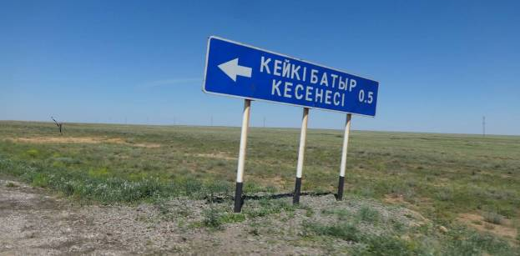

3 The resolution of akimat of Akmola oblast dated June 1, 2010 No. A-5/197 «About the approval of the State list of historical and cultural monuments of local value».
⁴The resolution of akimat of Kostanai oblast dated June 1, 2010 No. 207 «About the approval of the State list of historical and cultural monuments of local value of the Kostanai oblast».
5The resolution of akimat of the Aktobe oblast dated June 4, 2010 No. 180 «About the approval of the State list of historical and cultural monuments of local value of the Aktobe oblast»
- Baimyr batyr mausoleum is located in the territory of Dzhangeldy region approximately 18 km from Torgai village;

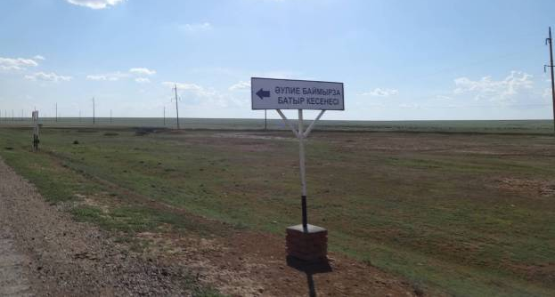

- А.Baitursunov monument is located in Akkol village, Dzhangeldy region
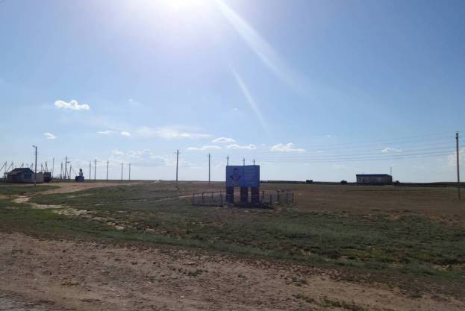

- According to Kazakhstan historical and cultural zonation the territory of road construction coincides with two extensive historical and cultural oblasts – Northern Saryarka and the Torgay deflection;;

Recommendations:
- To conduct on-site investigation of Expertise territory for the purpose of preparation of the conclusion of archaeological examination of final character;
Construction works without carrying out archaeological examination are connected with risks for the project.
AccordingtoArt.127 of the Land code of the Republic of Kazakhstan dated June 20, 2003 No. 442-II
In case of n case of detection of the objects, having historical, scientific, art and other cultural value, land users are obliged to suspend further conducting works and to report about it to authorized body on protection and use of objects of historical and cultural heritage.
Carrying out all types of works which can create threat to existence of objects of historical and cultural heritage is forbidden.
AccordingtoArt.39ofLegislationoftheRepublicofKazakhstan dated July 2, 1992 No. 1488-XII «About protection and usage of objects of historical and cultural heritage»:
2. In case of detection of the objects, having historical, scientific, art and other cultural value, individual and legal bodies are obliged to suspend further conducting works and to report about it to authorized body.
- At carrying out construction works to observe vigilance and care. In case of detection of ancient constructions, artifacts, bones and other signs of material culture to work according to the Instruction on carrying out actions in case of identification of subjects of the territories which are of historical and cultural value during development (see the Appendix B)
Enclosures:
А. The historical and archaeological information on the region of research;
Б. Typology of monuments of archeology, characteristic for the construction territory of the road
В. Instructions on carrying out actions in case of identification of subjects, representing historical and cultural value during territory development.

Appendix А. Historical and archeological information on research region;

According to Kazakhstan historical and cultural zonation the road construction territory coincides with two extensive historical and cultural areas – Northern Saryarka and the Torgai deflection

Saryarka is the region covering the Kazakh hummocky topography and his periphery. This region was the large cultural centre in the ancient period andin the Middle Ages. It was promoted by an environment. The small steppe rivers and streams allowed ancient farmers to fulfill skills of creation of irrigational networks. The low technological level didn't allow them to ride the whirlwind of such rivers as Syrdarya and Ili. In these conditions in Saryarka the type of economy designated as "stream agriculture".

Saryarka is one of transit sites of primary settlement of the continent by the individual. Sites of vagrant hunters and collectors of the Stone Age are usually dated for the water sources so valuable in desert conditions. Water also attracted animals on which the most ancient people during a watering-place hunted.

The stone was the main material of which instruments of labor of that time were made. Therefore traces of human activity often manage to be revealed in places of an exit of stone raw materials. The most valuable breed was flint.

During a bronze era the mankind carried out break in the development – production of metal instruments of labor was mastered. Everywhere in the territory of Kazakhstan the making types of economy – cattle breeding and agriculture extended. The central Kazakhstan region becomes the largest centre of bronze metallurgy at this time.

At this time the Central Kazakhstan was included into an area of an andronian cultural and historical community and was one of its largest cultural centers. The Central Kazakhstan variants of cultures of an andronian circle – atasu and nurin are brightly allocated against synchronous cultures with wealth and an originality.

At this time the binding of human settlements to natural sources of water weakens as people learned to sink wells. For this reason even in deep areas it is possible to meet the remains of settlements of a bronze age.

In the early Iron Age there is a change of a business pattern – the basic mass of the population of Kazakhstan passes to nomadic cattle breeding. The nomadic cattle breeding throughout two millennia was the most productive farm pattern in arid conditions of the Euroasian zone of steppes.

Riding, mobile way of life of the population increased its mobility. Interregional contacts are extended. The large areas mastered by the person. At this time Saryarka and Torgai deflection appear in an area of tasmolinsky archaeological culture. The Tasmolinsky culture is included in turn into a circle of cultures of saksky type which along with cultures of Scythians and Sarmatians form the skifo-Siberian cultural unity.The main characteristic of this unity is so-called the «Scythian triad» are similar subjects of arms, horse equipment, and also Scythian animal style.
The beginning of the medieval period is marked by entry of the territory of Kazakhstan into structure of the Turkic kaganate⁸. During the subsequent periods the Central and Northern Kazakhstan appeared under the power of the kimaks and the kypchak tribes⁹.

In the developed Middle Ages Kazakhstan is a part of the Mongolian empire of Genghis Khan. In structure of the empire the region concerned to ulus Dzhuchi, in subsequent received the name of the Golden Horde. Throughout two centuries the region consisted in east wing of the Golden Horde. During political processes the region appeared under the power of the Kazakh sultans.

From XV century the region is a part of the Kazakh khanate. Kazakhs used the region as a transit site at seasonal meridional removements from North to the Southern Kazakhstan¹⁰.

During this period the population completely refuses from the under burial mound entombments. Burials of its bigger part are made out in the form of stone fencings or laying out. The population masters elements of gummy memorial architecture that is expressed in increase of number of mausoleum burials.

In the XVIII century process of Kazakhstan joining to the Russian Empire begins. Deepening of process of colonization brings to creation of the new administrative units which aren't considering traditional routes of movement and led to reduction of routes of removements and increase of settled lifestyle. The increase of number of the stationary dwellings representing winterings became archaeological expression of this process.

The Torgai region is allocated against other regions of Kazakhstan with expressiveness of cultures of the posglacial period – the Holocene. It coincides with mesolitas – the neolithic – eneolithic on an archaeological periodization¹¹.

It is possible to assume that mobile elements of life and economy played an essential role in life of the mesolytic population of the Turgai deflection. Possibly, they were closely connected with hunting, as one of main types of economic activity. The climatic situation of this time was probably favorable for hunting development. Much warmer and humid, than now, the climate of the second half of the boreal period, undoubtedly, highly affected on development of vegetation of the Turgai deflection. The steppe spaces covered with dense grassy vegetation, the island and tygai woods engaged the various representatives of both steppe, and forest fauna. Biological efficiency of numerous lakes and rivers was also considerably bigger, in this regard the number of waterfowl lived on them is significantly higher.

Neolythic site considerably surpass the mesolythic in the sizes. The proximity of forms and a set of instruments of mesolythic and neolythic monuments of the Turgai deflection testifies in itself to experience in the neolithic of many lines of economy of a mesolythic era for which the mobile way of life of people is supposed.

Appearance of such monuments as Bestamak and Sulukol 1 with their huge area can be explained with numerous seasonal dwelling of the population in these parts. Both monuments are located in very convenient places at wide sites of the valley of the small rivers in a place of their narrowing. River pools rich with fish and bird are dated for them. Nearby there is a wood site of ten kilometers length. Such combination of natural objects attracted people here at all times.

7Gumilyov L.N.Ancient turks. М.: 1967
8AkhinzhanovS. М. Kypchaks in history of Middle aged Kazakhstan .Almaty, 1995
9KlyashtornyiS.G.,SultanovG.I. Kazakhstan.. Chronicles of three millenium. Almaty, 1992.
¹⁰LogvinV.N. Turgai deflection in mesolite-eneolithic period.Author's summary ofdissertation in candidacy for a degree doctor of historical science. Surgut, 2002.

Addition the eneolithic of cultures in steppes of Eurasia is connected, probably, with the middle of the Atlantic period. In any case, the cultures of the Mariupol community of the East European steppes referred to an eneolithic are dated no later than the first half of the IV millennium B.C.
The modern science has a scanty information on an early eneolithic of the Turgai deflection. About economy of the early eneolithic population of the Turgai deflection as well as about cultural accessory, it is possible to speak only very allegedly. It is possible to think that mobility of the steppe population in an early eneolithic, in comparison with the neolithic, was significantly less. Decrease of mobility of the steppe population in an early eneolithic probably is to some extent connected with changes of a climatic situation.
Throughout an average eneolithic there are essential changes in flinty industry, at the beginning of this period during some time the main mass of instruments is continued to do from plates. At this time tips from plates, including kelteminar type probably gained the distribution. Then owing to some reasons there is a transition from lamellar to chip industry which undividedly dominates in a late eneolithic. Ceramics of this time round-bottomed, ornamented with prints of a gear stamp and a string.

AppendixB. Archeology monuments typology, characteristics of road construction territoryи

Period | Types of monuments | Archaeological reference
Stone Age | Parkings and workshops of a paleolith, mesolitas, neolithic, eneolit | The high concentration of monuments of this period is due to the wealth of the region stone raw material needed for the production of tools, and also abundance of the wild fowl which was object of hunting.
Bronze Age | The settlements, burial grounds, menhirs, irrigation systems, mine workings | In the Bronze Age Saryarka was the most developed in relations to the socio-economic in regions of Kazakhstan. This was facilitated by climatic conditions that are optimal for integrated farming tribes of that era, as well as the wealth of the region's non-ferrous metals. The last factor provides a stable economic base, high demographic and consequently the highest concentration of archaeological sites in comparison with the neighboring regions.
Early Iron Age | Burial mounds, Burial mounds "with mustache" | During this period, the number of archaeological monuments some extent reduced compared with the previous epoch. This is due to climate change, as well as the transition to nomadic cattle breeding.
Early Middle Age | Turkic funeral and funeral complexes in the form of fencings from stones, stone sculptures – balbala, kipchaksky kurganny burial grounds, rocky burials. | During this period concentration of monuments of archeology continues to remain comparable to the previous period.
The developed Middle Age | Ancient settlements, mausoleums. | This period corresponds to time of existence of the Golden Horde. At this time the Ulytau subregion becomes one of the political centers of possession of the eldest son Genghis Khan – Zhoshy (Dzhuchi). It caused the fact of sharp growth of the cities- residences.
Late Middle Age | Kazakh cemeteries and mausoleums | This period is characterized by growth of population in the region and respectively high quantity of monuments, mainly funeral type.
New Age | Kazakh winterings | During this period the population reduces mobility. There are stationary settlements at which the winter pasture of cattle was carried out.

Appendix B. Instructions on measures carrying out in case of identification of subjects representing the historical and cultural value during territory development (Procedure at detection of findings).
Law of RK «About protection and use of objects of historical and cultural heritage»
Article 39. «Ensuring of safety of objects of historical and cultural heritage at territories development»
item 2. In case of detection of the objects having historical, scientific, art and other cultural value, individual and legal bodies are obliged to suspend further works conducting and to report about it to authorized body.
item 3. Work carrying out, which can create threat to existence of objects of historical and cultural heritage is forbidden.

Objects which can be correlated to historical and cultural monuments are: bone remains of people and animals, artifacts¹², remains of architectural constructions, burials and industrial complexes.

At identification of similar objects it is necessary:

- to stop construction works;
- to enclose a site of detection of objects with an alarm protection;
- to inform the bodies for protection of monuments of historical and cultural heritage, subordinated regional governments of culture;
- to invite archeologists from the regional research centres.

Before arrival of experts it is necessary to conduct the following events:

- in case if archaeological material was naked, but isn't disturbed it is necessary to powder with soil observing precautionary measures,
- in case if archaeological material during works was moved it is necessary to put in firm not tight container (boxes from a cardboard or a tree), as the filler preventing free movement of findings in a box and direct contact with air it is recommended to use soil in which they lay down;
- before arrival of experts it is necessary to provide storage of boxes with archaeological material in the dry room;
- it is extremely desirable to record on what site, what finds were revealed;

In case the historical and cultural value of the revealed artifacts is unevident it is necessary to photograph them. At photography it is necessary to try to reach the maximum image sharpness. At a shot there has to be a subject allowing to present the extent of the photographed object – a ruler, folding meter or the widespread standardized subjects – matchboxes, banknotes, standard capacities, etc.

To touch archeological finds proceeding from reasons of their safety and sanitary and hygienic norms should only in gloves.

¹¹Artifact (Latin artefactum from arte – is artificial + factus – made) in archeology — the object subjected in the past to the directed mechanical influence, found as a result of purposeful archeological excavations or any casual event single sometimes. Examples of artifacts are stone instruments, jewelry, the weapon, ceramics, constructions and their details, coals of an ancient fire, bones having traces of influence of the person, etc.

APPENDIX 4
INFORMATION ABOUT THE NATURAL PROTECTED ZONES LOCATED ALONG ROAD SECTION

The Kurgaldzhin reserve in Akmola area

Flora – Fauna

There are 350 species of the higher plants in flora of the reserve which lion's share is made by herbs. Here only about 15 species of bushes which are met mainly in inundated thickets of the rivers - shrubby willows, hedge rose, a honeysuckle. In the territory of the reserve there are 45 species of the rare and endemic plants demanding special protection. This is endemic of Kazakhstan steppe – Kazakhstan astragal, relic – a jug yellow, a water-lily purely - white, Shober's saltpetre. Shrenk's tulip, a tulip hanging, a pasque flower – yellowish and opened are brought in the Red List of Kazakhstan.

In the steppe the pea tree and a meadowsweet are met, and on coast of lakes, often marking old housing of people or ancient graves, Shober's saltpetre – a prickly spherical bush with small rigid leaves and roundish black berries grows. The steppe is generally covered with herbs which can live at small reserves of moisture. There are feather grass, sheep fescue, biyurgun, a ferula, a wormwood.

Lakes and shors are surrounded generally with the plants adapted for salty soils - there are various solyankas, kermeks, sea blites.

But there are also such species of herbs which are not so strongly depended on dry and hot summer - there are water and semi-aquatic plants. The most widespread among them are – a reed and reed mace. Their thickets to 6 meters in height cover huge spaces, forming labyrinths of channels and protected from world around river reach. Standing in water, they are green all warm season.

Wildlife – Fauna

The fauna of the Kurgaldzhin reserve is typical for steppe and semidesertic zones. Here 38 species of mammals, 274 species of bird , 6 species of reptiles, 2 types of amphibious, 11 species of fish are registered. The fauna of invertebrates of the reserve is almost not studied.

The fauna of the Kurgaldzhin reserve is very rich with birds. The main sight of the Kurgaldzhin national reserve – is a flamingo colony. In the steppe birds of rare species remained: the bustard, a sociable lapwing, a demoiselle crane, a lot of larks, especially black and white-winged. In total there are 20 types in the reserve brought in the International Red List of IUSN, and 37 – in the Red List of Kazakhstan are registered.

Animals in the reserve are presented by 42 types, more than a half of them – rodents. In damp places the boar is ordinary. And saigas are found in dry steppe sites . By the end of the XX century the number of a saiga catastrophically fell, and now only separate small groups meet here. From predators the fox is most numerous, the badger, a wolf, a steppe polecat are ordinary. In steppe decreases it is often possible to meet hares - a hare and a white hare. On the territory of the reserve the roe also occasionally comes.

«Altyn dala» reservein Kostanai region
In the territory of Amangeldy, Zhangeldy areas along alignment pass there is "Altyn dala" natural wildlife reserve which is located at distance of 140 km from Arkalyk, in 75-80 km from the designed road to Amangely and 50-60 km to Zhangeldy areas. The territory of reserve makes 489766 hectares, and includes steppes, sandy sites and wetlands which are important habitats for many wild animals, for saigas in particular.
The saiga, boar, hare, wolf, fox, jackal, dog fox, ground squirrel, muskrat, jerboa, duck, goose, swan and others lives in Kostanai oblast.
The Uly-Zhilanshy site of the reserve includes virgin feather grass and sheep fescue dry steppes, which are replaced by cereal and wormwood steppe deserts to the south. The main places of kittenning and summering of betpakdaly population of a saiga are dated for this site. The site is valuable to preservation and restoration of a steppe complex of birds including the bustard, little bustard.
The Tosynkum site will keep the massif of sand - northern sandy deserts with rich cereal and wormwood pastures, and also wood and shrubby vegetation (the sucker, willows, chingil, tamarisk) in decreases. Here the rare relic species of a desert poplar – Asiatic poplar, on northern border of the area. The site is also important for saiga, floods of Kabyrga river and lake are valuable as a place of nesting and migrations water and semi-aquatic birds.
The Sarykopin site completely covers the territory of the existing Sarykopin state natural reserve created in 1986. Coasts of lakes are occupied with wetland and meadow vegetation. The system of lakes of Sarykopa is included into the list of key ornithological territories (IBA) as one of places of high concentration wetland and the semi aquatic birds in the period of their seasonal migrations and a molt, and also nesting of rare species (pelicans, etc.). Here the stiff-tailed ducks, white-eyed pochard, sociable lapwing, imperial eagle, little bustard, pale harrier, lesser kestrel, belladonna, at the end of the XX century one of the few places of nesting of the bustard remained.

Irgiz-Turgai reserve in Aktyube area
Irgiz-Turgai reserve is created for the purpose of preservation and restoration of natural complexes, protection of habitats (winterings, summering, kittening), ways of saiga migration – the representative of betpakdaly population; preservations of unique wetlands of Irgiz-Turgai lake system, as one of places of the greatest concentration of wetland birds in the period of seasonal migrations and a molt; nestings of a flamingo, natatorial and semi aquatic birds, places of spawning areas of fish. The natural reserve consists of two regional places – northern and southern which are divided by the Turgai state natural reserve (zoological). Northern regional place of 89 040 hectares, includes lakes of Olkeiek group and the valley of Olkeiek river. The southern regional place of 674 509 hectares, includes wetlands of the international value, system of lakes on Turgai river, Shalkarteniz flat hollow , Shalkarnur mountains, Kurdym lake , Karakol and Bakshakol located in lower reaches of Turgai river.
The vegetable world - Flora
The flora is presented by 430 views from 64 families and 216 generation: the largest families of Asteraceae (64 types) – a yarrow tansy, an austrian wormwood, halophytic sosury, divided cousine etc.; Chenopodiaceae (29 types), sedgy (24 types). From coastal and water vegetation the reed, a cane, reed mace, tuberous bulrush, flowering rush, water plantain, arrowhead, a water buttercup, bur reed, a horsetail, a water moss are noted; from the real water plants - water-lilies, duckweeds, pondgrass, water milfoil, naiads, bladderworts, hornweed, 9 types of harofits and 42 types of versions and forms of the dominating microseaweed. Fauna of Irgiz-Turgai reserve. According to zoogeographical zoning of Kazakhstan the territory of reserve belongs to the Central Asian subarea, the Kazakhstan-Mongolsky province, Kazakhstan district, a site of the western part of a semidesertic zone.
Fauna
In the territory of reserve 29 species of mammals, 250 bird species, 14 species of reptiles, 4 types of amphibious and 10 species of fish are met. The fish fauna is presented by ten types: sazan, silver and gold crucian, ide, roach, bream, tench, perch, ruff, pike. A Aral sazan , the tench, the bream are the delivered and acclimatized types.
Open landscapes are preferred by birds of prey: pale harrier, lesser and common kestrel, golden eagle, imperial eagle, steppe eagle and others, only 30 types. Here 32 rare and endangered species of the birds included in the Red List of Kazakhstan are met: pink and curly pelicans, the spoonbill, a glossy ibis, a small white heron, a flamingo, a small swan, whooping swan, red-breasted goose, stiff-tailed ducks, a white crane, a gray crane, demoiselle crane, the bustard, houbara bustard, strept, little bustard, sociable lapwing, slender-billed curlew, great black-headed gull, black-bellied sand grouse and pin-tailed sand grouse, Pallas sand grouse, duck hawk, saker falconsea eagles, white-tailed and grenadier, a golden eagle, imperial eagle, a steppe eagle, harrier eagle, fish-hawk, common vole, large-toothed souslik, southern birch mouse, mouse hare, on clay plains – fat-tailed jerboa, on the dry-type playa and saline soils - lesser five-toed jerboa, on easy soils – a yellow gopher and feather-tailed three-toed jerboa; in reed and the reed mace thickets on shallow sites on coast of the rivers and lakes the water vole, a muskrat, a boar meet. From predators on open spaces dog fox, steppe polecat, the fox, wolf live. In the southern part of reserve the saiga – the representative of betpakdaly population, lives in the past of the largest in Kazakhstan on an area and number. The main places of wintering, kittening and summering are – the plain between Turgay river and Shalkarnur's mountains. From the rare types included in the Red List meet Bobrinsky's leather jackets, Kazakhstan endemic and a barkhan cat, a rare small species in fauna of Kazakhstan.

APPENDIX 5
ROAD SECTION PHOTOGRAPHS

Astana – Turgairoadsection
Akmola oblast
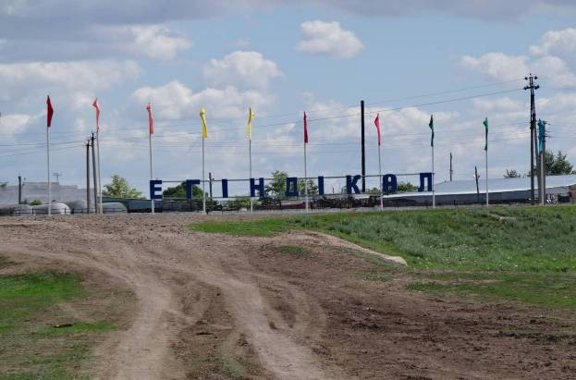
Figure 1. at 75 km from Astana Egindykol village, administrative centre of Egindykol region

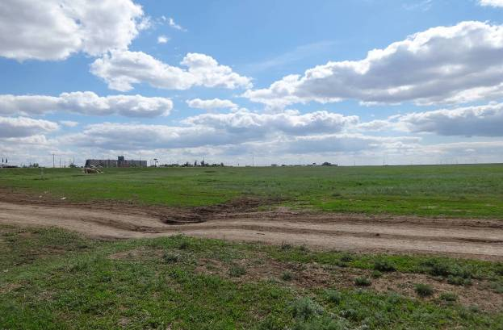
Figure 2.Egindykol village (panoramic view)
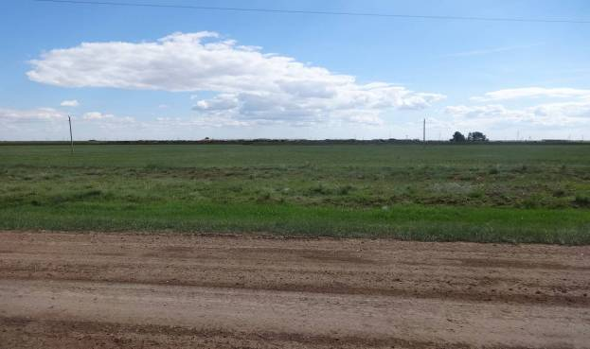
Figure 3. at 172 km road along Korzhynkol village

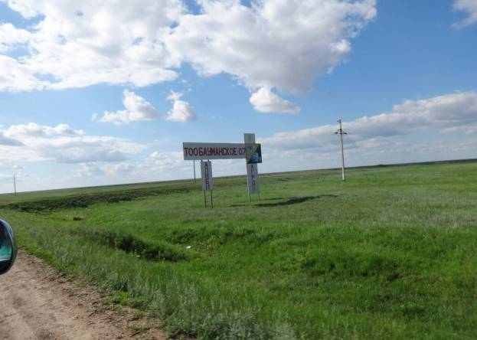
Figure 4.Agro-industrial complex “Baumanskoie07”LLP
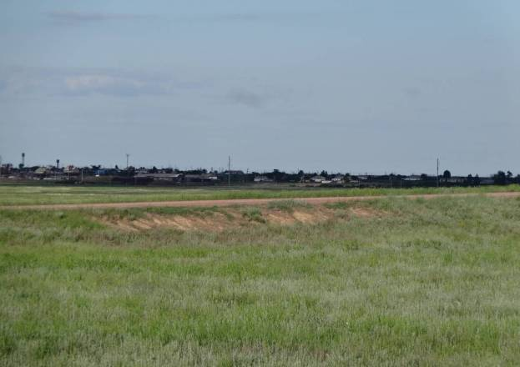

Figure 5. Panoramic view of Sepe village

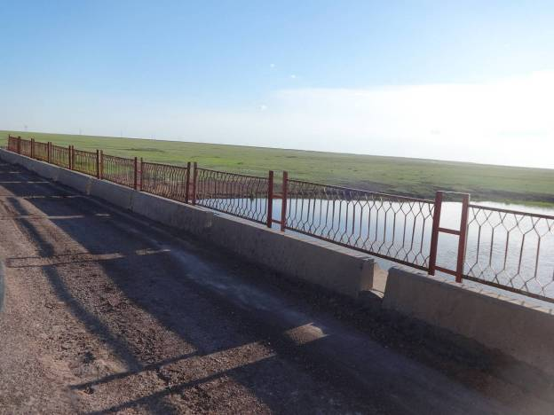
Figure 6. at 227 km Terissakan river, width 5 meters

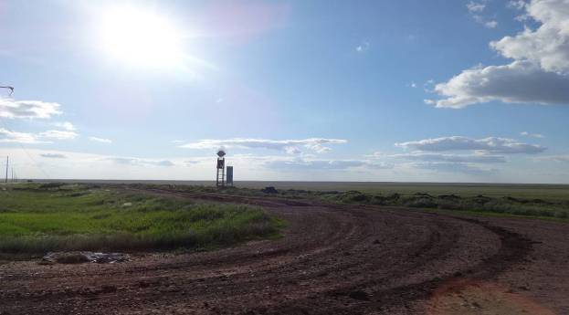
Figure 7.Road view along Sochinskoie village at 229 km

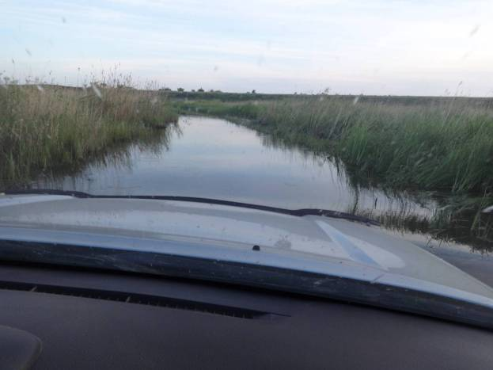
Figure 8.at Km 235, Off-road. Cross through Terissakan river, width 3 meters

Kostanai oblast
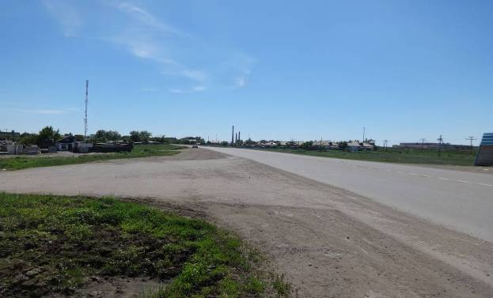
Figure 9.Panoramic view of Arkalyk town at 560 km

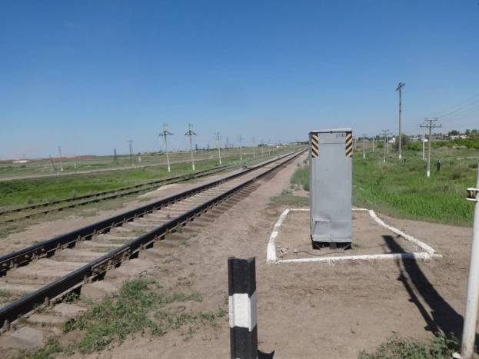
Figure10 .Railway crossing (Arkalyk t.)
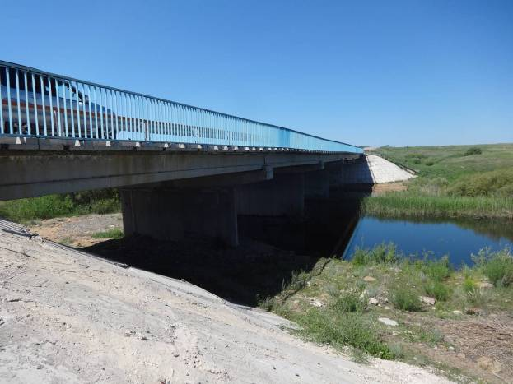
Figure11. at Km 590 Tasty river, width 3 meters

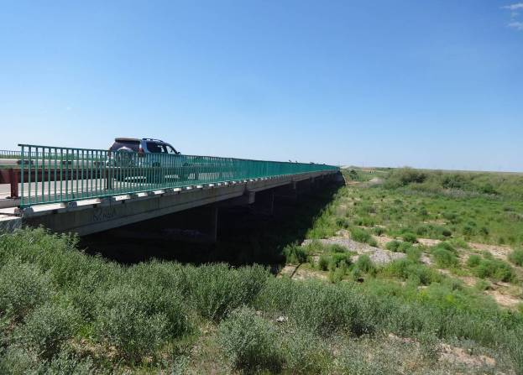
Figure12.at Km 613,5 bridge (season river)
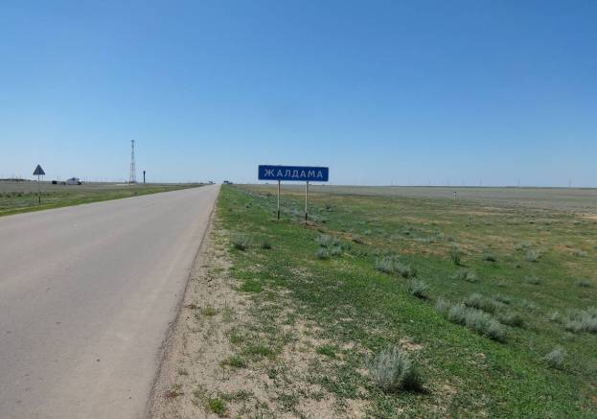
Figure 13. at Km 630 Zhaldama village

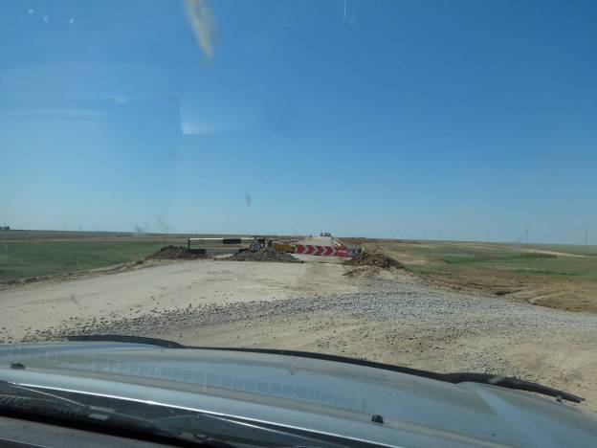
Figure14.At km 670 rehabilitation /construction works are carried out
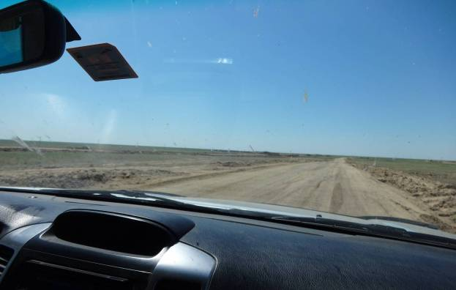
Figure15. By-pass road view

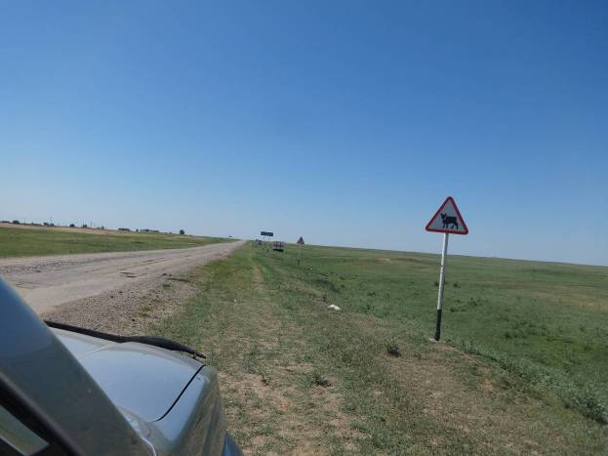
Figure16.Sign for cattle pass close to Akaidar village

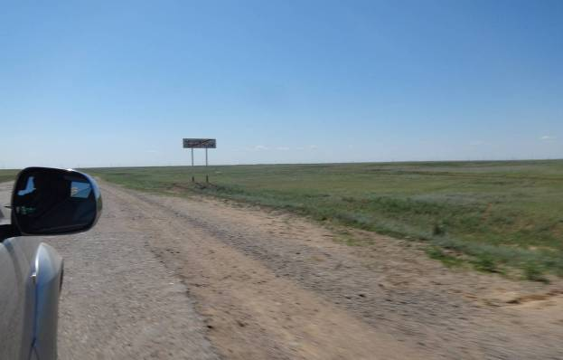
Figure17.Exit road from Amangeldy village

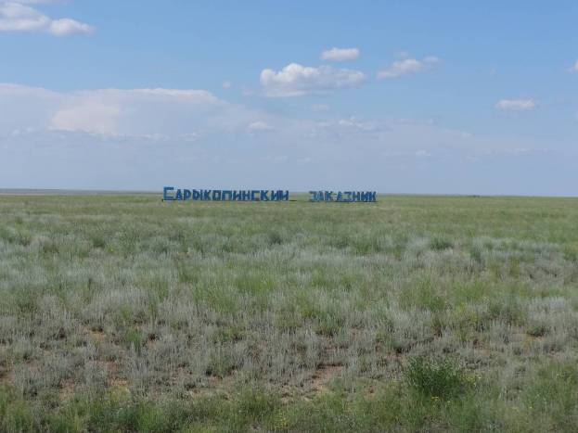
Figure18. Sarykopin reserve
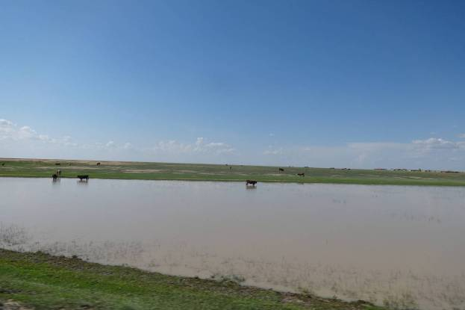
Figure19.River near Taush village

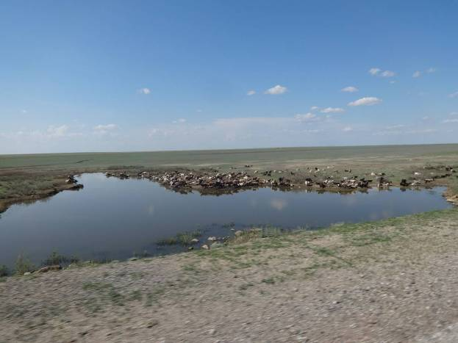
Figure20.River near Taush village
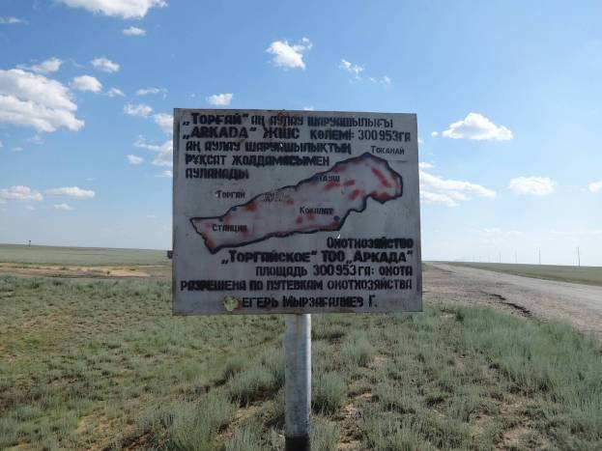
Figure21 «Turgaiskoye» hunter economy

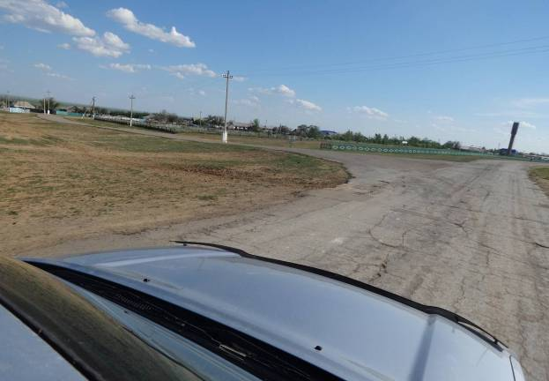
Figure22.Panoramic view of Turgai village
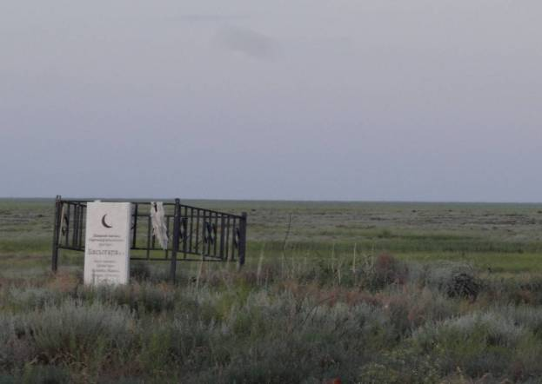
Figure23.MonumenttoHoly man, territory of Akshyganak village (on border of Aktobe oblast)

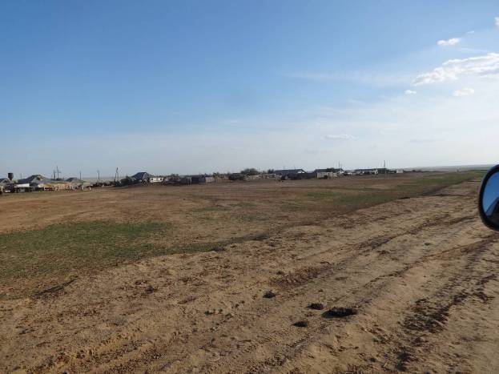
Figure24.Akshyganak village

6KadyrbayevМ.К.,KurmankulovZh.К.Culture of ancientcattle farmers and metallurgists of Sary-Arka. Almaty, 1992 7А.H. Margulan, К.А. Akishev, М.К. Kadyrbayev, А.М. Orazbayev.Ancient culture of Central Kazakhstan.Almaty, 1966.

